Authors: CIOFS-FP Lombardia, IES El Palo, Richtpunt campus Oudenaarde, ROC Amsterdam

Future skills for a better life in Sustainable Salons is a European project that aims to combine the sustainable ideas through education and training with innovative ideas within the sector.

This project has been funded with support from the European Commission. This publication reflects the views only of the author, and the Commission cannot be held responsible for any use which may be made of the information contained therein.

The project partners and associated partners within this program are:

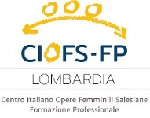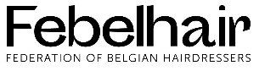

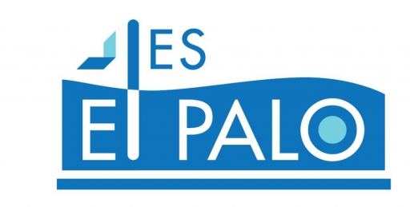

© 2023 Sustainable Salon project, Erasmus+ 2020-1-NL01-KA202-064515. No part of this document may be reproduced in any form without the authorisation of Stivako (project coordinator) and the authors.

Contact address:

Stivako [info@stivako.nl](mailto:info@stivako.nl)

Project website: [www.sustainable-salon.info](http://www.sustainable-salon.info)

Index

1. Setting up a sustainable business 4

1.1 Preparation 4

1.2 Laws and legislation 9

1.3 Producing a sustainable product 14

1.4 Brainstorming the concept, preparing the presentation for investors / experts and a pitch 15

2. Energy and sustainability 19

2.1 Energy in the hairdressing salon II 19

3. Water 32

3.1 Rules and laws (legislation) about water pollution in your country 32

3.2 Setting up a water-efficient (dream) salon 33

3.3 Companies that make products helping reduce / reuse / recycle / purify water 34

3.4 Corporate Social Responsibility in relation to water 35

3.5 Water-related CRS as a marketing tool 35

4. Waste 38

4.1 Waste legislation in your country 38

4.2 How do you set up a low-waste salon? 39

4.3 Corporate Social Responsibility in relation to waste 41

4.4 Entrepreneurial Innovation: hairdresser’s waste as new raw material 42

5. Management 43

5.1 Criteria for suppliers’ selection 43

5.2 What is a Sustainable supplier? 44

5.3 The quote 45

# Setting up a sustainable business

**Introduction to this lesson**

After grasping the concept of "sustainability" in level 1, you also started looking for yourself through various assignments on how to become more sustainable in the hairdressing industry.

You got notion about the waste produced in a salon and its impact on the environment.

You learned to work with different tools and scans to map the results around "acting sustainably" and to calculate the carbon footprint.

The impact of acting on nature and the climate was discussed in more detail and how the United Nations is working on these factors with the SDG’s.

In level 2 we mainly looked at what measures you can take as a hairdresser to become more sustainable. You now know that a lot depends on making correct and informed choices, such as choosing the right supplier, the choice of raw materials, how will you recycle your waste. All the decisions made must, of course, fit within the legal framework of your country and place of residence.

You also designed your own test to measure the carbon footprint of a hair salon.

Then now is the time to brand yourself as a sustainable entrepreneur. In level 3, you will produce your own sustainable product (fictitious or otherwise). You will make a clear presentation and present your sustainable business plan to a jury of experts. You will get the chance to convince them in a pitch discussion to invest in the production of your product.

**Summary**

1. Setting up a sustainable business

1.1. Preparation

1.1.1 Environmental system

1.2 Laws and legislation

1.2.1 European laws and legislation

1.2.2 National laws and legislation

1.3 Producing a sustainable product

1.4 Brainstorming the concept, preparing the presentation for investors / experts and a pitch

1.4.1. Brainstorm and defining the concept

1.4.2. Preparing the presentation for the experts/investors

1.4.3. Preparing the pitch discussion

1.1 Preparation

**KNOWLEDGE UP**

First things first: acquire the skills, both theoretical and practical, necessary to start a salon business, as well as a realistic expectation of the sustainable practices you can implement. Find a great accountant who can assist you in determining how much money you can put into the salon and any environmental kickbacks that may be available if initiated from the beginning by using blogs or podcasts, learning about accounting and how to keep track of your numbers, and finding a great accountant.

You can adhere to a budget and business plan based on this. Consider how much energy it will take to run all of the salon's dryers, and check to see if there are any grants available for the installation of renewable energy. Always seek out a mentor whenever possible. Someone who has already done exactly what you want to do in your field will be able to offer you a wealth of information and save you a lot of time and money in the long run because they have already gone through the process.

**GET CLEAR ON WHAT A SUCCESSFUL AND SUSTAINABLE SALON BUSINESS IS TO YOU**

How do you know whether your salon should be a beauty salon or a hair salon, or both? By doing this, you can start to look at costs and how much you need to take in addition to estimating your forecast or turnover. Consider how you will accomplish that.

Consider sustainability and environmental stewardship from the start of your salon, as many businesses are beginning to adapt their offerings and business models to reflect the future. When you open, making this a high priority in your plan will be a significant unique selling point.

Understanding who your salon will serve is also essential. What desires would a real person have? Keep that person in mind as you design your environment. Choose a name for your salon based on this that reflects who you are and how you want your brand to be perceived by actual customers.

**COMPETITORS**

It may seem obvious, but knowing who your local rivals are allows you to tweak your unique selling proposition. What will set you apart? Since so many businesses have adapted to COVID and made the conscious decision to go green, you should think outside the box about novel ways or incentives that you could offer your customers that are different.

**FINANCE / LOANS**

Write everything down on paper to make a business plan so you can know how much money you have to invest. This will keep you on track and ensure that you put your money where it is most needed for your business.

To prepare your salon for success, get the loans and other funding you need. After you've prepared for the worst-case scenario, make sure you have some money on hand. When starting a business, insurance is a non-negotiable requirement that ensures complete protection on all fronts; therefore, budget for this upfront.

Let's take a look at some easy ways to make your salon startup more sustainable now that we know the most important things to think about and do.

**RECYCLE RECYCLE RECYCLE**

Recycling is one of the easiest and most cost-effective ways to make your salon more sustainable. Recycling shampoo and conditioner bottles, for example, may seem obvious; however, you can recycle all of the cut hair as well.

Hair booms, which are used to absorb oil, and hair mats, which fit over drains to protect waterways, can both be made from recycled hair. Hair booms cut by our customers were recently utilized in a successful Irish ocean spill last month.

Having separate bins for hair color tubes, PPE, and foils is also helpful when recycling. To ensure that you are aware of which bins belong where, label each one. Look into local collection companies that can come and take your waste to specialist recycling or incinerating sites if your local council cannot accept your recycling but you know it can be recycled. Bring your bottles back to us to be recycled, and we'll give you a discount on your next purchase. This is also great to offer to customers.

**WATER ECO HEADS**

Water eco heads are an excellent addition to your hair salon because they use less energy and conserve water. They can cut your rinse time in half by controlling the water pressure and creating a powerful stream. Reusing rinse water is one of the most common and effective ways to save water in today's salons. It also works very well.

**DON’T CONFUSE SUSTAINABILITY WITH ORGANIC**

Customers may be tempted to misunderstand the terms "sustainable" and "organic," but there is a difference: "sustainable" is a step ahead of "organic." A sustainable method or product is not only environmentally friendly but also concerned about the future. Sustainable products are not only environmentally friendly, but they can also be reused for a long time, reducing the need to frequently purchase new ones.

You'll also do well to use products and packaging that break down into biodegradable materials whenever possible and to prioritize sustainability when making purchases. Another way to save money on energy and get closer to your sustainable salon goal is to use bamboo hair dryers and brushes.

INVOLVE YOUR COMMUNITY

A great way to keep customers and make more money over time is to keep your community informed about what you're doing and how you're becoming more sustainable as a salon, especially when you're just starting out. Customers need to know that you are addressing this problem and contributing to the community and industry as a whole. It's also a great way to get ahead of competitors who might not be using sustainable practices right now.

You will be well on your way to developing a hair salon startup that is both profitable and long-lasting if you carry out any or all of the aforementioned actions.

1. **Environmental system**

An organization can use the international ISO 14001 environmental standard to improve its environmental performance. An organization seeking to systematically manage its environmental responsibilities and contribute to the environmental pillar of sustainability is intended to use this International Standard.

The ISO 14001 standard has several parts:

In the first column the practical translation in accordance with the ISO norm standard is mentioned.

The 2-3-4-5th column shows the phases the company goes through using the plan-do-check-act method. The improvement mechanism from 'not present' (red) to a company ‘improvement cycle present' (blue).

When improving environmental care in your salon or company, you can distinguish 3 phases:

• phase 1: preparation

• phase 2: position determination

• phase 3: improving care for the environment

In phase 1, you create the preconditions for successfully completing the project within a set period.

In phase 2, you assess how you currently perform in the field of environmental care on the basis of various questionnaires. You determine which aspects have already been properly arranged, and which points still need improvement.

This positioning is divided into two main topics:

• good housekeeping

• compliance with legislation and regulations

In phase 3, you make a plan based on the identified bottlenecks on how to further improve the situation.

**Phase 1: preparation**

In order to successfully complete the project of putting environmental actions into place within a predetermined time frame, it is sensible to establish a number of preconditions.

The following ideas come to mind:

* Include key individuals in the project

Even in a small business, the director, manager, or owner is not solely accountable for environmental care. It may be helpful to complete the assignments with one or more key figures, depending on the size of the business.

These advantages include:

• a broader basis for finding solutions because two people know more than one

• creating support because key figures can tell their colleagues what the project entails and why the organization is working on it during the day

* Inform employees

Informing your employees about environmental care early and correctly promotes the motivation to get started; The workers are aware of their actions—"being aware is doing consciously" This can be done casually during daily work or over coffee on a Friday afternoon.  You can, if necessary, give it a more formal feel by holding a joint meeting, holding a work meeting, or sending out a newsletter.

* Planning

Before beginning the implementation of 20 Standard practical environmental care aspects in the school or salon, it is recommended that a plan (planning) be created.

This is the plan:

* are you able to outline your strategy in detail (who and when)?
* you can track your progress by marking the steps you've completed. The "Environmental action plan" can be utilized during the implementation phase (see phase 3).

**Phase 2: Position determination**

You have successfully completed the first phase through preparation. In other words, you will determine your starting position during the position determination phase: How can you score when you haven't worked on getting better? The primary inquiry is, how does my salon or school view environmental impact?

Step 1: Determination on a general level

To get a first impression and determine your starting position you can use the free to use extended self-assessment tool:

 Is your company/school sustainable? The link is: <https://zelfscan.eu/sustainable/>

This tool reveals how you perform in relation to the following (environmental) aspects of your salon or school: raw materials, administration, waste, energy, water, and legislation (Based on the ISO standard).

The following free self-assessment tools can be utilized to get an idea of the level of awareness that exists within your salon or school regarding the environment:

• Awareness on sustainability and environment (School) link: <https://zelfscan.eu/awareness_schools/>  • Awareness on sustainability and environment (Salon) link: <https://zelfscan.eu/awareness_salons/>  (Seen from an ISO standard: this tool has interfaces with standard 7)

To get an idea on the position on the organization context of your salon/school you can use the free self-assessment tool: Organization context of a sustainable salon: link: <https://zelfscan.eu/sustainable_salon/>  (Seen from ISO standard).

Step 2: Determination per work process

Using the Internal Audit form Practice, we will investigate the organization's work processes in greater depth during this phase. The form has questions for each workplace that discuss the previously determined impact on the environment.

As the company's or school's internal auditor, you use the questions to evaluate the situation.

One of the four assessment levels can be defined:

• Agree, the situation meets the requirements

• Observation: it is not yet fully satisfied but with a small adjustment it can be solved

• Minor = Small shortcoming: It is not sufficient, can be solved but not immediately

• Major = Major shortcoming: the situation does not meet the requirements.

Step 3: Determination the position on the organization context

Using the Internal Audit form System, we will investigate the organization, leadership, planning, and support in greater depth during this phase. There are questions on the form for each aspect that discuss the organization's impact as previously determined.

As the company's or school's internal auditor, you use the questions to evaluate the situation. One of the four assessment levels can be defined:

• Agree, the situation meets the requirements

• Observation: it is not yet fully satisfied but with a small adjustment it can be solved

• Minor = Small shortcoming: It is not sufficient, can be solved but not immediately

• Major = Major shortcoming: the situation does not meet the requirements.

**Phase 3: System Improving care for the environment in the salon**

You were able to determine the extent to which the school's salon or the salon in the school performs well in the environmental field by reading the previous chapters, which explained which environmental factors are essential for hair and beauty.

This chapter explains how to approach the identified bottlenecks in a methodical manner and how to guarantee that environmental protection will continue to be adequate in the future.

Make an action plan

You can develop a strategy for structurally improving the environmental situation in your salon once you have a clear understanding of the issues with the environment: This is referred to as an "environmental action plan."

Environment and planning

An important tool for structurally improving environmental care is the environmental action plan. The rate at which the planned actions are fully implemented is higher the more precisely the environmental measures are defined.

A shopping list and the action plan should be compared. A shopping list is simple to make if you have a lot of things to buy. If you don't, you might forget to buy something, which would force you to go back to the store.

The shopping list and the environmental action plan both serve the same purpose. The environmental actions should still be written as precisely as possible. Put another way, You can, for instance, select "will adjust the place where you mix the dyes of the coloring process" as an action, but it's better to specify which actual adjustments are required. There is a good chance that you will forget environmental actions if you have not clearly documented your shortcomings.

Include a column with specific costs in the plan if you, as the plan's author, do not have the authority to make actual investments.

If the plan is approved by management, they can use your cost forecast to determine which budget should be set aside for environmental care enhancement.

You won't have to worry if you do everything you're supposed to do well. You'll be a happy director, manager, or owner. However, this is extremely uncommon in practice; There are areas that can be improved in every business. It is frequently impossible to address all areas of improvement simultaneously: Time, human capacity, and financial resources are always limited in your budget.

As a result, you'll need to prioritize what needs to be done first and what can wait. on the internal audit form with orange or red markings!  It is essential that all interested parties, particularly those named as responsible implementers in the plan, are informed about the content after the planning has finally been established.

1.2 Laws and legislation

**European laws and legislation**

Over decades, the EU has developed some of the highest environmental standards in the world. Environment policy safeguards the health and well-being of EU residents, safeguards Europe's natural resources, and helps the EU economy become more environmentally friendly.

Our well-being, our economy, and our health all depend on the quality of our environment. However, it faces numerous significant obstacles, not the least of which are the effects of climate change, unsustainable consumption and production, and a variety of forms of pollution.

Environmental legislation and policies in the EU help businesses move toward a sustainable economy, preserve clean air and water, ensure proper waste disposal, and protect natural habitats.

The European Union leads international climate negotiations and develops and implements climate policies and strategies. It is committed to ensuring the successful implementation of the EU's Emissions Trading System (EU ETS) and the Paris Agreement. EU nations have agreed to accomplish various goals in this regard over the coming years. In addition to promoting low-carbon technologies and adaptation measures, the EU aims to ensure that climate concerns are taken into account in other policy areas like transportation and energy.

Articles 11 and 191-193 of the Treaty on the Functioning of the European Union serve as the foundation for EU environment policy. According to Article 191, the EU's environmental policy explicitly aims to combat climate change. The EU's commitment to a "high level of protection and improvement of the quality of the environment" is reflected in its overarching goal of sustainable development (Article 3 of the Treaty on the European Union).

The laws and legislation followed by the European Union can be found on the following webpage: <https://eur-lex.europa.eu/content/summaries/summary-20-expanded-content.html>

**National laws and legislation**

**Belgium**

Let’s say you want to start up a company or a business in Belgium. What legal obligations do you have to fulfil in terms of the environment, waste management and recycling?

Sorry, but there is no ready-made solution. This is due to the intricate structure of the nation. But rest assured: Aid is on its way. The website below helps you see better by providing an overview of each region and a few useful links.

It's important to note that Belgium's environmental laws are complicated. The regions are almost entirely in charge of environmental policy. As a result, the regulations governing environmental permits, pollution, and waste management differ in the Flemish, Brussels Capital, and Walloon regions.

The policy is also distributed across additional policy levels. Product standards, protection from ionizing radiation, hazardous waste transportation, nuclear energy, and other issues are handled by the federal government. European regulations apply to some areas.

However, provinces and communes also have their own environmental regulations to complete the circle.

When you add all of this to the fact that it is a topic that is always changing, you can see why you can't easily find an answer to a straightforward question like: What responsibilities do I have to the environment?

<https://www.bebat.be/en/blog/legal-environmental-obligations-belgium>

**The Netherlands:**

In accordance with the Activities Decree, numerous businesses are required to provide a notification upon starting up or making changes. Others call for an "All-in-one Permit for Physical Aspects limited environmental impact assessment" (also known as an "OBM") or an "All-in-one Permit for Physical Aspects for the environmental aspect."

**Companies that have relevant impact on the environment**

Companies that have very little or no impact on the environment are exempt from many environmental regulations. This is true for many stores, for instance. If a company possesses all of the following characteristics, the environmental regulations apply:

it is a company or something the size of a company

* its activities take place in one location and not in multiple locations
* the activities have a duration of at least six months or return regularly to the same location
* the activities are listed in Annex I of the Decree on Environmental Law ('Bor')

**The Activities Decree**

Companies are subject to environmental regulations in the Activities Decree. The Activities Regulations provide detailed explanations for many of the rules in the Activities Decree. Unless they have little or no impact on the environment, all Dutch businesses are subject to the Activities Decree.

There are distinct guidelines for various kinds of businesses in the Activities Decree. The Activities Decree distinguishes between companies of types A, B, and C. When a company is subject to the Activities Decree, it is frequently required to notify the government of any new operations or changes. "Customized rules" can sometimes be used to deviate from the Activities Decree's guidelines.

**OBM: The All-in-one Permit for Physical Aspects limited environmental impact assessment**

An uncomplicated permit without regulations is the "All-in-one Permit for Physical Aspects Limited Environmental Impact Assessment" ('OBM).

Before the Activities Decree takes effect, businesses subject to the OBM must undergo an assessment. This evaluation, for instance, may concentrate on efficient waste management and local nuisances like noise, odor, and air quality.

The Activities Decree typically refers to businesses as type B as being subject to the OBM. In some cases, in addition to the All-in-one Permit for Physical Aspects for the environmental aspect, a type C company may also require an OBM.

**The All-in-one Permit for Physical Aspects environment**

An All-in-One Permit for Physical Aspects is required for environmental aspects of some activities because they are too complicated to be covered by general rules.

These activities are listed in Annex I of the "Bor" Decree on Environmental Law. The Activities Decree Internet Module (AIM) processes this data. The AIM determines whether an OBM or an All-in-one Permit for Physical Aspects is required for the environmental aspect.

The majority of businesses do not require an environmental aspect All-in-One Permit. An All-in-One Permit for Physical Aspects will be available to approximately 22,000 businesses in 2016 for environmental aspects. This is 5% of the businesses that have a significant effect on the environment.

Companies that require an All-in-one Permit for Physical Aspects for the environmental aspect are type C companies within the meaning of the Activities Decree.

**Company types and environmental regulations**

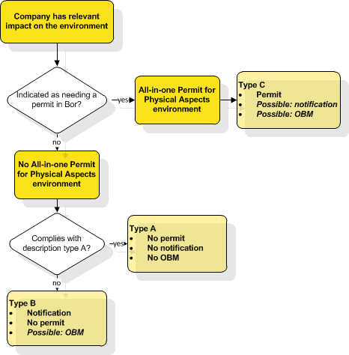

**The competent authority for companies**

The competent authority for a company is the government body for that company, which:

* ensures compliance with general rules and permit rules
* may grant a permit
* may prepare rules that deviate from the general rules

The Bor indicates which government body is the competent authority for companies. This government body may be authorised for:

* the All-in-one Permit for Physical Aspects Environment
* the All-in-one Permit for Physical Aspects limited environmental impact assessment (OBM)
* the Activities Decree

In most cases, the appropriate authority is the municipality. The province can only be the competent authority for closed landfills and certain complex industrial companies (like IPPC companies). A minister from the government may be the appropriate authority for some special businesses.

<https://rwsenvironment.eu/subjects/environmental-0/system-environmental/>

**Italy:**

The key environmental legislation is the Environmental Consolidated Act (Norme in materia ambientale or Codice dell'Ambiente) (Legislative Decree no 152/2006) (ECA). The ECA has six parts:

* Environmental general principles.
* Environmental Impact Assessment (EIA) and Integrated Pollution Prevention and Control (lPPC) permit (autorizzazione integrata ambientale) (AIA)
* Water resources management  and soil protection.
* Waste and packaging management.
* Remediation of contaminated sites.
* Air protection and air emissions.
* Environmental damage.

There are separate environmental laws regulating specific areas, for example:

* Presidential Decree no. 59/2013: Single Environmental Authorisation (autorizzazione unica ambientale) (AUA).
* Legislative Decree no. 49/2014: waste electrical and electronic equipment (WEEE).
* Legislative Decree no. 166/2010: ambient air quality.
* Legislative Decree no. 188/2008: waste batteries and accumulators (WBA) and others.

According to the Italian Constitution, environmental regulation is the sole responsibility of the state. The Ministry of Ecological Transition (MET), formerly the Ministry of the Environment and the Protection of Land and Sea (Ministero dell'Ambiente e della Tutela del Territorio e del Mare), is the primary national authority (Law Decree no. 22/2021 was converted into Law No. 55/2021).

Other national regulatory authorities include the:

* Ministry of Health (Ministero della Salute).
* Ministry of Economic Development (Ministero dello Sviluppo Economico).
* Ministry of Cultural and Landscape Heritage (Ministero dei Beni Culturali e Ambientali).
* Interministerial Committee for Ecological Transition (Comitato Interministeriale per la Transizione Ecologica) (CITE).
* Scientific agencies with a regulatory role including the:
  + National Institute for Environmental Protection and Research (Instituto Superiore per la Protezione e la Ricerca Ambientale) (ISPRA); and
  + Superior Health Institute (Istituto Superiore di Sanità) (ISS).

The regions are able to issue environmental regulations wherever they have delegated legislative authority. Permits can be issued by the local government. Among these authorities are the:

* Regions, provinces and metropolitan cities.
* Ambit Authorities (Autorita' d'Ambito) (ATO) (which organise and govern integrated water supply).
* Regional Environmental Protection Agencies (Agenzia Regionale per la Protezione Ambientale) (ARPA).
* Local Health and Safety Agencies (Agenzie di Tutela della Salute) (ATS).

<https://uk.practicallaw.thomsonreuters.com/1-503-2608?transitionType=Default&contextData=(sc.Default)&firstPage=true>

**Spain:**

There are numerous threats to the equilibrium and survival of the environment, a complex system of great importance to human welfare and our future. In light of Spain's accession to the European Union, the government has implemented policies with the intention of overcoming these obstacles.

The OECD's environmental performance review report on Spain, which was released in early March 2015, acknowledges Spain's significant progress in this field over the past few years. It emphasizes the remarkable progress that has been made in a number of aspects of environmental performance. These aspects include a less resource-, energy-, and carbon-intensive economy, a significant expansion of protected natural areas, and the implementation of new, efficient legislation to significantly reduce the burden of bureaucracy on individuals and businesses and to improve coordination among public authorities.

The full range of research efforts that are carried out as part of an administrative procedure to identify, predict, and evaluate the environmental impacts of a proposed plan, program, project, or activity are referred to as environmental assessment. the exercise's objective was to come up with appropriate corrective and preventative measures with the goal of avoiding significant negative effects and properly safeguarding the natural resources and environment.

Law 21/2013, of December 9, 2013, on environmental assessment is the fundamental piece of legislation that governs the environmental assessment of plans, programs, and projects. This law implemented a significant procedural reform of this legal instrument on prior control with the goal of simplifying and expediting procedures, which in turn strengthened environmental protection.

Individuals are able to participate in the public reporting and consultation phases of the environmental assessment process that is applied to projects as well as public plans and programs in order to ensure that the public is involved and that the process is transparent. In response to the various environmental documents produced during environmental assessment processes, citizens can file claims and comments.

<https://www.lamoncloa.gob.es/lang/en/espana/stpv/spaintoday2015/environment/Paginas/index.aspx>

1.3 Producing a sustainable product

With all the knowledge and skills you have learned and practiced throughout the different levels, you will have to incorporate everything in a final assignment on sustainability.



**Make a presentation of your sustainable business plan, using the criteria below.**

**Present your presentation to a jury of experts/investors.**

**Convince them in a pitch discussion of your sustainable product.**

1.4 Brainstorming the concept, preparing the presentation for investors / experts and a pitch

**Brainstorm and defining the concept**



* **Brainstorm about a sustainable product that you would like to be produced in the hairdressing sector.**
* **Think about a suitable name for the product.**
* **Define the concept and philosophy and how does this fit into the SDG’s.**
* **Choose raw materials and describe their impact on people, planet, profit. 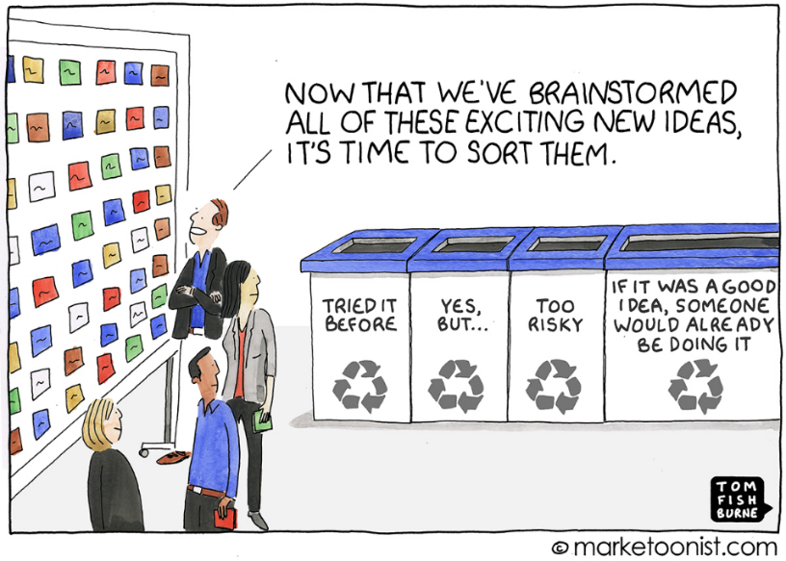**
* **Think about the providers: local or not?**
* **Manufacturing of the product: where + how?**
* **Define the packaging.**
* **Think about means of transportation.**
* **Describe the marketing strategies and the growth rates.**
* **Think about ways to recycle.**
* **Complete the financials.**

**Preparing the presentation for the experts/investors**



**Name of the product**  
- define the choice of the name

**Market opportunities**  
- define your market: What business are you in?  
- total market size: What is your niche?  
- customers: clearly define exactly who you serve

**Problem – solution**  
- problem: define the problem/need you are solving and for who  
- solution: who else is already doing this and what are they doing right or wrong?

**Product and service**- tell the story of your customer and how they use/value your product

**Manufacturing**  
- which raw materials do you use and why this choice?  
- what about the packaging?  
- what about transportation?   
- how will you recycle your own waste and waste from your product?

**Marketing and growth strategy**  
- where are your customers looking today and finding the product.  
- where will you get in front of them?  
- how will you achieve your target growth rates?  
- what are the most important and unique channels and methods you will use to find and win customers?  
- how are you doing it differently than others in the space?

**Competition**  
- who do you compete with?  
- what makes you unique?

**Financials**  
- highlight each of the following items yearly for at least 3 years: total customers, total revenue, total expense, EBITDA (Earnings Before Interest, Tax, Depreciation and Amortisation)

**Investment**  
- how much money do you need from the investors?  
- how will you use the money?  
- what advice do you need from the experts?

**Preparing the pitch discussion**

To learn how to give a presentation pitch, and if we can expand on what the author says, this doesn't just happen; It necessitates spending a lot of time and thought crafting messages that elicit empathy and deep resonance.

Make sure you spend all of your time focused and attentively crafting the ideal message that will inspire your audience to take action. If you do, the results will be obvious, and as you progress, your confidence in delivering these speeches will naturally and significantly grow. Being in charge of your gearing and how you use it is the goal of this long-term exercise.

The "hook"—the amount of time you have to get your prospect's "lean in" and pique their interest—is the first eight seconds. In part, this is due to the fact that during this first segment, we typically hold an audience's full attention before naturally losing it.

After that, you want to respond to a few important questions from your audience.

Simply create a one-sentence answer for the following four questions:

* What do you do?
* What problem do you solve?
* How are you different?
* Why should I care?

The pacing aspect is at the heart of the first suggestion. You are not required to rush through a pitch just because it is anticipated to be brief. Keep it understandable. Pause for a moment to breathe. Take your time with it so that your audience can hear your ideas. Don't rush through a speech to make up for the limited time you have. Instead, practice. Make sure you pick the appropriate words and memorize them. Then proceed cautiously through them.



Make revisions, edit, and check once more if you want to create the perfect pitch! Repeat each word until you find the one that best conveys the exact idea or concept you want to convey. Correct them!

On the other hand, you should try to expose yourself to your friends and family. In particular, you should look for business partners, colleagues, and people in and outside of your field who can tell you how your pitch for business is going. Try to truly listen to feedback, take note of it, and make sure you incorporate it later rather than fighting, being offended, taking observations or corrections personally, or even trying to justify the content of your pitch when you present it to people inside or outside the industry.

This is because a great business pitch takes into account the human side of everyone who is listening.

Listen to your audience and work on making your content and delivery better until you can combine the significance of data with an emotional call that makes audiences forget what you said and how you said it, but leave with a new perspective and, more importantly, a willingness to support your efforts.



**Create visually appealing presentations as much as possible. The goal is for your visuals to give power and create engagement that adds to your message or speech. Then, also work very conscientiously on your messaging.**

**Conclusion**

* Keep it brief.
* Be concise.
* Make a difference in attracting your intended audience by being persuasive, sharing your goals, problem, solution, and skills.
* Perform a series of preparatory exercises.
* It really takes a lot of practice to master this kind of pitch, go over the right words at the right pace, and have a powerful impact on a person or group.
* Carry around a business card. If your pitch is successful, providing your investor with your contact information quickly and effectively will help your company grow.

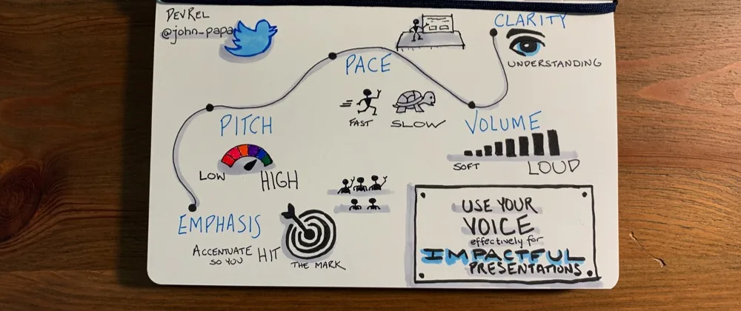  
  
**Sources**

* <https://startupsmagazine.co.uk/article-how-start-your-own-salon-business-using-sustainable-practices>
* chrome-extension://efaidnbmnnnibpcajpcglclefindmkaj/https://www.sustainable-salon.info/_files/ugd/19e0ec_d39b1cab103a4184b88ff3b12dfe9c0a.pdf
* https://www.sustainable-salon.info/kopie-van-output-1-inventory-research
* <https://eur-lex.europa.eu/content/summaries/summary-20-expanded-content.html>
* <https://rwsenvironment.eu/subjects/environmental-0/system-environmental/>
* <https://uk.practicallaw.thomsonreuters.com/1-503-2608?transitionType=Default&contextData=(sc.Default)&firstPage=true>
* <https://www.lamoncloa.gob.es/lang/en/espana/stpv/spaintoday2015/environment/Paginas/index.aspx>
* https://slidemodel.com/elevator-pitch-presentations-guide/

Images

* <https://marketoonist.com/2018/07/positioning.html>
* https://slidemodel.com/elevator-pitch-presentations-guide/
* https://dev.to/azure/sorry-were-you-saying-something-how-the-pitch-of-your-voice-can-make-your-story-more-engaging-8ad/comments

# Energy and sustainability

2.1 Energy in the hairdressing salon II

In the previous unit we have studied how to select a green energy supplier that does not pollute by using renewable sources, we have also learned that it is our duty to the environment to make efficient use of lighting systems, air conditioning and salon equipment, through small gestures such as turning off the light when it is not necessary or closing the windows when the air conditioning is on, as they do not cost any effort or money and yet they save energy which is beneficial for the environment, but also for the professional's pocket.

Keep in mind that air conditioning and lighting alone make up a high percentage of the hairdresser's expenses, the other part of the bill is mainly due to the use of tools and appliances. We recommend that you follow the practical advice given in this unit to reduce your electricity bill; for example, if you are going to buy an electrical appliance, don't forget to check the energy labelling because, with equal performance, by choosing one of the higher categories (A or B) you can achieve significant energy savings in the medium and long term.

Finally, don't forget to use water responsibly, not only because excessive water consumption is not sustainable, but also because the fact of having to heat it also entails a high cost. With all these measures, energy and economic savings are guaranteed, although we could apply many more.

In this topic you will learn about current legislation to achieve a more sustainable environment, we will provide you with an energy consumption calculator so that you can monitor your own spending, we will go into other higher level measures to achieve savings and optimize your salon facilities and finally, you will learn about the investments you would need to implement improvements, as well as financing options and possible subsidies to transform your salon into a truly sustainable salon.

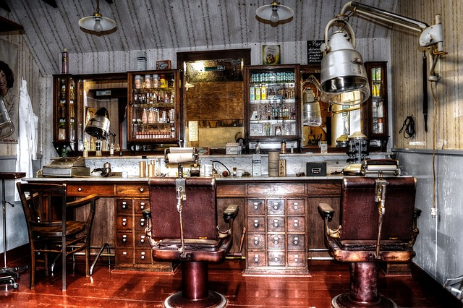

**Summary**

1. Legislation.
2. Calculate energy consumption.
3. Digitisation for savings.
4. Innovation and efficiency to reduce consumption.
5. Cost of investments. Financing and subsidies.
   * + 1. **Legislation**

Due to the importance and threat of climate change, all international and national institutions have issued a series of regulations to promote what is called "energy transition", i.e. the replacement of non-renewable energies with cleaner and more sustainable ones. In this sense, and in order not to bore you with too much data, we will try to make an outline of the most important standards at global, European and national level. You should bear in mind that the use and generation of energy is something that concerns all countries, since the economic growth of societies and the preservation of the environment depend on it. Therefore, the greater the commitment of the different governments, political parties and citizens to respect the established laws, agreements and pacts, the more equitable, supportive and sustainable economic growth will be. We must banish the idea of "as I can afford it, I abuse resources".

**-The 2015 Paris Agreement,**

**- United Nations Framework Convention on Climate Change 2018 and**

**-The 2030 Agenda for Sustainable Development**

**-The European Green Deal of 2019.**

**-Regulation (EU) 2019/943 and .**

**- Directive (EU) 2019/944 of the European Parliament and of the Council of 5 June 2019 concerning common rules for the internal market in electricity**

-Regulation **on Thermal Installations in Buildings (RITE)**

**-Law 7/2021 of 20 May on climate change and energy transition.**

**- Royal Decree-Law 14/2022, of 1 August, on energy saving and efficiency measures and the reduction of energy dependence on natural gas.**

Bear in mind that laws are constantly being modified and that, in addition to the legislative framework we have just mentioned, there are also regional and even municipal regulations. Therefore, when you are going to open your hairdressing salon, do not forget to check the legal requirements regarding electrical installation and energy saving that are in force and applicable, as in addition to complying with the law, it is possible that you may find financial aid or subsidies to improve the energy efficiency of your salon.

* + - 1. **Calculate energy consumption.**

We have been making continuous references to the importance for the planet and for future generations that our economic growth model is sustainable and that the energy we use comes from renewable sources and is as clean as possible. But if, unfortunately, you are still one of those who think that "tomorrow does not matter but only the here and now", we are going to show you that the energy efficiency of your hairdressing salon or home is going to save you a lot of money.



In other topics you may have used different tools or calculators to measure your carbon footprint, water consumption or the concentration of hazardous chemicals in cosmetics. What we propose now is a tool to know exactly the energy consumption in the hairdressing salon and its economic cost. It is true that the bills from the electricity companies sometimes show us statistics of our expenses and we know that electrical appliances such as the washing machine or the heating are very expensive in terms of energy consumption. But if we really want to save money, we have to know what each and every one of the equipment we have in our salon consumes and, from there, look for cheaper alternatives.

To make energy calculations, it is necessary to know how electricity is quantified and to know that it is calculated in kilowatt hours (kWh): 1 kWh is the energy consumed by an electrical appliance with a power of 1000W for one hour. When we see an appliance that runs on electricity, such as a hairdryer or an iron, it usually has a label indicating its power, which is the number of watts (W) consumed by the appliance. For example, if you look at the Dyson supersonic hair dryer, you will see on the label on the handle that it consumes 1600 watts (W).

In this topic you will learn how to calculate the consumption of electrical appliances in your hairdressing salon or studio. Let's start by studying the consumption of a series of light bulbs in a hairdressing salon:

|  |  |
| --- | --- |
| Step 1 | If there are nine bulbs in a room and each bulb is 100W, the total wattage consumption of the lights can be found by multiplying the number of lights by the watts they consume.  Consumption in W (9 bulbs) = 9 x 100W = 900W |
| Step 2 | To find out the watts per hour, we need to know how long they are on for. Let's consider that they are on for 9 hours.  900W x 8h = 7,200 Wh |
| Step 3 | Now, to determine how many megawatt hours this is, as this is the variable that appears on electricity bills, we divide the number of watt hours by 1,000,000.  7,200Wh÷ 1,000,000 = 0.0072MWh |

To calculate how much energy the room consumes in lighting per year, we have to calculate how many hours they are on in that period of time. To do this, we need to calculate the number of hours they are on per day, the number of days they are on per week and the number of weeks per year.

|  |  |
| --- | --- |
| Step 1 | We calculate: the lights are generally on for eight hours each day five days a week and on Saturday only for 4 hours:  (8h/day x 5) + 4h = 44 hours/week |
| Step 2 | If we consider that about 40 weeks a year are worked, we have:  44h/s x 40 = 1,760 h/year |
| Step 3 | Finally, to know the energy consumed in a year, we must multiply power x hours per year:  0.0072 MWh x 1,760 h/year = 12.672 MWh/year |

Now we want to calculate the economic cost that this means for the hairdressing salon, for which we need to know the price of MWh. As of January 2023 this price is €85.80, so we would make the following calculation:

|  |  |
| --- | --- |
| Step 1 | 12.672 MWh/year x €85.80 = €1,087.3 annual expenditure for the hairdressing salon bulbs alone. |

But this way we could take forever to calculate the consumption of a salon, evaluating one by one all the elements likely to consume energy and that is not our goal. On the contrary, our mission is to make your life easier, which is why we put in your hands a calculator specifically designed for the consumption and expenses in the hairdressing salon.

* + - 1. **DIGITALIZATION FOR SAVINGS**

Taking air conditioning as an example, you should know that, for example, a variation of just 1°C generates a saving of approximately 7% in air conditioning, nothing less! For this reason, the use of devices such as thermostats, switches, time programmers, etc. allows a more effective regulation of the temperature and, therefore, of the energy consumed.

So how can we fine-tune this control? The answer lies in home automation, which consists of a set of systems and processes that automate a closed environment such as your workplace, through the intelligent management of technology and communications to control all the elements of that environment, with the aim of providing well-being, comfort, security and, in the short-medium term, savings.



Domotics will allow us to manage, in an integrated way, the different devices in the hairdressing salon, such as electrical appliances, lighting, awnings and blinds, air conditioning, security systems, etc. By simply using a computer, a mobile phone, a console or a remote control, you can effortlessly control the entire system of your salon from anywhere, allowing you to program each parameter exhaustively to suit your requirements and needs.

Home automation will allow us to manage multiple elements, thus contributing to savings and, therefore, to sustainability, for example:

* Intelligent lighting systems can adapt the level of artificial lighting to variations in sunlight, adjusting it automatically. In the same way, they can act on awnings, blinds and/or curtains, making it possible to make the most of sunlight without increasing the cost of air conditioning.
* Motion sensors, located in transit areas such as corridors, toilets or storerooms, detect the presence of people and only illuminate when necessary.
* Controlling the switching on and off of lights on the premises prevents lights from being left on and causing unnecessary expenditure.
* Intelligent climate control systems adapt the indoor temperature according to the outside temperature, time of day, area or the presence of people.
* Time schedulers allow appliances to be started at the most convenient time based on tariffs.

With all this in mind, installing a smart system in your salon could be a great investment as, with a small initial outlay, considering that the cost will always depend on the level of home automation you decide to install, you could quickly recoup your investment through savings and, at the same time, respect the environment.

* + - 1. **INNOVATION AND EFFICIENCY TO REDUCE CONSUMPTION**

Not all halls lend themselves to the highest level of sustainability and savings due to the building in which they are located, but there is some potential for reducing consumption in any premises without, of course, negatively affecting the comfort of customers and employees. To achieve this, it will be necessary to promote responsible habits and actively involve all users.

In this section we will compile advanced consumption reduction measures, some cheaper and easier to implement than others, but all with the same ultimate goal: to control and reduce costs while protecting the environment.

**Anti-heat or anti-cold window films:** solar window films allow you to enjoy the light without the sun heating up the room as they have the ability to reject up to 90% of the sun's energy and reduce the incidence of UV rays by 99%, thus preventing discoloration of the elements behind the glass, preventing glare and, if desired, also providing privacy.

Thermal foils are able to reduce heat loss in the glazing, thus saving on heating costs and improving the quality of the glazing.



**Thermal insulation windows:** if, instead of using vinyl, you decide on a larger renovation, a very interesting option is thermal insulation windows. They are high-tech glasses with a permanent magnetronic coating, ideal for large windows or windows with high solar exposure, which achieve a great thermal insulation of cold and heat without blocking the passage of sunlight and maintaining the views.

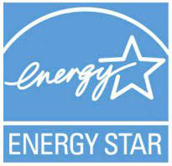

**Use Energy Star labelled IT equipment:** if you are buying a computer or printer for your salon, make sure it has the Energy Star logo; for example, printers are 25% more efficient. Also, don't forget other ways to save energy, such as switching off automatically after a period of non-use, setting the screen brightness to a low level and choosing dark images for the wallpaper, without animations in the screensaver.

**Reduce water consumption:** the issue of reducing water consumption is dealt with in a separate unit, however, it is unavoidable to include it also when we talk about energy as it implies a significant energy saving due to the reduction of the consumption necessary for heating or pumping, therefore, do not use hot water if it is not necessary and only consume the water you need, avoid leaving taps open that deplete the hot water reserves.

**Hire a company specialized in energy consultancy:** Beyond home automation, which presents a mixture of automation and comfort systems that we have seen can be great allies when it comes to saving energy, there are companies specializing in optimizing the nominal consumption of energy in various installations; these companies can modify and improve the installation of your salon (electricity, water, gas, heating, etc.) on 4 levels, the sum of the 4 being the greatest optimization of resources:

* Counting: this is the first and most basic level of any meter, which accumulates the totals consumed in Kw/h, volume in m3 of water or gas.
* Measuring: through electronic analogue/digital numerical control systems, we can have a real-time reading of the instantaneous or accumulated consumption in time bands of our installation: temperature, current, voltage, power, harmonic distortion, water volume, etc., which indicate that the installation is working properly.
* Signaling: is the local checking, on LED screens, display units, touch screens or remotely on telephones, computers and monitoring apps, of the on/off status of the circuits, fault warnings, alerts for exceeding minimum and maximum consumption thresholds, etc.
* Sending: is the installation of actuators, relays and on/off switches for any of our electrical, water, heating, cooling systems in accordance with the signaling of the previous level. These components prevent accidental free consumption elements or eventual failures that are not controlled.

**Thermal and/or photovoltaic solar panels:** if the building that houses your premises allows it, the installation of solar panels is a reliable, economical and ecological option. From the simplest to the most complex, there are the following types:

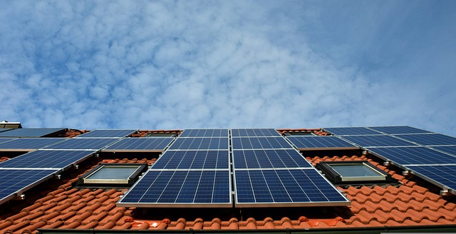

* Solar thermal panels consist of collectors that capture the sun's heat and feed it to a grid of heat carriers consisting of glycol and water. A grid of pressurized water pipes from the grid passes through this grid and is heated. They are usually accumulated in a tank or accumulator of 300 liters and have the capacity to maintain the temperature at night. They can heat water up to 80ºC which, when mixed with cold water, can perfectly supply the tasks of the hairdressing salon.
* Solar photovoltaic panels are composed of silicon collectors that exchange photons of light, releasing electrons and generating a continuous charge. This charge could be stored in a battery system but this is costly, its most common use is to power the equipment on the premises through the use of an inverter/alternator. In addition, by using a bi-directional meter, the current generated and not in use can be "sold" to the local electricity grid, thus reducing the electricity bill. In this way we achieve significant energy savings, zero ecological impact and the possibility of generating profits.
* Hybrid solar panels. They combine the two previous technologies. They generate electricity and heat water using the sun's heat and photonic energy. They are currently much more expensive although they are on the rise and will moderate in price.

**Water heating:** in addition to traditional water heaters, such as gas or electric water heaters, we can find more sustainable improvements on the market that will reduce your electricity bill:

* **Water pre-heaters:** this consists of a tank similar to the water heaters we are used to, but it incorporates several resistors inside, with which cold water can be heated up to +15 degrees directly with direct current from photovoltaic panels without the need for an inverter. It can also be powered by a 230V alternating current resistor if necessary. The advantage is that this pre-heated water, when it reaches the boiler, heat pump or water heater, does not need much energy to bring it up to the desired temperature and, therefore, the savings are considerable.
* **DHW or aerothermal heat pumps:** their operation is similar to the compressor/evaporator of an air conditioner, compressing and evaporating a refrigerant liquid inside a water tank and thus heating it. These systems can even be connected to air-conditioning splits, which also provide air-conditioning. They work by extracting heat energy from the outside with compressors to the evaporation circuit, the higher the outside temperature, the more efficient the system will be, heating water and cooling rooms with a very low electricity cost. They are the most efficient in energy expenditure (around 360% compared to a normal thermogenerator) but it is true that at very low temperatures (below 5ºC) their energy performance begins to reduce, so they are not the most suitable system for very cold climates at the moment.

**Wind generators:** If we replace the solar panel with a turbine and a generator that converts the movement into electricity, we obtain a system with the same components as the photovoltaic installations and with the same advantages. Wind generators are most commonly used in places with little sun and a lot of wind and there are mini turbine models that can be placed on any terrace or roof.

Since photovoltaic solar panels and wind generators have similar installations (alternators, inverters, batteries), a combined configuration of both technologies could increase profitability exponentially, with wind making up for the lack of sun and vice versa. Electricity generation, water heating, sustainability and an ever-increasing payback period make these energy-saving technologies the immediate future.

**Change premises:** does it seem like an irrational decision? Maybe it is... or maybe not. In recent years, regulations have established energy efficiency and renewable energy requirements that must be met in the construction and renovation of buildings. All buildings constructed from December 2020 onwards must be "nearly zero consumption", so any newly constructed premises will be more efficient and consume much less. If you opt for this solution, take into account the building's energy rating, natural lighting and good communication so as not to lose contact with your customers.

* + - 1. **Cost of investments. Financing and subsidies (European and local level).**

As you have already learned, there are many alternatives and innovations that currently exist to improve the energy efficiency of buildings and companies. You have also analyzed your energy cost structure and which of your installations or equipment you should modify, but of course, the problem is always the same:

* Is it profitable to undertake such investments in my hairdressing salon?
* How much will it cost me?
* Where do I get the money for this transformation?

**5.1 Return on investment**

We trust that by now you are convinced that ecology and sustainability are always profitable from the point of view of the well-being and development of mankind. That's why we know that your concerns are economic, i.e. you probably think that you don't have enough resources to afford these investments in renewable energies and therefore, although you would like to "do something", you don't dare. Let's see if we can help you.

In life there are times and situations that are more or less prone to take on new challenges, and in these times we live in there is a general clamor that we have to act NOW to slow down climate change, with Europe being the continent that is promoting sustainability the most. In addition, Europe's energy security is seriously threatened by our dependence on third countries for oil and gas imports. The EU aims to reduce greenhouse gas emissions by 40% by 2030, with a 27% share of renewable energies.

In this context, the European Commission has launched several programs to help improve the energy efficiency of buildings. With 40% of energy consumption and 36% of pollutant emissions in member countries being in our homes and premises, having efficient buildings means reducing pollutant emissions by consuming less energy, lowering energy bills for consumers, and generating competitiveness and jobs.

These European energy efficiency subsidies are classified as follows:

European efficiency aid

**European funds for national initiatives**

**Financial Intermediation Programmes for SMEs**

**Direct aid for large projects**

In fact, there are so many European initiatives that you may get lost in the tangle of information and bureaucracy, so we advise you to focus on the support available in your country or region, and don't forget that many of them come from transferred European funds.

However, we are going to show you one of the measures created by the European Investment Bank to quickly find out the potential savings you could achieve by implementing a certain energy efficiency project. Therefore, if you know what the investment would cost you and the savings obtained, you can easily calculate the profitability of such an investment.

[EEQuest](https://eequest.eib.org/white) can be used to evaluate projects in any of the 27 EU countries, is available in all languages, allows you to analyze up to 20 energy efficiency measures in buildings and industry, and you can access the tool free of charge without registration.

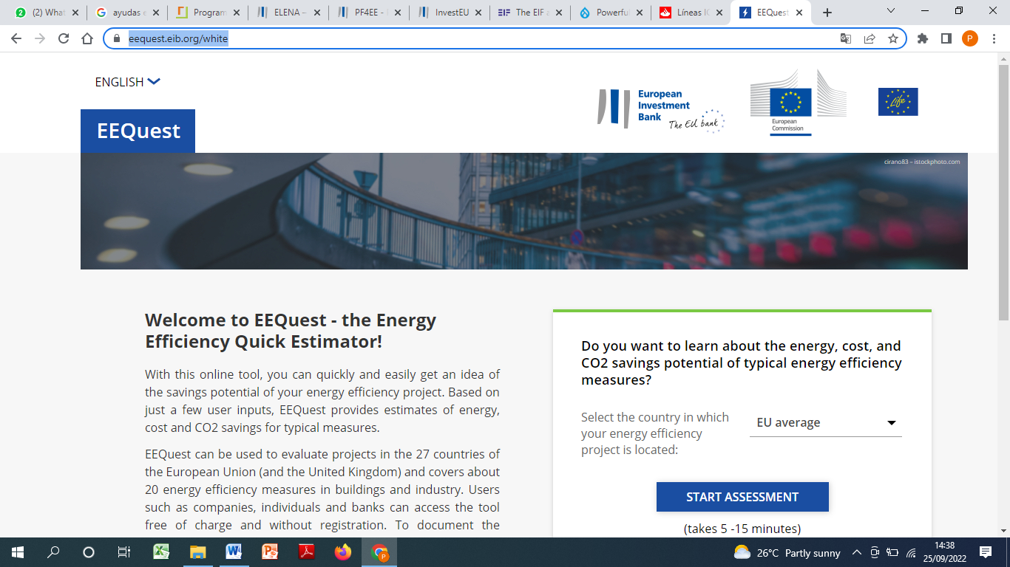

Here is the link: <https://eequest.eib.org/white>

This European tool can also be very useful when applying for external funding to undertake such investments.

**5.2. National grants and subsidies for the energy efficiency of your salon.**

To promote energy efficiency and renewable energy actions and projects, public administrations offer project financing and the development and management of public aid programs that affect the main energy-consuming sectors.

At the same time, you can also find banks in the private sector that have specific credit lines for this purpose. However, we are going to focus only on the Public Aid that we currently have in Spain.

The IDAE is a public body under the Ministry for Ecological Transition whose objective is to promote the energy transition.

In order to promote energy efficiency and renewable energy actions and projects, the IDAE's functions include financing projects and developing and managing public aid programs that affect the main energy-consuming sectors.

The financial resources managed by the IDAE come mainly from the European Regional Development Fund (ERDF), the National Energy Efficiency Fund, the General State Budget and the Institute's own funding.

There is an enormous variety of aid and incentives in this area and, by way of example, we are going to indicate those that may be of interest to you:

* Aid for energy rehabilitation and air-conditioning of buildings
* For the implementation of thermal renewable energy installations in different sectors of the economy.
* For efficient and sustainable mobility...

But if there are many actions that are incentivized, so are the public bodies that give these aids, as there are budget items from the State, the Autonomous Community and even the City Council. We leave you this link where you can consult all of them:

[https://www.idae.es/ayudas-y-financiacion/ayudas-en-materia-energética](https://www.idae.es/ayudas-y-financiacion/ayudas-en-materia-energ%C3%A9tica)

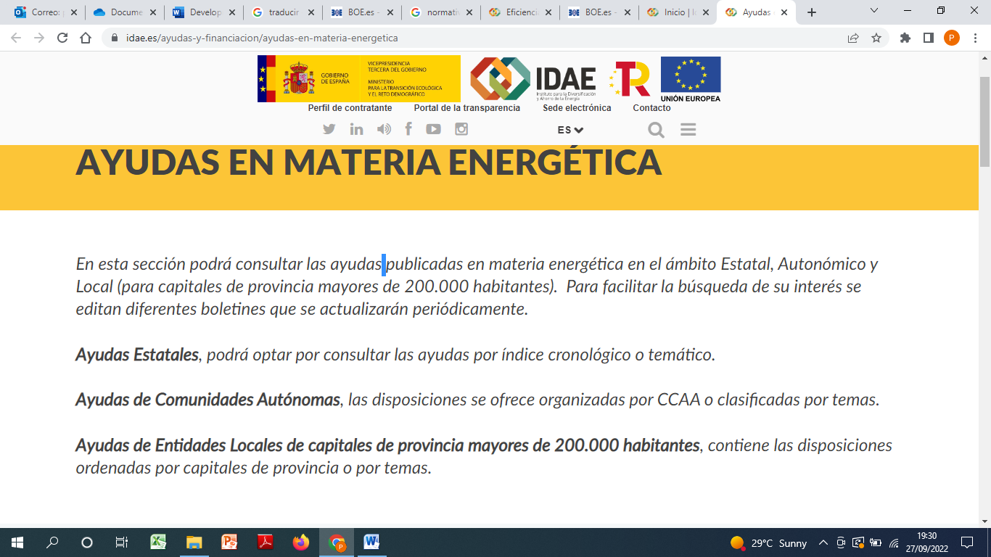

Before we finish, we would also like to remind you that some banks offer loans and credit lines that benefit from public funds. Here is an example of the ICO (official credit institute) loans and the European Investment Bank (EIB) loans that Banco de Santander processes.

https://www.bancosantander.es/empresas/financiacion-avales/inversiones-proyectos-empresariales/lineas-ico-fondos-europeos/lineas-bei.

After all this information, you may be thinking that all this aid is for large companies, or that there are many requirements and formalities to access this financing. Certainly, whenever we apply for financial aid, we will be asked for some previous studies and we will have to fill in a lot of documentation, but for that there are companies and public bodies that are dedicated to the processing of these aids. Ask for their advice and remember that the first thing to do is to draw up an energy efficiency plan indicating what you want to do, why you want to do it and the economic viability of the investment.

**Sources:**

[https://www.idae.es/ayudas-y-financiacion/ayudas-en-materia-energética](https://www.idae.es/ayudas-y-financiacion/ayudas-en-materia-energ%C3%A9tica)

<https://www.compromisorse.com/rse/2014/10/24/10-maneras-de-ahorrar-energia-con-la-iluminacion/>

<https://megalux.es/eficiencia-energetica-y-ahorro-en-la-iluminacion/>

<https://www.leroymerlin.es/ideas-y-consejos/consejos/ahorra-energia-en-climatizacion.html>

<https://www.lacasadelelectrodomestico.com/blog/como-ahorrar-en-climatizacion-con-el-aire-acondicionado-inverter/>

<https://www.baxi.es/ayuda-y-consejos/ahorra-en-climatizacion>

<https://www.ocu.org/vivienda-y-energia/equipamiento-hogar/noticias/cambio-certificacion-energetica>

<https://www.iberdrola.es/blog/energia/nueva-clasificacion-energetica-electrodomesticos>

<https://www.naturgy.es/empresas/blog/elegir_proveedor_empresa>

<https://www.smartenergy.com/how-to-choose-an-electricity-provider/?lang=es>

<https://solar-energia.com/dimarsa-instalaciones-de-aerotermia/?gclid=EAIaIQobChMIxLWV1Z3K_AIVF7TVCh0HJAITEAAYASAAEgIZUPD_BwE>

<https://www.baxi.es/presupuesto-sustitucion-gasoleo-aerotermia?gclid=EAIaIQobChMIxLWV1Z3K_AIVF7TVCh0HJAITEAAYAiAAEgL-_vD_BwE>

<https://www.laminotech.com/laminas-aislantes-termicas/?gclid=EAIaIQobChMI0M_l7Z3K_AIVbhoGAB08AAvnEAAYASAAEgI-0PD_BwE>

<https://www.idae.es/uploads/documentos/documentos_11187_domotica_en_su_vivienda_08_3d3614fe.pdf>

<https://core.ac.uk/download/pdf/35291967.pdf>

<https://estudiomaes.es/?gclid=EAIaIQobChMItfu1rJ7K_AIVArLVCh0zJgEbEAAYAiAAEgLT2vD_BwE>

# Water

**Summary**

* 1. Rules and laws (legislation) about water pollution in your country
  2. Setting up a water-efficient (dream) salon
  3. Companies that make products helping reduce / reuse / recycle / purify water
  4. Corporate Social Responsibility in relation to water
  5. Water-related CSR as a marketing tool

Goals: this chapter will make you look at water management and water sustainability at a salon management level. What does it take to set up and run a water-efficient hairdresser business which is not harming the environment and even attracts customers by being more sustainable?

Objectives:

* think about and find out how water legislation is regulated in your country or region
* work out a step-by-step plan for setting up and running a water-efficient hairdresser salon
* learn about companies providing systems and products to help in more efficient water usage
* get introduced to the corporate social responsibility in relation to water

Introduction

In previous chapters we have talked about water, water pollution and water saving in general and within a hairdresser salon context in particular. This chapter provides an overview and a number of assignments which will help you get a notion of legislation around water-related issues in your country or region, think about and describe a business plan focused on water-efficiency in a potential (dream) salon and will introduce the concept of corporate social responsibility in relation to water.

3.1 Rules and laws (legislation) about water pollution in your country

In most (European) countries the distribution and purification of water is regulated by law.

In the Netherlands, for example, there is a Water Law (Waterwet) since 2009, a part of which is the ‘Surface waters pollution law’ (WVE or ‘Wet verontreiniging oppervlaktewateren’) which is dealing with the water pollution of the ground / surface waters.

In other countries, especially where water not as generously available as in the Netherlands, the government is forced to exercise even more control about the state and protection of this vital for all humans, animals and crops resource. The climate change seems to especially threaten more Southern parts of Europe, meaning for instance that the South of Spain is going to be called the new Oman in the future.

There might also be organs or institutions that are meant for water regulation in a country or region. If we keep the example of the Netherlands – a very famously water-rich country – the so-called water boards are public bodies established on the basis of the Water Boards Act that is charged with the regulation of water management in a specific region in the Netherlands. In other countries you might find



* Search the web for the information on the legislation concerning water pollution in your country. Is there a special law dealing with the issue? If not, maybe there are institutions that deal with water policies and rules? How do those law(s) / rules apply to the hairdressers?
* Please study the water protecting law(s) – if applicable – and find out the main points of it. What does it say about water pollution? Are there any other measures concerning water usage or waste water utilization the entrepreneurs need to be concerned about?
  1. Setting up a water-efficient (dream) salon



Giving water-saving advice

Based on your results from the ‘Fill the water measuring bag’ task in module 2, what advice can you give to an owner of a hairdresser salon in order to save water? Write down 3 to 5 tips how to make sure the water is not wasted unnecessarily. Think of all the hairdressing processes (shampooing, cutting, colouring, perming) and other processes at a salon (e.g. washing the towels, washing the dishes, mopping the floors etc.).

My water saving tips to a hairdresser salon owner are:

1.

2.

3.

4.

5.



Water saving as part of the business plan for your Dream Salon

Imagine you are writing a business plan intending to get a financing from the bank for opening a salon of your own. Since in the South of Europe (imagine you are located there even if you are not!) the expectation is that access to water will become less and less abundant in the near future, a decent water saving plan is an important condition for getting this financing.

What steps and procedures would you describe in your business plan to convince the bank you have thought about water saving steps in your future salon? What about minimizing water pollution?

3.3 Companies that make products helping reduce / reuse / recycle / purify water

There are companies out there which an entrepreneur (an owner of a hairdressing salon) can work with for reducing, reusing or purifying the water.

E.g. [Hydraloop](https://www.hydraloop.nl/) (a company that provides systems for collecting, treating and re-using the water from showers, baths, washers and dryers, heat pumps and air conditioning units), companies producing water-saving faucets, showerheads etc.



* Please look up 2 or 3 of these companies on the internet. What kind of principle(s) is their water-saving or water-purifying solution based on?
* Do you know any salons or other companies that use an independent water-recycling system? If not, try to find them online!

Image by Freepik

3.4 Corporate Social Responsibility in relation to water

Unfortunately more and more people nowadays experience water stress and in the near future the situation will only get worse. This has to do with both geographic and temporal mismatch between freshwater demand and availability. It means that a lot of places (the North of Africa and lots of regions in Asia) have trouble getting access to fresh water. This can be due to physical or economic reasons. Physical water scarcity means there’s just not enough water available in the region to satisfy all the needs of the ecosystem. Economical water scarcity means that there is no sufficient infrastructure to make water available there where it is needed. All beings, humans as well as animals, depend on water for survival.

Our planet renews it freshwater supplies through rainfall, but its amount is much less than what people get out from earth – this means that deforestation, industrial activities, intensive farming and urbanisation have resulted in ground water levels dropping dangerously fast.

That is why we need to act now! This is also the reason why more and more companies apply the so-called corporate social responsibility practices in their operations and processes.

**Corporate social responsibility (CSR).** Inverstopedia.com defines the Corporate social responsibility as a self-regulating business model that helps a company be socially accountable to itself, its stakeholders and the public. By practicing CSR, also called corporate citizenship, companies become aware of the ways they impact various aspects of society (among other things, economy and environment), either intentionally or not. A by-product of this awareness is that a company can then choose to operate in ways that benefit the society instead of harming it. CRS practices can not only enhance some aspects of the society, but also promote a more positive image of the brand or company – a win-win situation!

Image by yanalya on Freepik

* 1. Water-related CRS as a marketing tool

It is important for an (aspiring) salon manager or owner to bear in mind how powerful it can be to use the CRS practices of their business in their marketing and communication messages. The customers nowadays, becoming more and more environmentally conscious, will be selecting businesses they want to buy goods of services from based on whether or not they are involved into some kind of CSR. It is especially smart to promote these kind of practices if you are already engaged in them. Think of hanging around some posters, adding a disclaimer on your website or socials that you are saving water / sorting waste / using green hair and scalp products, are awarded a quality mark or certification etc.



Think of any actions a hairdresser salon can take to promote the CSR in relation to water?

Next to the salon itself, think of other companies engaged in the operations of the salon, like hair cosmetics manufacturers, appointments software supplier etc. What kind of water-friendly CSR actions can these organisations take?

 Interesting fact: example of CSR in relation to water

ID&T (a Dutch entertainment and medium enterprise founded in the early 1990s and operating many of the largest electronic dance music events in the world) has introduced Join the Pipe project. The project is committed to a world with less plastic waste, in which everyone, everywhere in the world, has access to safe drinking water. By promoting drinking tap water from reusable bottles and refill stations the organisation aims to reduce the use of plastic. With the proceeds of their products they set up drinking water and clean-up projects in developing countries. Drinking water points are for example available in several schools across the Netherlands as well as at ROCvA, one of the participants of the Sustainable Salon projects.



Study the website of Join the Pipe (scan the QR code to go there). What can you tell about the mission of the project? Can a hairdresser salon owner work together with the organisation? What are the collaboration opportunities for (small) businesses you can find about on their website?



Sources:

<https://www.hydraloop.com/why-recycle>

<https://www.investopedia.com/terms/c/corp-social-responsibility.asp>

<https://join-the-pipe.org/>

<https://www.cec-amsterdam.nl/opening-join-the-pipe-tappunt/>

https://www.waterschappen.nl/

# Waste

**Summary**

* Rules and laws (legislation) about waste in your country
* How do you set up a low-waste salon
* Corporate Social Responsibility in relation to waste
* Entrepreneurial Innovation: hairdresser’s waste as new raw material

Goals: Introduction into a more sustainable way of dealing with waste at a hairdressing salon management level and setting up a low-waste salon

Objectives:

* getting acquainted with how legislation around waste is regulated in your country or region
* working out a plan for setting up and running a low-waste hairdresser salon
* introduction and analysis of the corporate social responsibility in relation to waste

Introduction

If in previous chapters we looked at waste and waste management in general or at a hairdresser salon in particular, this chapter will get you acquainted with the notion of waste management from the perspective of a salon owner / manager. We will first look at different ways of how legislation around waste can be arranged in your country or region, then we move on to elaborating a setting up and running a low-waste salon and we finish with looking at CRS (corporate social responsibly) concept in relation to waste.

* 1. Waste legislation in your country

In different countries the legislation and rules around waste management are arranged in different ways. Sometimes there are laws dealing with this issues, sometimes there are (semi) governmental organisations and institutions that regulate and manage it.



What are the rules and laws (legislation) about waste in your country? Where can you find the information? Study the websites of the (local) government / authorities on this subject. Is it clear what rules do hairdressers / salon owners have to follow? Is there a professional association that can help professionals or entrepreneurs with this kind of issues? What is the name of this association in your country? Where else can you go for advice? Work the answers out to a short manual for young professionals / starting entrepreneurs.

Image by redgreystock on Freepik

4.2 How do you set up a low-waste salon?



Imagine you have to write a business plan for setting up and opening of your dream salon (this might even be the task in the course of your training!).

How can you take care of the environment and make use of sustainable business practices? Imagine that only the most sustainable business plan will be granted a financing / loan and you really need the money for your dream enterprise.

Write down all the aspects you can think of to win the competition! Think of:

* What product supplier you will go for: do the products have green(er) ingredients in them?
* Whether your energy supplier provides green energy
* Ventilation in the salon
* Water-saving measures
* A more sustainable option for the foils
* Coffee cups (paper or ceramic / glass and why) and coffee / tea / sugar supplier (Fairtrade / eco-friendly)
* What furniture you are going to use
* Sorting the waste
* What detergents you are going to use for washing up, laundry, mopping etc.
* Paperless administration (online communication / marketing / scheduling / finances)
* Flushing the toilet and operating a washing machine with collected rain water
* Any other green and environmentally friendly / friendlier measures?
* …

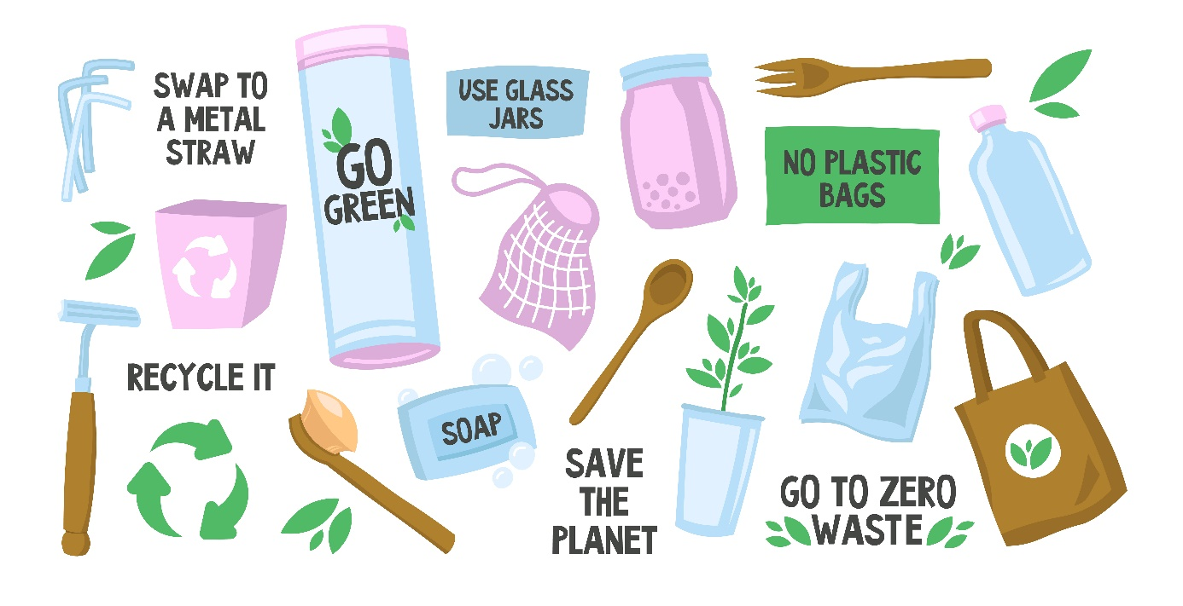

Image by pch.vector on Freepik

4.3 Corporate Social Responsibility in relation to waste



**Corporate social responsibility (CSR)** is concept we have talked about before. According to Investopedia.com, it refers to a business model that helps a company be socially accountable to itself, its stakeholders and the public. By practicing CSR, also called corporate citizenship, companies become aware of the ways they impact various aspects of society (among other things, economy and environment), either intentionally or not. A by-product of this awareness is that a company can then choose to operate in ways that benefit the society instead of harming it. CRS practices can not only enhance some aspects of the society, but also promote a more positive image of the brand or company – a win-win situation!

If you think of the environmental aspect of CSR at a hairdressing salon and in relation to waste, what kind of practices can a salon owner / manager apply in order to minimize the impact of his/her business? Think of sorting the waste, using green(er) products, reusing or recycling the packaging etc. Write down all of your ideas for a more waste-efficient salon. Also here do not forget that your CSR practices can be used as a marketing tool for attracting and appealing to the (potential) environmentally-minded customers.

Image by rawpixel.com on Freepik



4.4 Entrepreneurial Innovation: hairdresser’s waste as new raw material

Zsofia is a young and innovative entrepreneur from the Netherlands and she’s trying something new out: textile and clothes made from **human hair**. According to Zsofia, you need 26 (chemical) manipulation steps to use the sheep wool for cloths, while it’s only 2 for human hair! Human hair has amazing qualities: it’s a limitless resource and it’s also antiallergic. The garments she makes are still in the experimental phase, but will soon be available on the market:

**In 2 groups discuss with proper arguments:**

* Group 1 defends the PROS of the human hair clothes (the ‘win-win’ aspects)
* Group 2 is very sceptical and comes with the CONS as arguments, they are not convinced.

Scan of the Dutch ANKO December 2022 magazine article (in Dutch)*

*ANKO is the general Dutch hairdresser professionals organization

# 5. Management

5.1 Criteria for suppliers’ selection

Whether you’re in retail, consumer services, or business-to-business, THE KEY QUESTION IS:



“**What should I be looking for in a supplier?”**

Here are key factors to consider when selecting suppliers.

Price

Ask the supplier to quote for different quantities.

Example: delivering one day of training compared to delivering 10 days; supplying 500 widgets compared to 5,000; supplying five pies compared to 50.

Quality

Your supplier might quote you a fantastically low price, but you need to make sure the quality’s right. It’s no good getting your widgets at a knock-down price, if they fall apart after a year or two. Find ways to evaluate the quality of the supplier’s work or products, such as asking for samples, customer endorsements, etc. Where appropriate, ask to visit them at their premises and see for yourself what quality control measures they take.

Minimum order quantity

Ask the supplier what’s their minimum order quantity. Being able to order frequently and in low quantities, (‘just in time’) means that you don’t have to tie up a lot of working capital in stock, nor have large storage facilities. However, the cost to the supplier of production, and/or delivery of very low quantities might rocket up the price.

Delivery time

How long would it take from the time and date the order is issued until they actually deliver it? Would this vary according to precisely what’s being ordered? E.g. if they need to ship goods in from abroad this could take longer than sourcing locally. If they’re manufacturing a bespoke product for you, how long will it take them to tool-up?

Payment terms

Will they give you credit, and if so how much? How many days would they give you to pay their invoice? If you pay promptly, would you get a discount? If you pay up-front for the first order, would they be willing to give you credit on future orders?

Financial stability

You need to be confident that your supplier isn’t going to suddenly go insolvent. Take out credit checks with an agency, or request copies of their latest accounts from [**Companies House**](https://www.gov.uk/government/organisations/companies-house) (but bear in mind that the supplier’s situation might have changed since the accounts were filed). If you pay in advance and the supplier’s business goes under, your chances of getting your money back might be slim.

Capacity

Does the supplier have the infrastructure to cope with your business? If you’re only ordering a small number of items or commissioning small amounts of work it’s unlikely to be a problem. But if you, or another customer, are placing significant orders, will they be able to cope? If they’re planning to hire more staff, buy more kit, or sub-contract work, can they do this and still maintain the required quality?

Customer service

When you’re checking out prospective suppliers, pay careful attention to how they deal with you – this may be a good indicator of how they will perform if you do business with them. How well do they communicate with you on the phone and via email? Are they polite and clear? Do they return your calls promptly. Do they send you the samples you requested by the date they promised?

Social responsibility

In terms of social and environmental responsibility, your business will be judged not only on what you do, but also what your suppliers do. For instance, if a customer complains to you about over-packaged products, you can’t excuse yourself by blaming it on the supplier – you are the business that is selling the product and must take responsibility ultimately.

5.2 What is a Sustainable supplier?

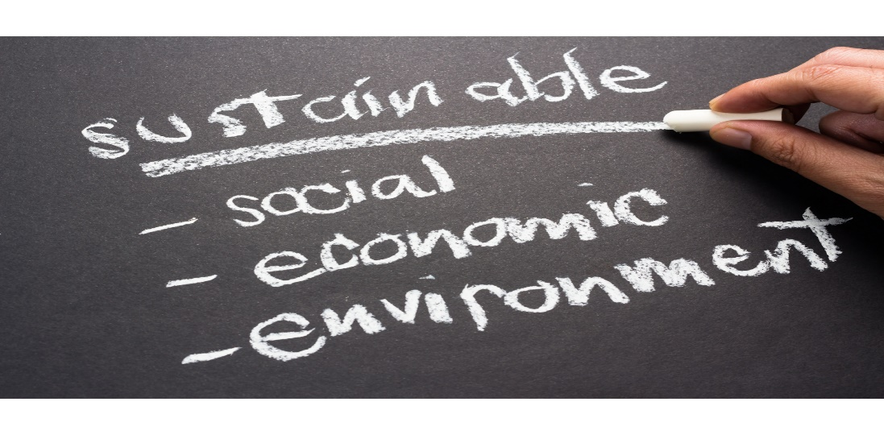

In addition to the criteria mentioned above, it is important to remember that the search for suppliers must also consider the concept of sustainability.

In other words, within the supply chain it is necessary to keep in mind that sustainability takes into account three additional criteria: economic, environmental and social.

When selecting suppliers, it is good to check that they also meet these three requirements.

In the diagram you will also find a list of sub criteria to consider:

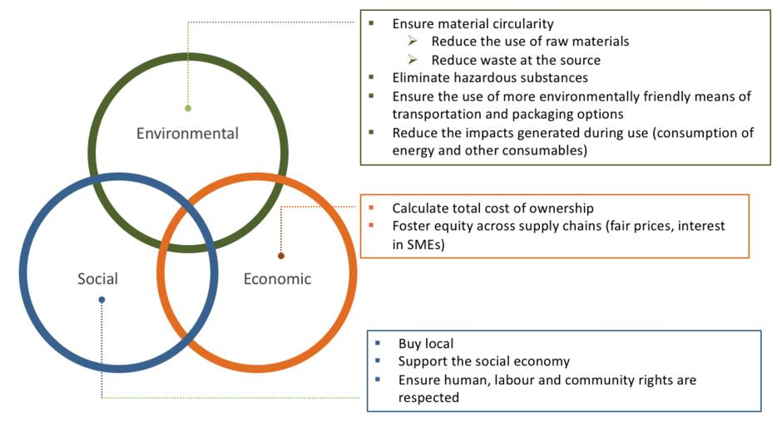

In conclusion, sustainable procurement involves a thorough review of what you are buying and who you are buying from. For sustainably oriented companies choosing suppliers that align with a companies values and improve overall performance can be daunting. Analyzing each link in the supply chain is a good starting point.

Suppliers should be assessed in terms of the environmental, social and economic risks they present.

**1)Environmentally oriented** supply chains look at procurement with an eye to reducing carbon footprints and minimizing energy and water use. Resource efficiency is essential as we are currently using almost twice the amount of resources the earth can produce. Recycling, waste and end of life issues should also be considered throughout the supply chain.

**2) Socially oriented** supply chains focus on procurement from suppliers that respect human and labor rights and are mindful of poverty concerns.

**3)Economic** considerations are about ensuring adequate margins and secure access. Other important supply chain considerations include logistics and transportation.

Reassessments of suppliers should occur on a regular and ongoing basis.

Here’s the steps you should consider:

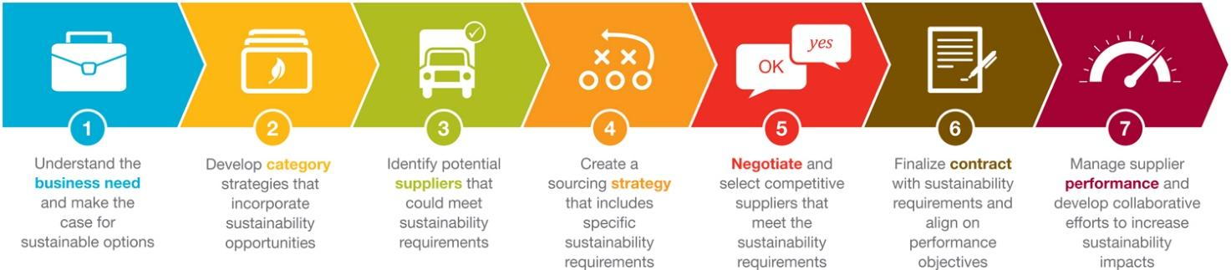

5.3 The quote

When you decide to buy a good or service, it is normal that you want to look for the best price: it is therefore necessary to ask for a quote from different suppliers to find the best price for what you want. Usually, it is easier to send an email to the various suppliers to be "tested". This is for two reasons:

1. You can ask for exactly what you want and need in writing, so as not to get confused
2. Having the written estimate, the supplier will then not be able to change price suddenly during construction, unless you agree.

There are important rules for requesting a quote:

1. Be as specific as possible, then provide as much detail about the type of product or service you want;
2. Be short and concise;
3. Be formal but polite.

**Example request**

Let's see how to structure an email and then an example/fac simile.To send an email with the request for a quote, be formal and polite.

In the email subject write "**Request a quote**". Then it starts like this:

**Dear Sir/Madam ____,**

If you know the name of your interlocutor, otherwise even

**Dear Sir/Madam,**

After that, you must immediately say the reason why you are sending the email. Here are some example phrases:

* **I would like to request a quote for _______.**
* **I would be interested to know the price of _______.**
* **Please send me a quote per______.**
* **Please, could you provide me with a quote for ______.**
* **I would be grateful if you would send me a quote for _____.**

Provide as much detail as possible about the product you want but be concise. If applicable, you should include the following information:

**If you are asking for a service, please indicate:**

When you want it (the time within which you want the product or work);

* Where you want it
* Material required.

**If you are asking for a product**, please indicate:

* Where you want them to deliver it;
* What do you need it for.

To conclude, close the email like this:

* **I hope to have an answer as soon as possible;**
* **I look forward to hearing from you.**

Then sign the email with your name and surname, after writing:

* **Kind regards;**
* **Cordially;**
* **Thank you in advance.**

**Refuse**

You have received quotes and there are some that have not satisfied you: for example, one is too high, another is unclear. You therefore wish to inform the company that you do not accept it, but you want **to politely refuse the proposal**.

In fact, consider that the person who sent you the quote has dedicated part of his time to you, and it would be courteous of you to at least provide an answer.

Here's what you can write to politely decline a quote:

Dear Sirs,

Thank you for your availability and for the offer you have sent us. We would like to inform you that we have received another proposal more suited to our needs and that we have accepted.

Kind regards,

John Doe

**How to ask for a discount**

You have received a quote, that company convinces you and you would like to make it do the work or, if it is a product, you would like to buy it from there. Only that the quote is a bit high and you would like to ask for a discount.

Here is an email requesting a discount.

Dear Sirs,

Thank you for your availability and for the offer you have sent us. We found your proposal interesting and would like to come to a conclusion. However, the price is beyond our budget: what is the discount you are willing to offer us?

Kind regards,  
John Doe



1. Identify 3 potential suppliers and explain why you choose them and the relation with the 3 established sustainable criteria
2. Create a dynamic presentation (using for example Canva or Prezi) to report your boss the reasons for your choice
3. Request a quote by email for at least 2 products