Wednesday:
In the morning we got to know the students from Spain, Italy and the Netherlands. We visited the greenhouse where they grow the plants themselves, they make the products from these plants. In the afternoon we learned to make sustainable hair scrub, soap and a hair mask ourselves, this was a very instructive experience. At the end of the day we made preparations for Friday's video.
In the evening we had a communal dinner with all students and teachers.
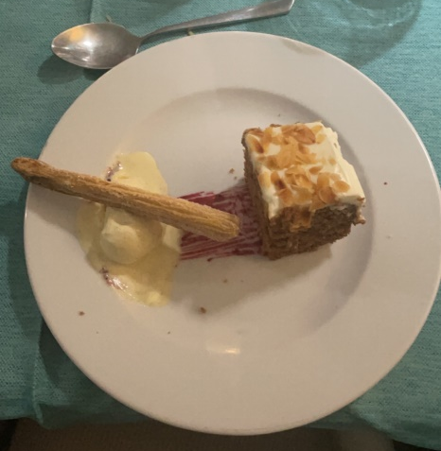
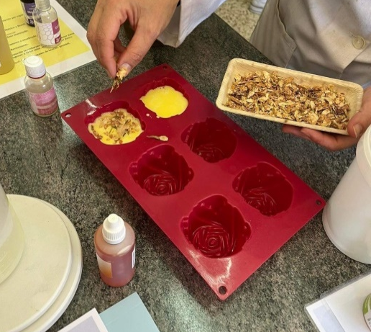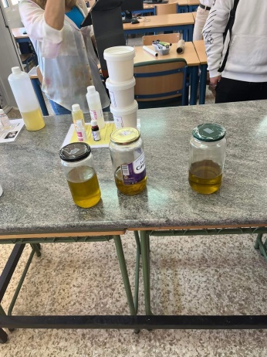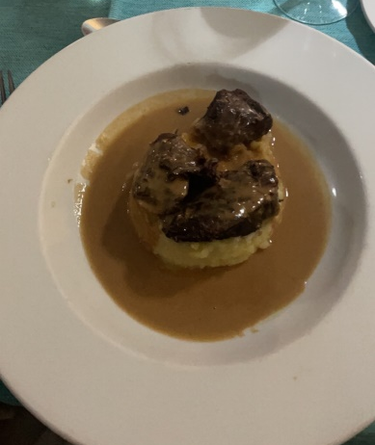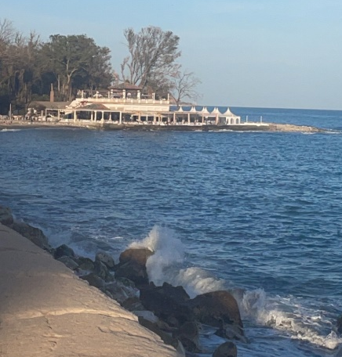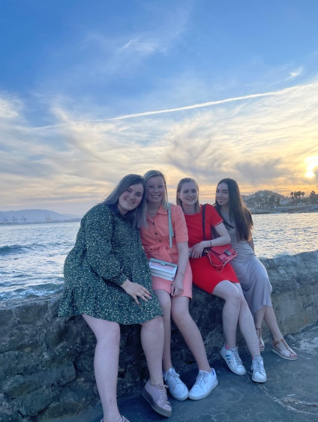

Thursday
Thursday we went to the recycling park. First we got an explanation how it all works for a better environment. We also got a tour in the bus of the recycling park. In the afternoon we got free and we went shopping and went to the beach was a nice day.
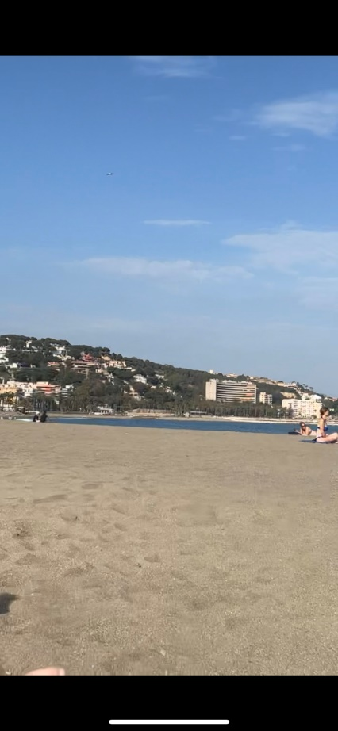
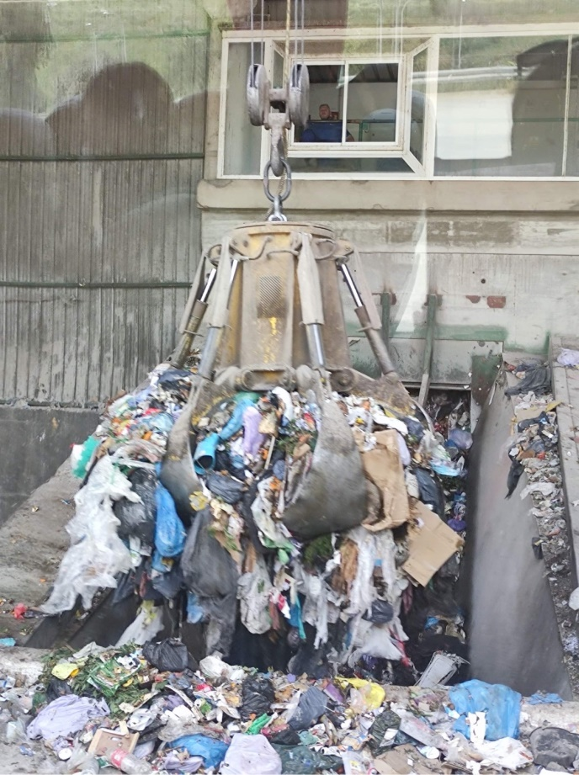

Friday
Friday we went back to the Spanish school in the morning we finished the movie. In the afternoon we had lunch as a break. In the afternoon we wrote this report and it is time to go home. It was 3 instructive full days for all of us. Also met a lot of new people.

