

Authors: CIOFS-FP Lombardia, IES El Palo, Richtpunt campus Oudenaarde, ROC Amsterdam

Future skills for a better life in Sustainable Salons is a European project that aims to combine the sustainable ideas through education and training with innovative ideas within the sector.

This project has been funded with support from the European Commission. This publication reflects the views only of the author, and the Commission cannot be held responsible for any use which may be made of the information contained therein.

The project partners and associated partners within this program are:

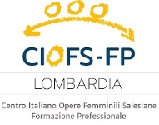****

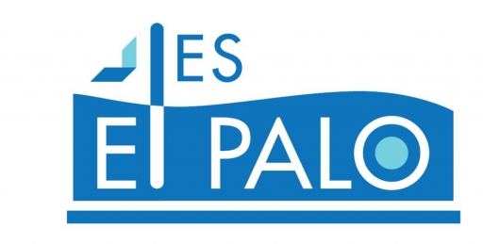

© 2023 Sustainable Salon project, Erasmus+ 2020-1-NL01-KA202-064515. No part of this document may be reproduced in any form without the authorisation of Stivako (project coordinator) and the authors.

Contact address:

Stivako [info@stivako.nl](mailto:info@stivako.nl)

Project website: [www.sustainable-salon.info](http://www.sustainable-salon.info)

Index

1. Becoming a sustainable hairdresser 4

1.1 How to act sustainable as a hairdresser? 4

1.2 How to choose the correct supplier? 5

1.3 How to choose the raw materials? 7

1.4 Carbon footprint calculator for hairdressers 11

1.5 The impact of a hairdresser’s carbon footprint 12

2. ENERGY 14

2.1 Energy in the hairdressing salon I. 14

3. Water 26

3.1 Water pollution by hairdressers / water pollution per work station 26

3.2 What can a hairdresser do to have less impact on the water resources? 29

3.3 How to measure the quantity of water used at a salon 30

4. Waste 32

4.1 What waste does a hairdresser produce? 32

4.2 Environmentally friendlier product alternatives 33

4.3 Hairdresser’s waste as a resource 34

5. RAW MATERIALS 36

5.1 International Nomenclature of Cosmetic Ingredients (INCI 36

5.2 Labels and certifications in the cosmetic 37

5.3 Cosmetic Products Safety Data sheets 39

5.4 Raw materials used at a hairdresser salon 40

6. MANAGEMENT 49

6.1 Warehouse management 50

6.2 The warehouse of a hairdressers’ salon 52

6.3 What’s an order? 55

# Becoming a sustainable hairdresser

**Introduction to this lesson**

In this lesson, you will learn to make conscious business choices that will help you run your salon in a sustainable way as a hairdresser or barber.

You will become aware of what impact certain choices, sustainable or otherwise, have on your carbon footprint and how difficult it is to find the right tools to calculate that impact.

This is precisely why it is not only important to believe in figures, but all the more important to really do your bit to preserve our beautiful planet. To become a sustainable entrepreneur, you need to be aware of a number of factors to make informed choices for the benefit of your business.

You need to think carefully about the choice of raw materials you want to work with, as well as suppliers. How do you deal with waste and what regulations should you follow in your country?

How big will the impact of your choices be on the environment? If you have thought this through very carefully, you can make conscious and informed choices, taking into account important factors such as legislation, economic forms and material and supplier choices.

1.1 How to act sustainable as a hairdresser?

Do you want to know how to make your salon more environmentally friendly? In the salon industry, eco-friendliness and sustainability have become buzzwords in recent years, but going green is more than just a fashion statement.

Beauty has a price, and right now that price is too much for our environment. The health of our planet is significantly impacted by hair and beauty salons. As business owners, it is your responsibility to set an example.

We know that vegan hair dye, carbon-neutral furniture, and only natural light can be confusing, but don't let that put you off or into the "too hard" category. Being environmentally friendly is now easier than ever.

Keep in mind that even small adjustments can have a big impact. Making simple, long-lasting routines that you and your staff can stick to will help you reduce your carbon footprint. Start making greener choices now, and your customers and the planet will love you for it!

Give yourself the opportunity to establish a budget, organize your pricing, and investigate novel approaches to uncovering your company's hidden cash.

**So, what does it mean to be "eco-friendly" and why is it important for my company?**

Reducing environmental damage is at the heart of eco-friendly behavior. In your salon, spa, or barbershop, you can practice eco-friendly practices by being more aware of how you use resources like energy and water.

Why are green salons necessary? In a nutshell, there's no reason not to! Eco-salons are gaining popularity all over the world. Going green has many advantages that far outweigh the effort required. You will not only help make the environment healthier, but you will also save money and get new customers. Not bad for a few simple new habits, isn't it?

The most important reasons to consider salon sustainability are as follows:

**People**

Going green is, without a shadow of a doubt, a chance to acquire new customers. You could exponentially increase your clientele: pregnant women, those who place a high value on environmental sustainability when making purchases, and those who are sensitive to harsh synthetic chemicals

Products with eco-friendly initiatives, such as recyclable packaging or ingredients that are ethically produced or sourced sustainably, are frequently purchased by many consumers. A great way to boost sales and referrals is to incorporate these products into your business and promote the environmental benefits to customers! This is your chance to stand out if your rivals have not greened their salons.

**Profit**

The idea that going green will cost you a fortune is one of the most common misconceptions. In fact, these eco-friendly practices will probably help you save money. Take a look at it. If you turn off the lights and unplug any appliances that aren't in use, you'll save money on your utility bills, right?

This indicates that operating expenses will eventually decrease. Fixing leaking faucets in your hair basins or turning off lights in treatment rooms that are empty will help you save money and the environment.

What are your retail sales like? Prices are also becoming more competitive as demand for vegan, cruelty-free, or environmentally friendly goods rises. Happy retail sales!

**Planet**

Since salon owners are major contributors to waste, they should implement more sustainable business practices because climate change is a growing concern. Since there is no such thing as a planet B, the use of waste and toxins in beauty and hair salon treatments (hair foils, plastics, etc.) has drawn criticism. Fortunately, we still have options for turning things around.



**Think of some changes you can make fairly quickly in the salon to become more sustainable.**



**Read the article on the Internet. Are there any more changes you didn’t think of?**

<https://www.appointfix.com/blog/how-to-have-an-eco-friendly-hair-salon.html>

1.2 How to choose the correct supplier?

Companies are going to great lengths to present themselves as environmentally friendly as customers become increasingly eco-conscious. Even though putting an emphasis on sustainability may have good intentions, many businesses are guilty of "greenwashing" or "green sheen," or marketing themselves as environmentally friendly while merely going through the motions.

In the 1960s, hotels started using the term "greenwashing" when they told guests to reuse their towels, presumably to save water and chemicals, when the real motivation was to save money on towel laundering.

Companies that engage in greenwashing may believe they are reaping the benefits of customer perception and brand loyalty without significantly improving sustainability. However, regardless of whether the business is B2B or B2C, if the truth is revealed, there can be a significant backlash. Truly green businesses employ sustainable practices at every decision point in their operations, particularly with their suppliers. Fortunately, improving the environment and establishing green supplier networks are not mutually exclusive. There is no need for businesses to choose between being environmentally conscious and fiscally responsible.

"Sustainable efforts often help to simplify and streamline supply-chain operations, providing an economic benefit for customers and suppliers alike through lower prices and improved service levels," wrote procurement practitioner and college professor Rich Weissman. In point of fact, the less expensive green alternative frequently prevails. The supply chain and society are better off as a result of the rise of sustainable economics.

Companies can use the examples provided here to show that their "green" practices can withstand scrutiny and have a significant impact.

**Communicate the sustainability goals of your company to the procurement team.**

Procurement is always looking for ways to demonstrate its complete alignment with enterprise-wide goals. The opportunity to do so naturally arises from sustainability. Due to the benefits of consumer loyalty, sustainability goals are typically stated publicly. As a result, procurement has access to this data and can associate it with particular supply-chain and spend management practices. Procurement teams should establish formal policies that show how sustainability goals are incorporated into their sourcing and supplier-management processes, as well as identify and track progress against sustainability-specific metrics, in order to avoid even the appearance of greenwashing. This will guarantee that goals are met.

**Know how your current suppliers meet their own sustainability goals.**

Procurement should go beyond a supplier's claim that its facilities or practices are sustainable if the goal is to have a measurable impact on the environment. Suppliers can be asked to provide specific sustainability goals and metrics, and procurement can look for evidence that these policies are followed. Visit the supplier's facility to observe sustainability practices firsthand if at all possible. This is especially important if procurement wants to claim credit for doing business with the supplier because it is more environmentally conscious than its rivals. If a supplier does not back up their claims of sustainability, a buy-side company runs the risk of being greenwashed.

**Centralize and consolidate eco-conscious spend data.**

Any environmentalist will tell you that even small adjustments can have an impact. It is absolutely necessary for the business to be able to consolidate the total impact over time because contributions to sustainability can be made in a distributed manner by numerous buyers and through numerous enterprise purchases. This not only establishes a virtuous cycle but also demonstrates that the company's commitment to sustainability is not just a publicity stunt. When buyers are aware that they are a part of a larger, more successful effort, they are more likely to use similar judgment in their own corporate purchasing decisions.

**Expand partnerships with green/sustainable suppliers by tracking certifications and relevant experience in the supplier master or supplier network.**

Many suppliers choose to pursue cross-industry certifications because the threat of greenwashing is so significant. These make sustainability efforts more visible and accountable, and they give procurement more confidence that the businesses in their supplier network are actually eco-friendly. Certifications such as LEED, the Green Business Bureau, Energy Star ratings, and standards like ISO 37101 and ISO 26000 are examples. Although it is beneficial to require sustainability-based certifications and documentation, procurement is accountable for their upkeep. This way, the buy-side company won't accidentally take credit for achievements that weren't made if a supplier's status changes or its certifications expire.

**Look at your suppliers' suppliers (also known as tier 2, tier 3, or "n-tier" suppliers).**

It's possible that a company's suppliers collaborate with other businesses to increase their actual sustainable supplier spend. “The typical consumer company's supply chain creates far greater social and environmental costs than its own operations, accounting for more than 80% of greenhouse gas emissions and more than 90% of the impact on air, land, water, biodiversity, and geological resources,” according to McKinsey's Anne Titia Bove and Steven Swartz. The greater a company's willingness to look deeper into a supply chain, the greater its impact and the greater its recorded results.

Sustainability, as previously stated, has the potential to be cost-effective as well as a significant source of brand goodwill and customer loyalty. Sustainability programs must focus on more than just doing good in order to make sense; Additionally, they must benefit communities and the environment equally to the company and its shareholders. There may even be additional benefits, such as tax breaks or award programs that receive a lot of attention, depending on the industry or sector in which a company operates.

At the end of the day, the goal is for stakeholders, suppliers, and customers to praise the company's efforts to go green and make the world a better place to live. It is the responsibility of the companies that implement these programs to ensure that they have a real impact beyond greenwashing. Through the supplier master and supplier network, procurement has the opportunity to manage these efforts in accordance with enterprise goals and objectives because eco-consciousness is centered on supplier selection and capabilities.



**What conditions do you think a good supplier should meet?**



**Write down the contact details of at least 5 suppliers that meet your criteria in the grid on the assignment paper.**

1.3 How to choose the raw materials?

You need to understand what that term means in order to select the appropriate raw materials.

Even though all of the raw materials come from nature, there are three categories based on where they come from.

1. Plant/tree-based – materials like vegetables, fruits, flowers, wood, resin, latex are obtained from plants and trees.
2. Animal-based– materials like leather, meat, bones, milk, wool, silk are all obtained from animals.
3. Mining-based– materials like minerals, metals, crude oil, coal, etc. are obtained by mining the earth.

Apart from this, a manufacturing unit divides the raw materials into 2 main categories.

1. Raw materials directly: Direct raw materials are the primary component from which a finished product is made. For instance, furniture such as beds, tables, and chairs are made directly from wood. are created Leather used to make shoes, bags, purses, and other items is another example.

2. Subsidiary raw materials: In contrast, indirect raw materials are those that are used in addition to direct materials to produce the final product. For instance, the nails, varnish, and glue. used in the production of bed, chair, and other wooden furniture. are all raw materials in indirect ways. Similarly, the colors, lining fabric, buckles, metal hoops, zips, glue, and so on. Shoes, bags, and leather purses are all made from indirect raw materials.

Controlling the quality of the raw materials (excipients, components, etc.) used to make a healthcare product is just as important as controlling the quality of your active pharmaceutical ingredients and finished product.

As part of your quality system, managing your raw materials will help ensure that your finished healthcare product meets its quality characteristics. It is prudent to implement such a system early on in product development and incorporate it into the design.

Key considerations when selecting the raw materials:

* **Is there sufficient evidence to guarantee the material chosen and its by-products' safety?**

For instance, is the raw material "generally recognized as safe" (GRAS) and used frequently in the regulated industry? Is it known to have toxicological concerns, such as the potential to cause cancer?

* **Would the raw material lead to any pharmaceutical response or is it considered an inert substance?**

Does it raise concerns about interactions with your drug substance for pharmaceutical products? Does it make your product a combination product instead of a medical device, necessitating different regulatory requirements and pathways? If so, is there another agent that could assist you in avoiding a more challenging route?

* **Is the supply of this material limited?**

If so, can another raw material take its place? If this is not the case, it is critical to guarantee the supply of this material during the clinical or commercialization phases (by entering into a contract with the supplier or finding an alternative supplier).

* **Is the material compatible with your finished product?**

Excipients, for instance, can make up more than 90% of a product's weight in pharmaceuticals. Therefore, evaluate the compatibility of the components that may influence the dosage form's quality (such as hardness and dissolution rate).

* **Is the ingredient available as a pharmacopeial grade or medical grade?**

If so, does it meet the requirements of the jurisdiction in question? If not, can another ingredient be used in its place?

In conclusion, a scientific evaluation of the healthcare product's quality, safety, and efficacy is necessary to ensure that the appropriate materials are chosen.

Implement a robust supplier management program to ensure and control the raw ingredient quality once the product design is finalized.

This program should generally be based on Good Manufacturing Practices (GMP). Some possibilities include:

1. Reviewing the supplier history, including any relevant information on their manufacturing reliability
2. Determining the reliability of results reported on Certificates of Analysis (a document issued by a supplier to certify the quality and purity of each product lot)
3. Assessing the quality of raw materials through routine testing
4. Performing a supplier audit, if required
5. Considering information obtained via ongoing communication with suppliers

**In summary, know the supply chain of the raw material for your product.**

Document the security measures you take throughout the supply chain and identify and reduce risks.



**Which raw materials could be used for which purposes in a salon?**

1. **How to recycle waste?**

It is your responsibility as a salon owner or manager to ensure that your company follows the appropriate waste disposal procedures. Human hair, for instance, is non-biodegradable and can harm the environment if disposed of improperly.

It is your salon's legal responsibility to properly manage, store, and dispose of human hair waste. Because it must be transported and disposed of by a reputable provider, it will be illegal to take human hair to a local dump or to dispose of it at home.

There are many different kinds of waste that are produced in salons, and the kind of hair and beauty treatments that are offered is frequently a determining factor. In order to ensure proper disposal and recycling wherever possible, all waste must be stored in separate bins. There is occasionally a risk of contamination as well, especially since the majority of salon treatments involve body parts.

Every salon generates some kind of general waste as a result of their day-to-day operations, customers, and staff. Due to the nature of the treatments, products used, and type of salon you run, there are numerous additional types of salon waste. For proper storage and disposal, it is essential to know what each type of waste is.

Some of the main types of salon waste and examples you’ll likely produce are:

* General waste:Broken coat hangers, hair, and non-recyclable food packaging
* Clinical waste: Wax strips, cotton buds, pads, and bodily fluids
* Sharps waste: Tattoo and acupuncture needles, blades, micropigmentation pens
* Chemical waste: Certain cleaning products and bottles
* Plastic recycling: Product packaging, drinks bottles, and shampoo bottles
* Paper recycling: Newspapers and magazines, receipts and invoices

It is essential that your organization makes use of the appropriate kinds of bins to store all waste prior to collection and disposal in order to guarantee recycling and proper disposal of salon waste. When dealing with sharps and other types of clinical waste, contamination is a real threat, and this helps reduce the likelihood of it.

At the point where waste is generated, the majority of beauty salons and hairdressers have small bins and bags in their salons. You can then place larger salon waste bins outside or in a secure area away from treatment areas to collect waste before transporting it to a nearby facility for recycling or disposal.

Discover some common salon waste bins and bags for your business:

* 120L wheelie bin: A small two-wheel bin to store two or three bags of general waste and dry mixed recycling
* Sharps bins: Different colour lids indicate the types of blades, needles, and syringes to store from your salon
* Clinical infectious waste bags: Orange waste bags for contaminated masks, gloves, wipes, and dressings from your salon

It is essential to have an effective plan in place for salon waste management if you want to ensure that you fulfill your obligations, store all types of waste safely, and arrange for proper disposal. Reducing, reusing, and recycling as much waste as you can is part of your responsibility to the environment as the owner of a salon.

Finding ways to reduce your waste production is part of good management. By keeping your salon waste in the appropriate bins, bags, and containers, you can ensure that as much as possible is recycled. In order to ensure that your salon waste is removed and disposed of in an appropriate and legal manner, you must then arrange for it to be removed by licensed waste carriers.

Depending on the type of waste produced, different salon waste disposal methods may be required. This determines the type of waste bag, container, or bin to use for storage, the frequency with which it must be removed from your salon, and the method of disposal at the waste facility.

To properly dispose of salon waste, you typically only need to do a few things in your salon. To get rid of salon waste, simply follow these easy steps:

* When you produce any kind of waste, store it in a suitable bag or bin for the salon, keeping in mind any weight restrictions.
* Arrange for the waste bins in your salon to be picked up from a convenient location at a time and date that work for your business and the amount of waste you generate.
* Your bins will be taken to a nearby facility for proper recycling and disposal by licensed waste carriers.



**What waste do salons produce? Make an overview.**

Hair salons create a wide variety of waste in addition to human hair. Let’s check whether your list is complete or not.

* Tin foil, chemicals and hair dye
* Old scissors, aerosol cans, shampoo and styling product bottles
* Old hair straighteners, hair-dryers and salon equipment
* Receipts
* Packaging, cleaning products, plastic water cups, magazines and newspapers
* Wax strips, pads, cotton wool buds
* Sanitary bins

In light of the volume of waste generated by a salon, recycling strategies must be developed.

**How is this waste disposed of?**

The manner in which various kinds of waste must be stored and disposed of is governed by legislation, which provides a framework for the disposal of waste. To prevent contamination, salon waste can be divided into distinct categories, each of which has its own storage and disposal rules.

**General waste in hair salons**

This can include anything that doesn't fit into any of the other categories, like lunch leftovers, packaging that can't be recycled, receipts from the cash register, and even hair clippings. A reputable waste removal company will be able to collect this kind of salon waste if it is collected in bin bags and placed in bins.



**Can you name a reputable waste disposal company where you live?**

1.4 Carbon footprint calculator for hairdressers

As a hairdresser, you will need to use a variety of products, all of which have an impact on the environment over time. Products and services manufacturers are beginning to consider ways to reduce the amount of harm their products cause to the environment as they become more aware of these effects. However, they need to know how big a carbon footprint is before they can take steps to reduce it.

Every good or service, just like people, has a carbon footprint that can be measured. The total amount of greenhouse gases produced during the production, use, and disposal of a product is its carbon footprint.

There are a "basket of six" greenhouse gases that must be measured in order to calculate a product's footprint. These are:

* Carbon dioxide (CO₂)
* Nitrous oxide (N₂O)
* Methane (CH₄)
* Hydrofluorocarbons (HFCs)
* Perfluorocarbons (PFCs)
* Sulphur hexafluoride (SF₆)

**Create a calculator for hairdressers**

In level 1 you tested your own carbon footprint and gave solutions to improve your results. You also started up a campaign to make hairdressers aware of their ecological impact, based on the carbon footprint of their business.



**Can you remind a few actions a hairdresser could take to lower their carbon footprint?**

**If you need inspiration, watch the video:** [**https://www.youtube.com/watch?v=cr-tJ5TqoM4&t=179s**](https://www.youtube.com/watch?v=cr-tJ5TqoM4&t=179s)

On the Internet you’ll find loads of tests to calculate your carbon footprint. But can you find a specific one for hairdressers?

Indeed, it is very hard to find a good calculator. So, let’s make our own test.



**Work in pairs of four.**

**Which standards should be included in the test? How will you rate the standards?**

**Create a simple test in Excel. Make sure it’s practical and easy to use. Let the test in Excel inspire you. Present your test to the rest of the groups. Discuss the results.**

1.5 The impact of a hairdresser’s carbon footprint

The customer of today has more choices than ever before. Numerous positive outcomes have resulted from this, including the creation of additional jobs, entrepreneurs, and revolutionary product innovations. However, there has not been a balance between the growth of the industry and its impact on the environment. It is impossible to adequately describe the impact that the beauty industry has on the environment in a single article. Some examples include microplastic pollution, complicated international supply chains, and wasteful packaging. Some shocking facts include:

**‍‍Toxic ingredients**

* Oxybenzone in sunscreen has been shown in labs to be toxic to coral reefs and marine life
* Volatile organic compounds (VOCs) in fragrances, hairsprays, and hand sanitizers contribute to smog and air pollution, creating the same amount of chemical vapours as petroleum from vehicles (despite the fact that 15x more petroleum is burned as fuel)
* The notorious use of palm oil in over 70% of cosmetics has led to over 5% of tropical deforestation‍

**Packaging and Carbon Footprint**

* Wet wipes and face masks, a mix of fabric and plastic, were responsible for over 93% of sewer blockages and marine life damage in the UK prior to COVID-19. Similar statistics exist worldwide, primarily in North America and Europe.
* The global use of beauty products generates over 120 billion units of packaging annually.
* In addition to the impact of the packaging itself, there is the impact of the energy utilized in production and the carbon footprint of transporting ingredients and finished goods. Since COVID-19, the rise in personal sanitizers has made the problem worse by making people constantly throw away wet wipes, napkins, and chemicals. During COVID-19, many states in the United States saw an increase of at least 100 tons of wet wipes in landfills.

A few of the negative effects of the expanding cosmetics industry include air pollution, carbon emissions, water pollution, marine life extinction, deforestation, and smog.

Products must be designed with affordability and functionality in mind in order to mainstream sustainability. Sustainability is important to customers, but they won't give up either to make that choice. In order to assist a greater number of customers in moving toward eco-friendly solutions, transparency and product education will be essential.

‍**Green Washing**

The practice of marketing goods and services with eco-friendly characteristics but failing to live up to those claims is known as "green washing." Green washing products has never been easier thanks to the rise of online brands and digital marketing. In order to stand out as an authentic and truly sustainable brand, transparency and thorough education are once again the most important factors.



**Design a poster to be displayed stating the possible impact of a hairdresser’s carbon footprint.**

**The poster needs to be colourful and eye-catching whilst clearly stating what is required and why.   The winning design will be made into a poster and displayed in the appropriate area within the college.**  
  
**Conclusion**

That it is important to have a notion of what sustainability means should be clear by now. That it is all the more important to know what sustainability means for your profession as a hairdresser or barber should certainly be dawning by now. So it is vital that if you want to start a business in the future, that you think sustainably and that you know what impact practicing your profession can have on the environment. Small adjustments can make an immense difference.

**Sources**

<https://www.gettimely.com/the-source/salon-sustainability/>

https://www.supplychainbrain.com/blogs/1-think-tank/post/31677-how-to-choose-eco-conscious-suppliers-effectively

<https://www.cin7.com/industry-terms/raw-materials/>

<https://www.businesswaste.co.uk/hair-salon-waste-disposal/>

<https://ecohairandbeauty.com/carbon-footprint-calculator/>

chrome-extension://efaidnbmnnnibpcajpcglclefindmkaj/https://www.sustainabilityexchange.ac.uk/files/college_education_for_sustainable_development_hairdressing_workbook_-_student.pdf

https://www.onova.io/innovation-insights/the-beauty-industry-sustainability-problem

# ENERGY

2.1 Energy in the hairdressing salon I.

We hope that the previous unit has helped you to understand what energy is and where it comes from. We have also tried to clarify some concepts such as the differences between renewable energies and clean energies and how we can all make small gestures to save and thus improve the environment. Remember that the first thing we learn is what we do in our homes and therefore, if we have managed to make you aware of the importance of saving energy in your daily life, we are sure that you will also do the same in your hairdressing salon.

As a professional hairdresser, you have a great responsibility and opportunity to be what is called a "dynamic agent of energy transformation", not only because of the measures you can incorporate in your salon with the corresponding benefit to yourself, but also because of the example of good practices and sustainable measures you can offer to your clients and employees.

To help you in this task, in this topic you will learn about the conditions for the efficient use of energy systems that are commonly found in the workplace, as well as techniques to improve the consumption habits of workers, raising their awareness and responsibility towards the environment. In short, we are going to offer you some guidelines so that your hairdressing salon becomes a cleaner and more energy-efficient organization.

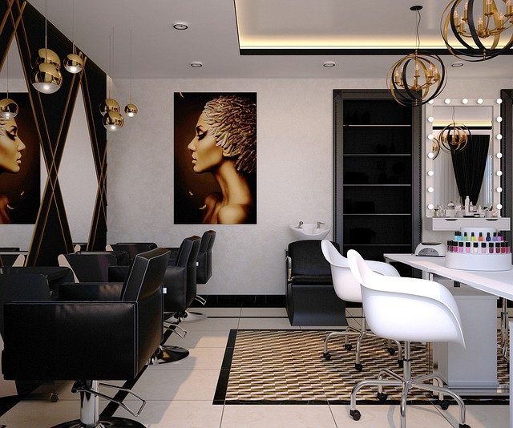

1. Energy suppliers
2. Reduction of consumption in the salon.
   1. Lighting.
   2. Tools and tools (battery or plug?)
   3. Household appliances.
   4. Air conditioning.
   5. Water heating.
3. **ENERGY SUPPLIERS**

As you already know, green energy, also known as clean energy, is non-polluting energy that comes from inexhaustible resources provided by nature, which is why it is progressively gaining importance as, by not producing polluting emissions, it helps to combat climate change.



This energy is generated and fed into the general electricity distribution grid, where it is not really distinguished from energy that is not of renewable origin. For this reason, it is the marketer that guarantees its origin as it is obliged to provide the user with the Certificate of Guarantee of Origin of the electricity, issued by the National Commission for Markets and Competition (CNMC).

The guarantee of origin certifies that a specific amount of kilowatt hours (kWh) of electricity has been generated through renewable energies. Thus, to assure users that the energy they will consume in their homes is green, the Guarantee of Origin and Labelling System for Electricity was created within the European framework.



But how do I select the best electricity supplier for my salon from the available options?

**SELECTING ENERGY SUPPLIER**

In order to select the most suitable supplier, there are a number of important factors to consider. Obviously price will be the determining factor, but there are also a number of other factors to take into account.

To simplify the selection process, here are some fundamental points to bear in mind in order to make an intelligent choice that meets all your needs:

**Analyze the profile of the available options:** in general, you should assess the characteristics of the suppliers, taking into account their position, activity, track record, prestige, quality standards, technology and infrastructure, and capacity to respond to contingencies. It is not a bad idea to know the opinion of other companies or clients who have worked with them.

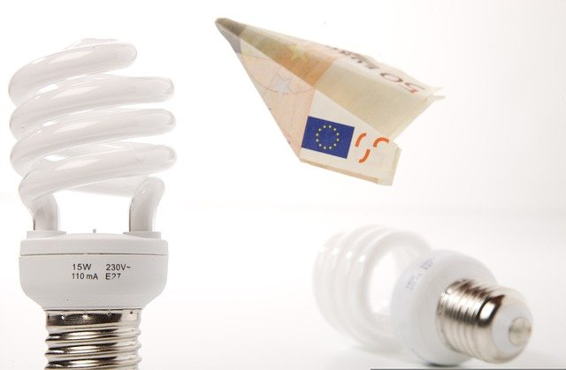**Calculate your energy consumption:** it is essential to assess how you use energy and whether your consumption rate is in line with the average according to the characteristics of your business. In a hairdressing salon, consumption is usually high, but compare it with previous years and assess whether it has remained the same, increased or decreased in proportion to the volume of business. Whatever your case may be, later on we will see measures to reduce consumption and, thus, the cost that is paid on a regular basis.

**Compare the tariffs of different companies:** price is often the most important selection criterion. Determining your average annual consumption will allow you to calculate the fee you would pay with other companies. Also assess aspects such as payment options and possible discounts offered by the supplier, but always carefully study the conditions of the different contracts, making sure that they include all possible supplements or taxes.

**Be critical of quality and after-sales service:** In the energy market, as in any other, a low-priced supplier is of no use if his products or services are not of high quality. But, just as important as quality or price and prestige, is the after-sales service. Study the guarantees, the advice received, the response of the technical service and, very importantly, the customer service and support when you need it.

**Value the corporate philosophy on sustainability and its ethical principles:** when deciding on a supplier, knowing the environmental impact of electricity use, we must also prioritize the protection of the environment and the conservation of natural resources by choosing trading companies that distribute green energy, with which energy consumption will be much cleaner and less polluting.

In short, in addition to the economic and service advantages offered by the suppliers, the added benefits of green energies are:

* Profitability
* Easy maintenance
* Energy independence (no dependence on purchasing from third parties)
* Energy efficiency
* Sustainability
* Environmental protection
* Conservation of natural resources (energy obtained from inexhaustible energy sources)

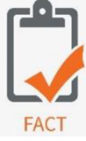You should bear in mind that the most powerful companies in the market already offer green energy tariffs to their customers, despite continuing to use non-renewable sources. In addition, there are small suppliers specialised in green energy that do not offer any other non-sustainable product. A final option would be renewable energy cooperatives, for which a monthly membership fee has to be paid to join the organisation.

1. **REDUCTION OF CONSUMPTION IN THE SALON**

For too long, business and environment have been opposing concepts and this is one of the causes of the climate change that we are clearly suffering today. For this reason, it is necessary to implement "eco-efficient" measures to achieve what we call "sustainable development", i.e. to achieve a reduction in environmental impact while maintaining the level of production.

To achieve this, it is necessary, among other measures, to reduce consumption in numerous areas, energy being one of the most significant and with which, as long as we are aware, we can have an impact at all levels, one of which, not insignificantly, is the economic savings that can be achieved.

The initial fronts to work on to improve electrical performance in our salon will be:

1. Lighting.
2. Tools and tools (battery or plug?)
3. Household appliances.
4. Air conditioning.
5. Water heating.
6. **LIGHTING**

One of the main areas of consumption in the salon where changes can be made to improve efficiency is lighting. Reducing consumption can be tackled on several fronts and with different methods. Some of the most important ones are mentioned below:

**Making the most of natural light:** using sunlight whenever possible is essential, for which the installation of windows and/or skylights is recommended, as well as transparent or translucent glass panels to separate spaces and use mirrors to multiply the light, thus making the most of sunlight. The same concept applies to windows and/or shop windows, which should be unobstructed, avoiding curtains or other elements that block the passage of light.

If total transparency is not desired, acid-etched matt glass can be used, although it would be advisable to place the matt areas strategically, as the light flow is slightly reduced by them.

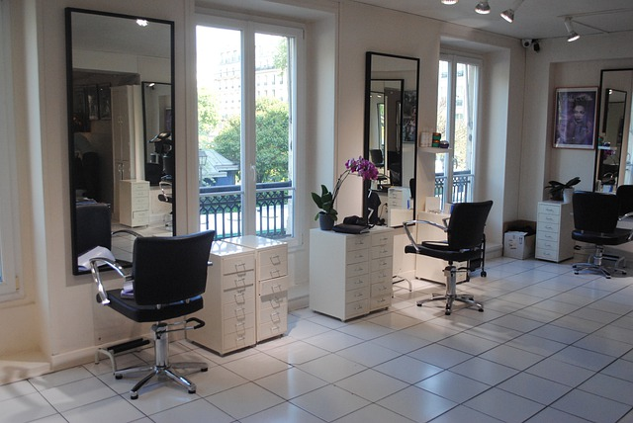

The only exception to this rule is in particularly hot climates, as this would increase air conditioning consumption.

**Decoration and paint:** walls and even furniture should be light-coloured to reflect light, as dark paint or furniture absorbs a lot of energy.

**Volumetric:** in areas lacking natural lighting, such as bathrooms, corridors or storerooms, it would be interesting to install volumetrics to detect movement and prevent them from remaining on while the area is not in use.

**Artificial lighting:** considering that despite the availability and use of sunlight in the room, the use of light bulbs in many cases is unavoidable, the use of LED lights should be considered as their consumption is much lower and their duration much longer. These bulbs should also be placed close to and/or oriented towards the mirrors so that they reflect the light, doubling their output. An interesting fact is that a 100W incandescent lamp operating for 50 days emits 43 kg of CO2 into the atmosphere, while a similar LED only emits 5 kg.

**Intelligent lights:** an interesting option is the use of intelligent lights that detect the amount of ambient light and regulate themselves to achieve a pre-set light output, so they would be operating at maximum in total absence of light and would be regulated to switch off according to the intensity of natural light.

**Clean the lamps: it** may seem silly but it is essential as the lighting level drops if the luminaires are dirty, which could lead to more light points being switched on, which is totally unnecessary when regular cleaning is encouraged.

1. **TOOLS... BATTERY-POWERED OR PLUG-IN?**

Over the years, the "modernization" of equipment has involved the elimination of cables, something that may seem convenient at first glance but is extremely harmful to the environment, as batteries are not only made with toxic elements and substances, but everything that works with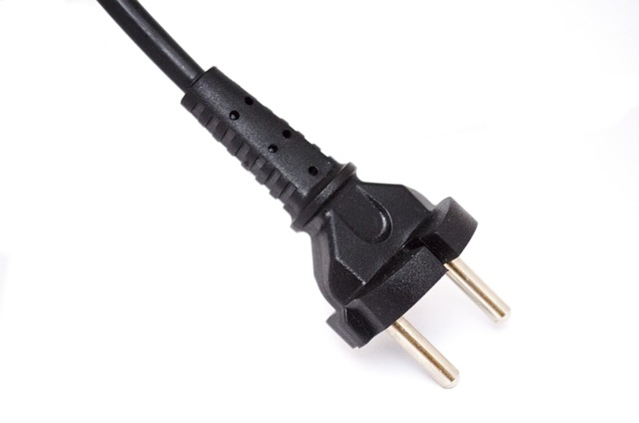 batteries has a much shorter useful life, which means more waste and the need to renew equipment, generating waste that degrades and has a high polluting power.

This applies to a multitude of equipment, the purchase of which we should consider whether the environmental cost is worth the benefit obtained (as we have already said, it is not). And in this bag we can include a lot of equipment, those used in hairdressing salons such as hair clippers or others such as hoovers, smart watches, etc.

In this respect, the only battery-powered items that are spared are laptops, as their technology has evolved so much that on average they consume 80-90% less than desktops, resulting in significant savings and lower CO2 emissions. In fact, the most efficient desktop computer still consumes 10 times more than many laptops.

1. **SMALL AND LARGE HOUSEHOLD APPLIANCES**

In a hairdressing salon we can find numerous electrical appliances, we call small appliances those ranging from classic plug-in tools such as irons, hair dryers or similar, to coffee machines or microwaves. Large appliances include washing machines, tumble dryers and refrigerators, for example.

The purchase or renewal of any of these appliances, especially large appliances, but also small appliances as they are investments for work, are important decisions that should not only be based on the design or performance of the different devices, but should also consider energy efficiency as a decisive selection criterion.

First of all, if you are going to renovate or buy, consider whether you really need it. Avoiding unnecessary and/or excessive consumption is essential to alleviate the climate crisis. Make a real list of your needs: how often will it be used, what needs are we going to cover, how long do we want it to last, how much space do you have, etc. Finally, choose a sustainable and environmentally friendly appliance and, if possible, one that has artificial intelligence, as home automation can help to reduce the energy bill.

But how do you determine whether an appliance is energy efficient? It has been 25 years since the EU consumer bodies created the energy label, which is an identification based on a series of technical controls and certifications that allows consumers to know the degree of energy efficiency of each household appliance. European regulations oblige distributors to display the label.

How to read this label? In the past, they were organized in 7 levels, from A to D and within A there were 3 categories, with A+++ being the most efficient label.

Therefore, household appliances were classified as follows:

* A+++, A++ and A+, green in color, for appliances with a high level of efficiency.
* A and B, in orange and yellow for medium-consumption appliances.
* C and D, in shades of red, for energy-intensive appliances.
* However, in March 2021 there was a change in energy labelling, according to EU Regulation 2017/1369, and they are now categorized on a scale ranging from A to G.
* The A+, A++ and A+++ categories disappear.
* Category A is reserved for new appliances with higher efficiency and technology and, for the time being, this category is deserted as efficiency improvements are foreseen in the future.
* Category B now covers those previously classified as A+++.
* A, B and C are represented by shades of green.
* D and E are represented by yellow and orange
* Categories F and G are represented by reddish colours.

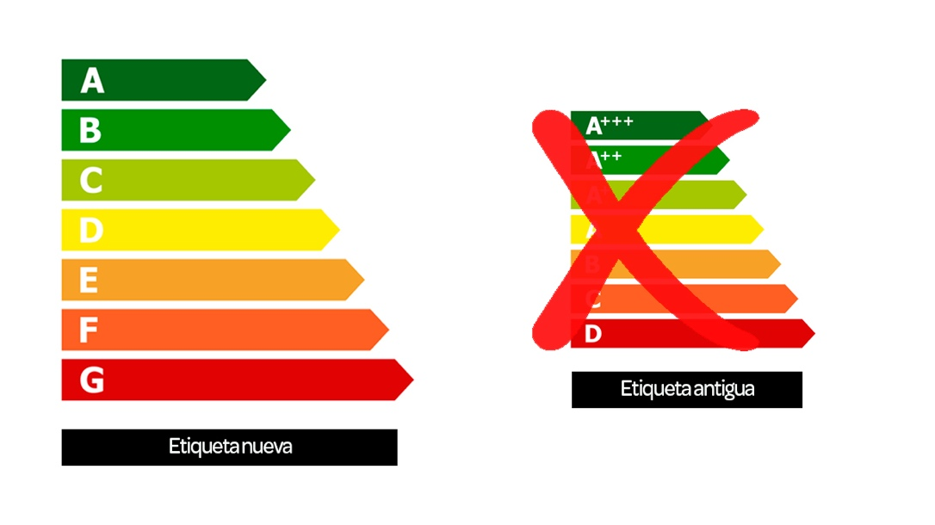

Despite this, market research shows that, even today, consumers still generally value price over efficiency, as energy efficient appliances are on average 15% more expensive. However, it seems that the reality that, in the medium term, efficient and sustainable appliances contribute greatly not only to the environment, but also to significantly lowering the electricity bill, so that the initial investment is more than compensated for, has not yet fully sunk in.

Finally, in addition to making a conscious choice when purchasing or renovating, measures to reduce consumption can also be implemented in the maintenance or use of these appliances, such as:

* Unplug appliances that are not used frequently, such as coffee machines or microwave ovens.
* Avoid keeping equipment switched on in stand-by mode, because although it may not seem like it, it is also consuming energy.
* At night, unplug all electrical equipment not needed at that time, including hairdryers, appliances and so on.
* Keep computers in economy mode when they are not in use (screen savers also consume energy) or switch them off if they are not going to be used regularly.
* Avoid batteries whenever possible and, if not possible, use rechargeable batteries.
* Make sure that the equipment is energy efficient; even some that do not carry the official energy efficiency label. In hairdryers, irons and other electrical items, there are "green" options that get the same power for much less consumption.
* If you are going to use the washing machine, tumble dryer or other similar appliance, always do it cold and with a full load.
* Whenever possible, avoid tumble drying and air dry towels.
* Schedule any appliances you can, such as the washing machine or tumble dryer, to run during the cheapest tariff hours.
* Use programmable sockets to charge equipment with a battery during the cheapest tariff hours.
* Keep equipment maintenance up to date so that everything runs smoothly and you can check that no energy is wasted.

1. **AIR CONDITIONING**

To function properly, the body must be at an internal temperature of between 36 and 37ºC. When this temperature is maintained without any physiological effort (sweating or shivering, for example), we are in a state known as thermal comfort.

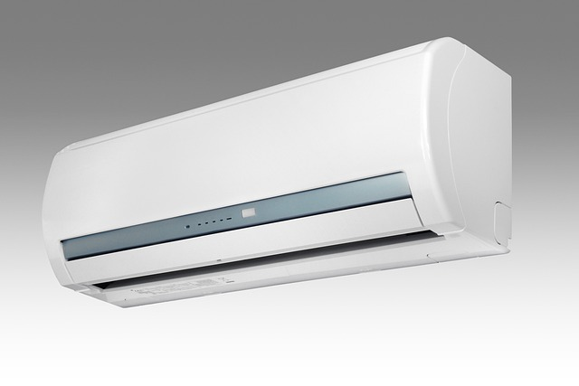

The definition of thermal comfort is included in the ISO 7730 standard as "That condition of mind in which satisfaction with the thermal environment is expressed", i.e. the temperature at which we are neither hot nor cold, which is essential when selecting or programming the air conditioning of the hairdressing salon, as it is a key element in providing the well-being that allows us to feel comfortable for both professionals and clients.

However, air conditioning alone can account for up to 35% of total energy consumption and is also a major generator of carbon dioxide, making it a priori neither economical nor sustainable; however, there are different ways of adapting air conditioning to maintain an environmentally friendly consumption.

**Tips for efficient use of air conditioning:**

**Insulate your salon properly:** a well-insulated workplace has fewer energy losses, so it is important to study the possibilities for improving insulation in walls, windows and doors, as well as in roofs and ceilings if necessary, which is where around 30% of energy losses occur.

**Ventilate the salon and make the most of sunlight:** good ventilation is necessary to ensure clean air, but it also has an impact on energy savings as it cools a warm room. In addition, in warm weather it is also advisable to use blinds that block the passage of sunlight, while in winter, the sun shining on the windows can make it possible to reach the ideal temperature without turning on the air conditioning system or keeping it to a minimum.

**Install awnings and/or opaque and semi-transparent blinds:** in hot climates, awnings are a very effective external parapet against the heat as they constitute a first barrier against the sun's rays, reducing the heat by up to 90% depending on their type and/or orientation without losing the view of the outside. Blinds are also very practical for maintaining air conditioning. There are models of different opacities depending on the need.

**Take advantage of automated systems and promote connectivity:** the use of thermostats in air-conditioning systems leads to more effective and efficient use. The thermostat avoids the constant temperature variation that leads to higher costs. Study what the ideal indoor temperature is and stick to it; it is a mistake to turn on the equipment by selecting the minimum or maximum temperature so that it cools or heats more quickly, as it will take the same time but it will cost much more because it does not stop when the desired temperature is reached.

On the other hand, the possibility of controlling the equipment via WiFi makes it possible to automate more efficiently actions such as switching on and off or managing the temperature of the air conditioning equipment.

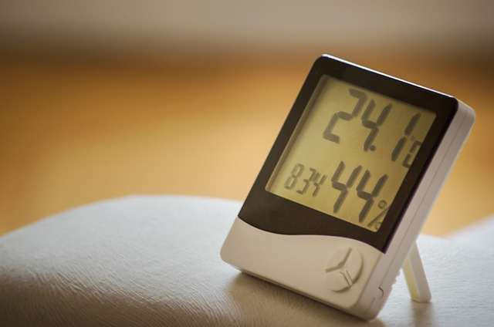

**Regulate the temperature:** one of the main keys to the efficient use of air conditioning equipment is to regulate it so that the ambient temperature remains close to 21ºC in winter and 25ºC in summer. Bear in mind that each degree more or less can mean an increase of up to 8% in the electricity bill.

**Don't forget maintenance:** regular maintenance of the equipment and its components (filters, pipes and others), preferably carried out by the Official Technical Service of the commercial company of your air-conditioning system, will guarantee correct operation, thus favoring energy savings, avoiding damage to the units and extending the useful life of the equipment. However, if the building has air conditioning systems that are more than 15 years old, they will not be very efficient, so it is recommended to replace them with new ones with the highest energy rating, as they will have energy-saving technologies (inverter in cooling, modulating in heating, among others).

**Choose the best air conditioning system for your premises:** opt for integral and efficient solutions that you can use both in summer and winter. Do not hesitate to consult with professionals in the sector so that they can recommend the system that best suits your room, as there are many factors to take into account: location, orientation, climate zone, surface area, distribution, number of workers and workstations, etc., but it is also interesting to know the two standards that determine the performance of the equipment: SEER and SCOP.

The most efficient air conditioner will be the one that offers more kW of cooling or heating per kW consumed. This ratio is the SEER (Seasonal Energy Efficiency Ratio) data for cooling mode and SCOP (Seasonal Coefficient of Efficiency) in heating mode; therefore, to find out the energy efficiency of an air conditioner you only have to compare the SEER or SCOP of the equipment, as the one that is higher will be more efficient and, therefore, will have lower consumption.

This table can serve as a guide:

|  |  |  |
| --- | --- | --- |
|  | SEER | SCOP |
| A+++ | <8,5 | <5,1 |
| A++ | >8,5 | >4,6 |
| A+ | >6,1 | >4,1 |
| A | >5,6 | >3,6 |
| B | >5,1 | >3,1 |
| C | >4,6 | >2,6 |

**Supplement air conditioning:** air conditioners alone regulate the temperature and guarantee thermal comfort, but we should not disregard other equipment that reinforce their efficiency and can even improve air quality, thus benefiting health and reducing consumption, such as dehumidifiers, humidifiers and fans.

High levels of relative humidity in the air not only increase the sensations of cold and heat, but also encourage the appearance of bacteria, mites, mold and fungi. Conversely, low levels of relative humidity dry out the mucous membranes of our respiratory system, also affecting the skin and hair and even the furniture. Dehumidifiers and humidifiers regulate the ambient humidity so that it stabilizes at the ideal values, which would be between 30 and 50%, more humidity if the climate is warm and less if it is cold.

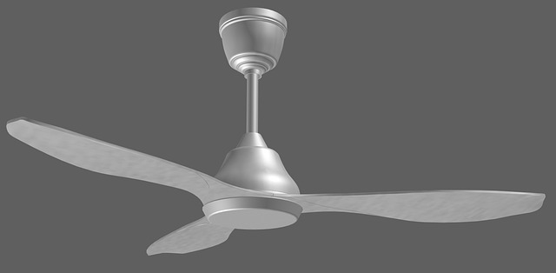In another category, but no less important, we find the fans, which are the most economical and efficient devices that can be used to cool the spaces, generating a current of air that manages to reduce or increase the thermal sensation depending on whether they are used in summer or winter mode. Unfortunately they cannot be used in all areas of a hairdressing salon, as there are areas, such as those where volatile chemical products are used, where their use would be inadvisable, but with good design and space planning, their use significantly increases the energy efficiency of the salon.

1. **WATER HEATING**

The moment of washing the hair is one of the most gratifying for the client in the hairdressing salon and a large part of the protagonism, apart from the professional's hands, is the flow and temperature of the water, which is why it is essential to always have hot water available for the client. However, it is also one of the salon's major sources of expense, as many liters of water are consumed and, for this reason, in addition to trying to reduce water consumption, which we will discuss in other units, an efficient water heater must be installed.

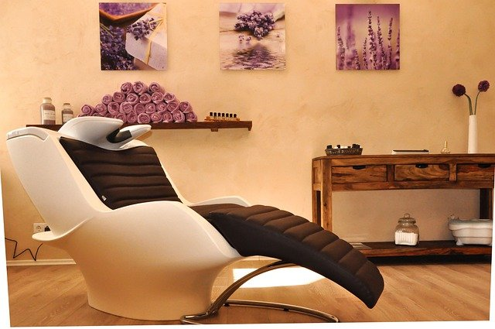

The type and capacity of the water heater to be used in the salon will depend directly on the number of workers and heads washed in a salon. It is estimated that 3 workers wash approximately 9 heads per hour. Another factor to take into account when choosing a water heating system is the space, as hairdressing salons are not always large businesses.

Traditionally, electric water heating systems have been used in preference to combustion systems, despite the latter being more economical, as the installation, gas supply and flue requirements are unfeasible in many halls.

When it comes to electric water heating systems, the industry has not stopped researching and innovating, coming up with more and more sustainable options.

**Electric water heaters with a tank:** their initial installation and maintenance are simple. The cost of the system is not high and the space they occupy is proportional to their capacity, which must be selected according to the needs of the room. Their disadvantages are the electricity consumption during the heating time and the recovery rate. On the other hand, in these systems it must be taken into account that the temperature of the water must exceed 60º to prevent the presence and proliferation of the "legionella" bacteria, and to maintain it constantly, so we can install temperature regulators known as mixing valves at the outlet of the water heater, which allow us to optimise the flow of water by mixing it with cold water.

Despite being a very standardised system, the useful life of these heaters is not very long (8 to 12 years), and what was a not very high initial investment, ends up needing replacement, a factor to be taken into account in the long run.

**Tankless/instantaneous electric water heaters:** they involve an initial economic investment, their great advantage is that they do not take up much space, but electricity consumption is high at the time of use and a high electrical power contract is required, currently averaging around 8 kW, but they do not generate expenses while they are not in use. Although the industry continues to improve them, they have not reached the expected efficiency because they do not provide a high flow rate compared to other heating systems although, to solve this problem of flow rate, there are combined systems of instantaneous heaters with accumulators, designed for rooms with more than 4 washbasins that need to be used simultaneously but, as in the case of accumulator water heaters, the water temperature must always remain above 60ºC.

**Gas water heaters: First of all, it must be taken into account** that these heaters are not instantaneous, so we lose liters of water until it reaches the washbasin, which could be recovered with the installation of water recirculation systems.

There are different heaters depending on the type of gas used, such as butane, propane and natural gas, all of which are economical systems in terms of infrastructure and the capacity to produce hot water on demand, without the need to maintain the temperature in an accumulator. These systems can be installed in rooms that meet the installation requirements, as they require the expulsion of gases to the outside, ventilation grilles for leaks and temporary inspections carried out by official bodies.

|  |  |  |  |  |
| --- | --- | --- | --- | --- |
| **Consumption of different types of heaters:** | | | | |
| **Type of heater** | **Features** | **Average consumption** | **Energy efficiency** | **Price (approx.)** |
| Butane gas | Containment canister to be replenished each time a canister is used up | 1-2 cylinders per month about 150-225 kWh | High | 15-30€ |
| Propane Gas | Cylinders of different sizes, up to 35 kg. and larger tanks | One 11 kg domestic cylinder about three weeks - 1 month about 3700 kWh. | Media | 13€ |
| Natural Gas | Piping from a central hub and distribution throughout the house via pipes | Using gas for domestic water, power and heating, an average of 5050 kWh is consumed. | High | 75-80€ |
| Electric | Tank for water, which is distributed throughout the house | Energy consumption is much lower. About 2800 kWh | High | 60€ |
| Solar | Solar panel system, water tank and piping connecting to the household installations | Electricity consumption is centered on the solar panel and thermosyphon system. About 1.5 kWh | Very high | Depends on the system installed |
| Instant | A system of internal electrical heating elements that heats the water as it passes through its piping circuit. | Energy consumption around 3000 kWh | High | 50-150€ |

We hope that after reading this didactic unit, you have learned how to select the best energy supplier for your salon that benefits your pocket and the environment, and that it has helped you to remember and/or learn multiple gestures and actions with which we can consume less energy or maximize its performance. However, we know that you will continue to ask yourself many questions as a hairdresser who needs electrical energy for your profession. We invite you to further explore this topic in the level 3 didactic unit: "Energy in the Hairdressing Salon II".

**Sources:**

<https://www.caloryfrio.com/aire-acondicionado/aire-acondicionado-domestico/consejos-uso-eficiente-aire-acondicionado.html>

<https://bropro.es/noticia/consejos-para-un-uso-eficiente-de-tu-aire-acondicionado/>

<https://laenergiadeluzia.es/eficiencia-aire-acondicionado-climatizacion/>

<https://e-ficiencia.com/consejos-uso-eficiente-de-calefaccion/>

<https://sunnity.es/tipos-de-calentadores-y-consumo/>

<https://www.naturgy.es/empresas/blog/tipos_de_calentadores_y_sus_principales_caracteristicas>

<https://www.elespanol.com/omicrono/software/20190425/ahorra-iluminacion-hogar-consejos/393711998_0.html>

<https://www.compromisorse.com/rse/2014/10/24/10-maneras-de-ahorrar-energia-con-la-iluminacion/>

<https://megalux.es/eficiencia-energetica-y-ahorro-en-la-iluminacion/>

<https://www.leroymerlin.es/ideas-y-consejos/consejos/ahorra-energia-en-climatizacion.html>

<https://www.lacasadelelectrodomestico.com/blog/como-ahorrar-en-climatizacion-con-el-aire-acondicionado-inverter/>

<https://www.baxi.es/ayuda-y-consejos/ahorra-en-climatizacion>

<https://www.ocu.org/vivienda-y-energia/equipamiento-hogar/noticias/cambio-certificacion-energetica>

<https://www.iberdrola.es/blog/energia/nueva-clasificacion-energetica-electrodomesticos>

<https://www.naturgy.es/empresas/blog/elegir_proveedor_empresa>

<https://www.smartenergy.com/how-to-choose-an-electricity-provider/?lang=es>

# Water

Goals: this chapter addresses the water use and water management within the context of a hairdressing salon and helps you look at ways to minimize the harmful effects on the environment water per work process / work station

Objectives:

* Introducing the notion of water use / water pollution per work station at a hairdresser salon
* Looking at ways to minimize the damage and save up water at a salon
* Becoming aware / measuring the amount of water used for different treatments
* Making the effects of using a water saving device visible

Introduction

Water is a very important topic in the hairdressing industry since most of the work processes need washing, rinsing and using water in this way or another. You can say that hairdressing is a very water-intensive industry. Also hairdressers account for quite some pollution to the water resources of our planet. We are going to have a closer look at it in the chapter to follow.

3.1 Water pollution by hairdressers / water pollution per work station

 Interesting fact: Did you know that, for example, with 5 minutes of rinsing a perm a hairdresser consumes 50 to 70 litres of perfectly clean drinking water?

And that with the use of chemical products and liquids, such as colouring, bleaching and perm liquid hairdressers pollute the water enormously? We are not even talking about the styling products, shampoos and conditioners. These are often full of silicones and microplastics. All these products disappear into the sewer. Treatment plants while doing the water purification, have the greatest difficulty filtering these plastic particles from the water.

Water pollution per workstation at a hairdresser salon

We are now going to look at the water pollution by hairdressers per work station, considering different processes at a hairdressing salon.

Image by prostooleh on Freepik

Cutting hair

For hair cutting, most of the time you use shampooing and conditioner application beforehand. Shampoos and conditioners are polluting the water after being rinsed off into the sewer. Try to wash the hair once, use as little product as possible (they are all well concentrated).

Use drip trays and dose limits, make sure that the screw caps are closed well after use.

Make use of sustainable and environmentally friendly shampoo (without PCB)

You might also consider asking your customer to wash their hair before coming to the appointment for a haircut – this will not save the water in general, since the customer would use the same amount of water at home, but this way you might avoid an ‘unplanned’ shampooing turn.

Colouring hair

Chemical residues are polluting the water. Try to avoid ammonia and sulphates in the products and use vegetable colours whenever possible.

To reduce the use of water while rinsing the colouring product, use water-saving water taps. There are for example water tap nozzles available that pulverize the water allowing to use less for the same purpose.

Image by prostooleh on Freepik

Perming and Straightening

Chemical residues form the perm liquid are polluting the water.

To reduce the use of water while rinsing the perming product, use water-saving water taps. There are for example water tap nozzles available that pulverize the water allowing to use less for the same purpose.

Image by valuavitaly on Freepik

3.2 What can a hairdresser do to have less impact on the water resources?

Businesses pay for the water they use, so making water use efficiency an everyday part of your working practices will save your business money as well as reduce the pressure on the environment.

A good idea is to start monitoring your water use – this will help you see where you use most water. This allows you to focus efforts on where most water is being used and to record the reductions of time.

You can train and encourage staff to:

* Shampoo once rather than twice
* Turn your water tap off between massaging / washing the hair
* Watch out for leaks and report if any
* Washing up/mopping floors while using half buckets as standard

**Use water reducing basin/shower heads**

* Use low aerators: these can give you water savings up to 10 litres/min per tap per use
* Use shower heads that are designed to reduce water consumption. These can deliver water savings up to 330 litres/day

**Towels**

You can use eco-towels. These can be made from a variety of materials such as bamboo-pulp, or made from wood-pulp which is a by-product, normally otherwise thrown away. Eco-towels absorb more than regular towels, are bio-degradable and highly hygienic. Since they are single use only, it means that no detergent, water or energy is needed for cleaning them. Sorted out paper towels can be taken for composting or anaerobic digestion.

Another great idea are very thin microfiber towels. They are more absorbent than regular towels as well, are much thinner and dry faster which means more of them will form a full load of a washing machine and less energy and water will be needed to wash them. Also, instead of using a dryer, these towel will dry quick and easy when hung out on a line (= more energy savings).

**Cleaning**

Using microfiber and its mechanical qualities can allow you to minimize or even eliminate the use of detergents for cleaning. A range of such products can be used with water only, varying in applications from floor to furniture cleaning.

Also, rather than using disinfectants it is possible to achieve a high standard of hygiene by using steam cleaners. They produce a small jet of steam and have low energy requirements. Hand held units are often rated at maximum of around 1000 watts.

**Chemicals**

A hairdresser can decide to minimize the use of chemicals such as perm and colouring and use plant-based colouring. Both do have an impact on the use of water but plant-based products will pollute the environment less.

To sum it all up, this is a shortlist of simple steps that will ultimately help you save water:

* Be aware of your water use
* Avoid wasting water
* Choose the right products and inspire others to do the same (for example, hair colouring products without ammonia or preferably plant-based colouring products)
* Use water-saving shower- and water taps
* Only turn on the washing machine and dishwasher when it is full
* Eat less meat (since meat industry uses humongous amounts of water!) and buy as many products as possible that are organic



3.3 How to measure the quantity of water used at a salon

Calculate the amount of water needed to wash / massage and rinse the hair of a customer [to be carried out during a salon class or at an internship in the hairdressing salon]

**Measurement nr.1:**

Fill a special plastic bag with litres measurement (example: <https://www.conservationmart.com/p-904-water-flow-rate-bag.aspx>, you can easily find them in your country as well) up with water. Time 10 seconds with a timer while the water is running into the bag. In this first measurement experiment you are not using any water saving devices on your shower head or water faucet. See example video: <https://youtu.be/yDUCBRNpytk>

Picture by katemangostar on Freepik  
Calculate how many liters of water you can save by using a water-saving tap

**Measurement nr. 2:**

Now use a water restricting device / nozzle on your shower head or the water faucet. Example of such a device is this: <https://ap.lc/FxPCb>. Time 10 seconds with a timer while the water is running filling your bag. Compare the two experiments. See example video 2: <https://youtu.be/mxPu3Pt7kUY>

Sources:

<https://www.conservationmart.com/p-904-water-flow-rate-bag.aspx>

<https://ap.lc/FxPCb>

<https://youtu.be/yDUCBRNpytk>

<https://youtu.be/mxPu3Pt7kUY>

# Waste

Goals: analysing the waste and waste management options at a hairdresser salon and looking at ways to minimize the negative impacts of it on the environment

Objectives:

* Identifying the types of waste specifically produced at a hairdresser salon
* The 3 Rs (reduce-reuse-recycle) in the context of a hairdressing business
* Looking at environmentally friendlier product alternatives for a hairdresser
* Leaning about the (unexpected) ways of using the hairdresser waste as a resource

Introduction

We have been talking about waste as a growing problem earlier in Module 1. Concerning a hairdresser salon, we can look at specific types of waster being produced there and ways in which we can influence either the amount (=reduce) or type of waste produced (=reuse?) and possibly try and recycle it to something new (=recycle)

4.1 What waste does a hairdresser produce?

**Within a salon quite some waste is being produced. Think of**

* **Plastic bottles and jars from shampoo / conditioner**
* **Glass (some hair products can be packed in glass)**
* **Plastic (think of plastic gloves)**
* **Paper**
* **Foils (highlights / balayage)**
* **Hair colouring tubes**
* **Human hair**
* **Waste from the kitchen / coffee / tea facilities etc.**



**Walk around a salon (it can be the salon you do your internship training at or otherwise the salon at school) and make a complete list of all kinds of waste that is produced in the salon. Do not forget the kitchen /washing machine (if available)!**

What are the effective ways of reducing / recycling the waste a hairdresser (salon) produces?

A lot of things in the hairdressing salon can be recycled. Think about hair, tubes from colouring, foils, plastic which is used for shampoo and conditioner bottles / containers.

Some of these waste types lend themselves perfectly for recycling.

**Plastics**

Most of the plastics are not biodegradable. To reduce plastics in the environment you can check if they can be recycled. Collecting plastic bottles (e.g. from shampoo / conditioner), cutting the bottom and the neck off and cutting it open, **you can put more than 20 bottles in one stack. In this way it takes longer to fill a basket / container with plastic** items and makes recycling easier and more efficient. Collect them and they can be used for makingother (hard)plastic items.

**Hair**

Hair that has been cut can be used for recycling. It is important though that only hair is collected, no other items.

Hair can be used as fertilizer; hair is one of the best natural plant fertilizers you could find on earth. This is because it contains 20 minerals and trace elements, it is also very high in protein and nitrogen.

For example: 100-200 pounds of cows produce 1 pound of nitrogen, 6-7 pounds of human hair produces 1 pound of nitrogen, so it is more effective to use hair as fertilizer.

Hair can be used by oil spills. Hair can turned into nets which can be put in a circle around an oil spill in the ocean. Because of its hygroscopic power hair can resorb the oil perfectly well.

**Mixed waste**

Some types of waste you cannot sort, so it goes to the mixed waste. At the recycling plant where it gets to later on, part of this waste will still be sorted – for example, metal, plastic and biodegradable items will still be recycled – but the rest will most probably end up in a landfill. The less mixed waste ends up in a landfill, the better for the environment. That is why it is our responsibility to minimize to amount of waste that cannot be made back to new raw material.

Companies like The Green Scissors (in the Netherlands) or Green Salon collective (Ireland and a few other countries) can help hairdressing salons sort and collect the different types of waste that a salon produces. They provide the suitable containers, arrange the pick up when the containers are filled up and bring the waste to the right place to getting recycled.



For a period of one week collect the leftovers from the colouring treatments into a transparent vase or bowl. Have a look at it at the end of the week, preferable with all of your team member together. What do you see? Is it much? How do you feel about what you see? How does this colouring products waste going to pollute the environment? Make a report of it and find out in what ways we can reduce it.

4.2 Environmentally friendlier product alternatives

As we have seen so far, a hairdresser can use quite a big range of environmentally unfriendly or polluting products, form shampoo, colouring and perm products with harsh chemicals to plastics (gloves) and foils. Most of these pollutants end up either in the sewer or mixed waste which means harming the environment.

However, some green minds have already thought of these consequences before and came up with some environmentally friendly(ier) products alternatives. You can buy and use greener versions of shampoo and conditioner without SLS /



In order to reduce the waste produced by a hairdresser (salon) or increase the amount of waste that can be recycled, alternative products can be used for the regular processes (think of enormous amounts of foil used for highlights / balayage). Do research into these 2 alternatives to aluminium foil (see links below). What principles of these products’ work make them better recyclable? What is the price difference with regular foil?

Refoil: <https://www.youtube.com/watch?v=KOuc0NCJfvs>

Paper not foil: <https://www.papernotfoil.com/>

4.3 Hairdresser’s waste as a resource

 Interesting fact:

**Recycled hair can be made into many (sometimes unexpected!) things:**

* Nets used for oil spills in the ocean
* Fertilizer
* Hair accessories: these can include hair accessories like wigs, extensions and hair pieces for fancy celebrations.
* Hair purses: an Australian artist called Polly Van der Glas recycles materials to make things from hair purses to human teeth.
* Hair jewellery: these have also been made from the same Australian artist. Bracelets are most popular to make out of hair because they are the easiest. However, necklaces and earrings have also been made.
* Clothing out of hair: designers have also used hair in their work to make dresses and trousers.
* Sculptures: artists have also been known to make hair sculptures. A hairstylist from Beijing, for instance, recreated Tiananmen Square using just recycled human hair. This is the link to the video of him creating it: https://www.youtube.com/watch?v=cJyPpwkM0jo
* Tribal Art: neck ornaments worn in Hawaii were made out of braided human hair. This shows a big contrast in how different types of hair can be used to make different things. The works of art are now located in the Honolulu Academy of Arts

See also the ‘**Entrepreneurial Innovation: hairdresser’s waste as new raw material’** task in Module 3

Sources:

<https://ecohairandbeauty.com>

<https://www.thegreenscissors.org>

<https://www.greensaloncollective.com/>

<https://www.youtube.com/watch?v=KOuc0NCJfvs>

<https://www.papernotfoil.com/>

<https://www.youtube.com/watch?v=cJyPpwkM0jo>

https://honolulumuseum.org/

<https://vanderglas.com.au/philosophy.html>

# Raw materials

**SUMMARY**

Introduction

* 1. International Nomenclature of Cosmetic Ingredients (INCI)
  2. Labels and certifications in the cosmetic products
  3. Cosmetic products: safety data sheet
  4. Raw materials used at a hairdresser salon

**Introduction**

The module aims to deepen the types of raw materials used for the production mainly of the products used within the hairdressing salons and, secondly, the furnishings and equipment. Without claiming to be exhaustive, the discussion will try to touch on all aspects of the topic and to suggest or encourage further study.

* 1. International Nomenclature of Cosmetic Ingredients (INCI**)**



The label on a cosmetic usually contains a list of cosmetic raw materials used for its production. The materials are referred to by using so-called INCI names. This abbreviation comes from the English words International Nomenclature of Cosmetic Ingredients. It is a unified naming system of chemical compounds in English and plants in Latin.

INCI standards for International Nomenclature of Cosmetic Ingredients. The INCI system was established in the early 1970’s by the Personal Care Products Council (former CTFA, Cosmetic, Toiletry, and Fragrance Association) and the list is maintained by the Personal Care Products Council. INCI names are used in the United States, the European Union, China, Japan, and many other countries, for listing ingredients on cosmetic product labels. With few exceptions, the INCI labeling names in all countries are the same. At the moment, there are more than 16000 ingredients in INCI list, which is the most comprehensive listing of ingredients used in cosmetic and personal care products.

It’s normal to feel confused by an INCI list at first. For this reason, there’s may resources and tools (like App or web Sites) that can help us in deciphering INCI names so we can understand more about what the ingredients is and/or what it does. For example, you can try this:

<https://www.ewg.org/skindeep/>

* 1. Labels and certifications in the cosmetic

**LABELS**



How a cosmetic product will turn out, entirely depends upon the raw materials used in it. From the look and feel of the product, its smell, to the most important factor – its effects are the results of the ingredients used to compose it.

Hence, the composition of a cosmetic product matters the most more than anything which is unfortunately also the most ignored thing because we hardly read the ingredient list while buying a cosmetic product. Either our focus is only on the price or the offers or we are simply influenced by an advertisement or some people.

When buying cosmetics, it is worth paying attention to the list of ingredients to be sure that the product will work in a manner declared by the manufacturer. One should remember about the rule according to which the ingredients included in the cosmetic are listed in a specific order, starting with those of the highest content in the product. This information allows consumers to make an informed choice when they purchase cosmetics. For this and other reasons, the preparation of a cosmetic product with a specific effect is not an easy task. One should select cosmetic raw materials so that the product has a homogeneous consistency, and the ingredients’ properties are in harmony with one another, ensuring the desired results. This applies to both natural cosmetics and preparations containing synthetic ingredients. Immagine che contiene persona

Specifically, The EU Cosmetics Regulation requires cosmetic products to provide the following information on the label or on the packaging:

* The name and the address of the company (Responsible Person).
* An ingredients list, in decreasing order of weight of the ingredients. This is mainly intended for people who have been diagnosed with an allergy so that they may avoid ingredients to which they are allergic. The same ingredient names are used across the European Union and most countries worldwide, so people are easily able to identify them.
* The nominal net.
* Any warnings that might be necessary on how to use the product safely.
* A “date of minimum durability” ("best used before the end of") or a “period after opening” to show for how long the product may be kept or used.
* What the product is (if not obvious from its appearance).
* A reference (batch number) for product identification.
* Country of origin (for products imported into the EU).

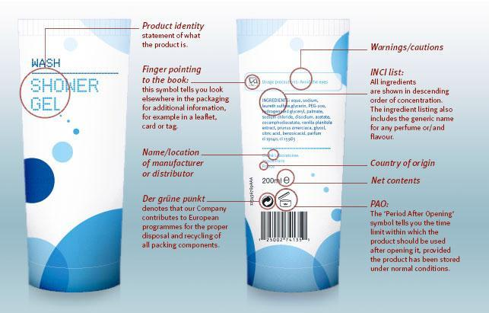

**CERTIFICATIONS**

Sustainability has become an integral part of the cosmetics industry. One of the manifestations of this development is the rising number of sustainability schemes and ethical labels.

The ethical label trend has its origins in the food industry. Demeter is the first such label, introduced almost 100 years ago for agricultural products grown according to biodynamic farming methods.

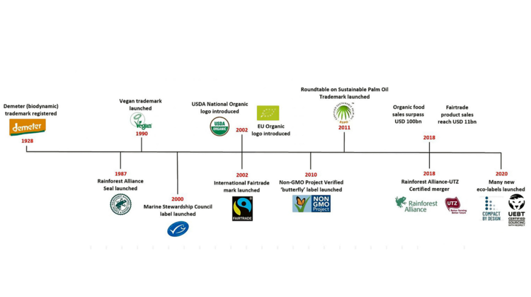

Organic is now the dominant ethical label in the food industry, with global sales growing from almost nothing in the 1990s to roughly $ 130 billion in 2020.

Most developments have happened in the last two decades, with the launch of many new ethical labels. One major difference between the food industry and cosmetics industry is that the organic term is protected by national (and EU) regulations in the former.

5.3 Cosmetic Products Safety Data sheets



In addition to the label information, there’s another tool that can help cosmetic sector workers to know and handle cosmetic products in the correct way: Safety Data Sheet.

A safety data sheet is a document created for substances or mixtures containing a wide range of information on the composition, physical, chemical, health and environmental effects of the substance or mixture and on the safe usage, storage and disposal of the products.

The knowledge of this information makes it possible for users or employers to take any measures which maintain human, environmental and occupational safety.

**Thinking activation**

* What are the main ingredients of your favourite cosmetic product?
* How do these ingredients benefit your skin/hair?
* What should you do if you have an allergic reaction to any ingredient in a cosmetic product?

5.4 Raw materials used at a hairdresser salon

**FURNITURE**

WOOD

The choice of the wood being used is decided by the type of furniture, the design and the budget. Hardwood like Teak and oakwood are dense and therefore more durable. They also lend themselves well to carving and finer detailing. Softer woods like on the other hand, ensures better workability, and is therefore not suitable for furniture that is in heavy use areas. Engineered wood such as plywood and particle board is made by combining thin layers of wood with adhesive, hence the terms teak ply, oak ply etc. A much more cost-effective option, engineering wood however has poor durability over time.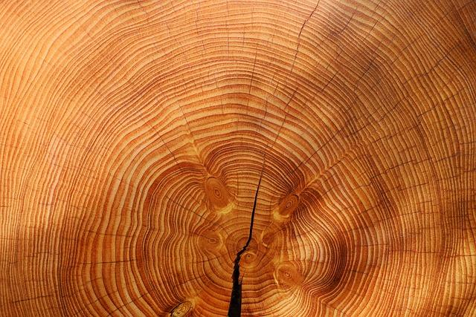

Natural wood can be easily identified by its distinct concentric rings. Most hardwoods have an open pore structure and rough grains on the surface. Softwood such as maple is relatively smooth with no grain indentations. When inspecting grain patterns, one must ensure that the surface is free of any knots, blemishes or other visual anomalies such as twisted grains. Other common defects to watch out for are cracks between adjacent rings.

GLASS

Glass is a solid-like and transparent material that is used in numerous applications in our daily lives. Glass is made from natural and abundant raw materials (sand, soda ash and limestone) that are melted at very high temperature to form a new material: glass. At high temperature glass is structurally similar to liquids, however at ambient temperature it behaves like solids. As a result, glass can be poured, blown, pressed and molded into plenty of shapes.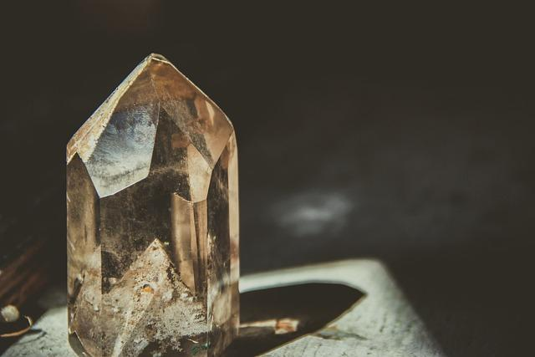

Glass is all around us nowadays and continues to offer cutting edge solutions, either in itself or used in combination with other materials for high-tech applications; a trend which is very likely to continue in the future.

Glass is a sustainable, fully recyclable material which provides great environmental benefits such as contributing to mitigating climate change and saving precious natural resources. It is also highly appreciated in many applications for its inert nature and its contributions to safeguarding people’s health and wellbeing.

**Thinking activation**

* What are some properties of wood and glass that make them popular building materials?
* Can you name some types of wood and glass that are commonly used in construction?
* How do environmental factors impact the durability and longevity of wood and glass structures?

STAINLESS STEEL

Stainless steel is a corrosion resistant alloy of iron, chromium and, in some cases, nickel and other metals. Completely and infinitely recyclable, stainless steel is the "green material" par excellence. In fact, its actual recovery rate is close to 100%. Stainless steel is also environmentally neutral and inert, and its longevity allows it to meet the needs of sustainable handcrafts. In addition, it does not release compounds that could change its composition when in contact with elements such as water.

In addition to these environmental benefits, stainless steel is also aesthetically appealing, extremely hygienic, easy to maintain, highly durable and offers a wide variety of aspects. Therefore, stainless steel can be found in many everyday objects.

*Stainless steel was accidentally discovered in 1913 by English metallurgist Harry Brearley while trying to develop a more durable gun barrel.*

LEATHER

Good quality leather is derived from the upper layer of the hide. The best quality leathers are the full grain and top grain varieties which bear marks of their natural origin such as subtle scratches, wrinkles etc. on its surface. Genuine leather also has a very distinct smell which fake leather or leatherette cannot replicate. Similarly, fake leather has a very even, smooth texture while genuine leather has some unevenness and the graininess in texture. Another way to identify good quality leather is to look for fat wrinkles. Real leather doesn’t chip off upon multiple bends and folds. Leather surfaces are coated with a light non-pigment aniline to increase stain resistance and enhance its appearance. Polymer-based coatings are used to increase its durability.

*Leather can withstand much higher temperatures than most synthetic materials, making it a popular choice for many safety items such as fireman's gear and welding gear.*

FABRIC

Upholstered furniture is often equated with luxury and sophistication. The world of fabrics is vast – cotton, silk, linen, velvet – the list goes on. The quality of fabric that one should look at depends on the usage of the furniture. For areas that have heavy usage, one must ensure that the Martindale of the fabric is high. Martindale is a unit for quantifying the abrasion resistance of fabrics, particularly for upholstery. While cottons and lines work great for tropical environments, they are harder to maintain over a long period of time and they show wear and tear easily. Natural linen is prone to wrinkles but looks beautiful in a home that is more natural and organic. Similarly cotton by its nature is porous and allows air to pass through. Good quality cotton can feel smooth and nearly silky on the skin.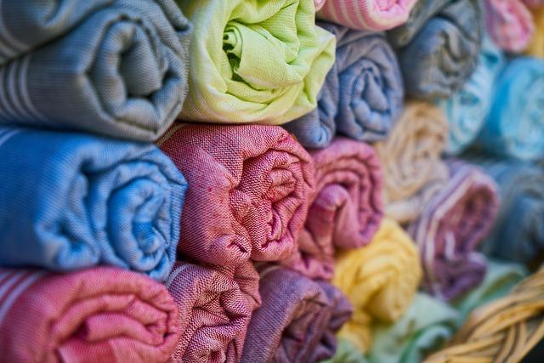

Fabrics like velvet, silk are used to create a luxurious feel. Ideally used in formal areas that are used less frequently, the range of colors and luster in these fabrics can be used to create a dramatic statement.

**EQUIPMENT**

In addition to some materials already mentioned regarding furniture, we need to deepen our knowledge of plastic.

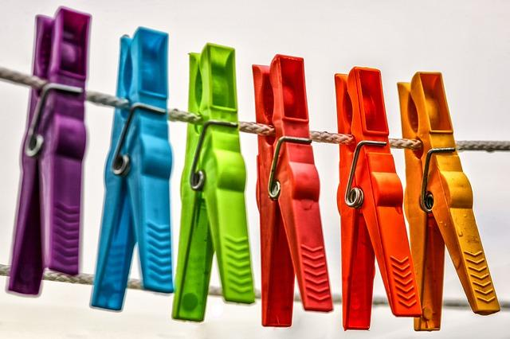

PLASTICS FROM CELLULOSE

Cellulose plastics are bioplastics that are produced by processing cellulose or cellulose derivatives into plastic. Cellulose plastics are made from softwood trees, which are used as the primary raw material in their production.

The bark of the tree is extracted and can be used as a source of energy in the manufacturing process. The tree is processed or heated in a digester in order to separate the cellulose fiber from the rest of the tree's fiber.

A byproduct of the digester's operation is resins and lignins. The byproducts can be utilized as a fuel or as a feedstock in the manufacture of other chemical products, depending on their composition. It is softwood that is the most commonly used raw material in the production of cellulose plastics, and the growing number of anti-deforestation rules is a significant impediment to the market's growth. The easy availability and low cost of conventional plastics are also significant factors limiting the growth of the cellulose plastics business.

PLASTIC MADE OF NATURAL GAS

The majority of people are unaware that natural gas is the starting point for a large portion of plastic manufacture. The cracker plant is the first stage in the process of making plastic from natural gas for use in manufacturing. Naptha (a crude oil-based product) and ethane (a natural gas liquid) are converted into ethylene in cracking operations. Ethylene is used as the starting point for a range of chemical products and plastics.Immagine che contiene cibo

A pipeline is then used to transfer the ethylene generated during the cracking process to another facility where it will be transformed into usable goods, the most often seen being polyethylene. Polyethylene, sometimes known as polythene, is the most widely used plastic today. It is a polymer that is mostly utilized in the packaging industry.

**"I think the environment should be put in the category of our national security. Defense of our resources is just as important as defense abroad. Otherwise, what is there to defend?"** (Robert Redford)

**Thinking activation**

* How long does plastic take to decompose, and what happens when it does?
* How can we reduce our use of plastic, and what alternatives are available?
* What are the consequences of plastic pollution in our oceans, and what can we do to help?

**COSMETICS PRODUCTS**

**DO’S**

Natural cosmetics are products that contain only natural raw materials – mineral resources and ingredients of plant or animal origin. In addition, they should be obtained as a result of such processes as: filtration, extraction, drying, distillation, pressing, milling, lyophilization and sieving. Obtaining natural raw materials with the use of the aforementioned physical methods, which process the material to a small extent, allows to preserve the nutritional values, vitamins and beneficial substances found in the raw materials.

Ingredients of animal origin can be used to produce natural cosmetics only when doing so is not harmful to the health or life of animals. Such raw materials are, among others, honey, propolis, lanolin and milk. In the production of natural cosmetics, it is also allowed to use cosmetic raw materials obtained in biotechnological processes, i.e. microbiological or enzymatic. Hyaluronic acid, among others, is obtained this way.

In addition to raw materials of plant and animal origin, in natural cosmetics you can also find:

* different kind of sea components (e.g. algae)
* essential oils,
* inorganic salts and oxides derived from minerals,
* natural emollients, dyes, emulsifiers (e.g. sucrose esters),
* naturally occurring active substances and preservatives (benzoic acid and its salts, benzyl acid, salicylic acid).

**DON’TS**

For the production of natural cosmetics, one shall not use mineral oils, paraffins, petrolatum, synthetic dyes, synthetic fragrances, synthetic preservatives, i.e. parabens or formaldehydes, as well as propylene glycol (PPG), silicones, BHT, SLS and SLES.Immagine che contiene logo

The ingredients of natural cosmetics have to be free from raw materials originating from genetically modified plants as well as from raw materials from dead animals or obtained in the manner harmful for them. It is also important to remember that the production of natural cosmetics requires undertaking measures protecting the natural environment.

A natural cosmetic product should not contain synthetic substances; although some certifying organizations consider the product to be natural if it contains less than 5% of synthetic substances.

**FUNCTIONS**

The effectiveness of raw material is the key topic in the selection process. Just because something is natural doesn’t mean it has to be magical. The properties of raw materials like emulsification, moisturization, cleansing, thickening, coloring, fragrance, or preservation must be considered before adding them to the list of ingredients for a cosmetic product. Here’s the main powers a raw material can have in Natural Cosmetics

**Antioxidants** – To fight off the aging of the skin, antioxidants are necessary. They also limit the growth of microorganisms and protect cosmetic ingredients from decomposition. Some of the natural antioxidants are polyphenols and flavonoids found in grape seeds, rosemary, and citrus.

**Emollients** – To soften or smoothen the skin, emollients are added which help build a barrier against water loss. Some of the natural emollients are – hydrogenated castor oil, coconut oil, honey, etc.

**Emulsifiers** – In order to combine two opposite phases like water and oil, an emulsifier is needed in cosmetic products. For example, GSC (Glyceryl Stearate Citrate), beeswax, are natural emulsifiers that help in stabilizing and obtaining the right consistency of the cosmetic product.

**Surfactants** – A multifunctional raw material with properties such as foaming agents, conditioning agents, emulsifiers, and solubilizer, is added to the cosmetic products to facilitate skin cleansing. Castor oil, Cocamidopropyl betaine obtained from coconut oil are known to be the best natural surfactants used extensively in the cosmetic industry today.

**Humectants** – Long-lasting moisturization is what everyone desires from a cosmetic product and humectants are responsible for it. Hydrogenated castor oil, aloe, honey, glycerol, and acid are the star humectants in natural cosmetics today.

**Plant extracts** – Since we are talking about natural cosmetics, botanical extracts are a must and the most important raw material. They are the active ingredients in natural cosmetics. Extracts of aloe, castor plant, green tea, etc., can be found in the ingredient list of natural cosmetic products that act as antibacterial, firming, strengthening, moisturizing, rejuvenating agents and are also safe for the skin.

Other than these, proteins, vitamins, oils, waxes, fats, butter, acids, minerals and trace elements, gums, and thickeners, fragrances are the other factors in raw materials that are important in the formulation of a natural cosmetic product.

**Activity 1** - Using an online collaboration board like Mural (<https://www.mural.co/>) or an online mind map creator, collaborate to create two different schemes:

1. FIRST ONE – A summary of the concepts learned in this module
2. SECOND ONE – A brief vocabulary of most important key words you discovered during this lesson

**Activity 2** - Below you can find the label of a cosmetic product. Using the knowledge base you’ve learned during the classes and any online tools or App you want, try to understand and explain it by creating a brief presentation with Google Slides or any other similar App.

**Activity 3 -** This is the INCI list found on the label of a cosmetic product that emphasizes the presence and benefits of Argan Oil. Is this true in your opinion? Try to explain why recording a short PODCAST with “Vocaroo” (<https://vocaroo.com/>).

*INCI: Aqua, Sodium laureth sulfate, Cocamidopropyl betaine, Sodium chloride, PEG-40 hydrogenated castor oil, Panthenol, PEG-200 hydrogenated glyceryl palmate, Sodium benzoate, Polyquaternium-10, Parfum, Dipropylene glycol, Glyceryl laurate, PEG-7 glyceryl cocoate, Polyquaternium-7, Citric acid, Argania spinosa oil, Alpha-isomethyl ionone, Geraniol, Limonene, Linalool.*

**Activity 4** - Try to find the correct meaning of the following symbols you can find in the cosmetic products labels:

|  |  |
| --- | --- |
| **Symbol** | **Meaning** |
| How to read a cosmetic label Getting started |  |
| How to read a cosmetic label Getting started |  |
|  |  |
|  |  |
|  |  |
|  |  |
|  |  |

**Activity 5** - Using “Book Creator” App (<https://bookcreator.com/>) or another free App you want, create a simply e-book about raw materials (RM) for cosmetics developing the followings concepts:

1. What are RM in cosmetics production
2. Difference between synthetic and natural RM
3. What RM are useful for in cosmetics production
4. Which are the main RM used in natural cosmetic products

Useful link - <https://www.bansaltrading.com/cosmetic-raw-materials>

1. Which are the main RM one shall not find in natural cosmetic products

Useful link - <https://www.products.pcc.eu/en/blog/raw-materials-for-the-production-of-natural-cosmetics/>

Create a brief video report, in which you are the narrator, to inform your colleagues and customers about the risks of using plastic mainly referring to its waste disposal and environmental impact.

You can use a Web App like Animoto (<https://animoto.com/education/classroom>) or similar.

**Activity 6 (Group Work)** – Divide students into 6 groups. Each group must create a presentation about one of the 6 raw material presented in Textbook (Wood, Glass, Steel, Leather, Fabric, Plastic) with information about:

1. Where to find it
2. How is made (composition) or produced
3. Its availability in the EU or from where EU must import it
4. Sustainability fact about it

Information can be found using Textbook or other sources like Internet or books and assembled using a presentation software or handwritten poster.

# Management

**Summary:**

**Introduction**

* 1. **Warehouse management**
  2. **The warehouse of a hairdresser ‘salon**
  3. **What is an order**

**Introduction**

What is a supplier? What is a warehouse management? But above all, why is it important to know this for a hairdresser?

If you want to start your own business, the first question that comes up in your mind is: “What can I do?” but also “how can I make my business profitable?” When starting a new business, “What is superfluous and what is not?” All owners operate in the same way: managers decide what kind of product or service to offer, first determining what their target audience is and what products these people consume or what services they want to use. For instance, goods and services will be provided to the customer in exchange for a financial amount; a part of this will then be used in turn to start the circle and to make sure that the company stays afloat. And it is at this time when the figure of the supplier becomes important.

For this reason, it is important to perfectly understand the role of supplier and how to manage an efficient warehouse.

**What is a supplier? Definition and examples**

A supplier is a person, organization, or other entity that provides something that another person, organization, or entity needs. During transactions, there are suppliers and buyers. Suppliers provide or supply products or services, while buyers receive them.

We commonly use the term ‘vendor’ with the same meaning as ‘supplier.’

In business, for example, every company has at least one supplier. Suppliers [supply or provide the company with materials, products, and services](https://marketbusinessnews.com/financial-glossary/supply/).

*BusinessDictionary.com* has the following definition of the term:

*“A party that supplies goods or services. A supplier may be distinguished from a contractor or subcontractor, who commonly adds specialized input to deliverables.”*

Suppliers are those companies that provide other goods or services necessary for the proper functioning of the enterprise.

The word supplier comes from the verb to provide which means to provide, to deliver.

In the field of business, managers or the purchasing department must negotiate delivery times and payment terms with their suppliers to strengthen a long-term relationship.

For the company or the contracting entity there are two types of suppliers: internal and external:

* Internal suppliers: refer to the company's workers who must deliver a certain product or service within a certain period of time. An internal provider, for example, are departments that create financial reports or market research.
* External suppliers: they are entities or companies that provide what is necessary for the proper functioning of the "buyer" company. External suppliers would be, for example, companies that sell raw materials for a factory.

Suppliers are caring *stakeholders* of a company, i.e. interest groups related to the company. The importance of this lies in the fact that they are factors that must be taken into account in the planning of strategic objectives.

* Stakeholder
* Strategic objectives

Suppliers can also be classified according to the type of good and service they offer, generally divided into 3 categories:

* **Suppliers of goods**: they are those who offer specific and necessary tangible products for the market. Among the suppliers can also be classified according to the type of good and service they offer, generally divided into 3 categories:
* **Suppliers of goods**: they are those who offer specific and necessary tangible products for the market. Among the suppliers of goods we can find, for example, companies that produce items, furniture, goods for resale, among others.
* **Service providers**: these are companies or individuals who supply intangible products. Among the service providers, we can find: Internet service providers, telephony, cleaning, legal services, etc.
* **Resource providers**: refers to economic resources, in particular credits, capital and shareholders. Among the providers of resources we can find: banks, credit institutions, government, among others.

6.1 Warehouse management

With the word warehouse we refer both to goods, packaging, raw materials, products finished, to spare parts that are present in the company to be sold, consumed, used,

and to the premises where they are kept, stored and stored.

The structures to be used as a warehouse must be built in such a way as to exploit as much as possible the space available and to ensure the temperature and humidity that allow the best storage of stocks.

The equipment must be such as to facilitate the subdivision and sorting of goods and to allow an easy movement of the means of transport and lifting that are used for perform deposit operations.

The warehouse can be divided into three zones:

* **The acceptance zone** must take into account that the arrival of the goods is not easily programmable and you can overlap more products, so you need a rather large space.
* **The shipping area** may be smaller than the acceptance, as it is the company that decides when to send the goods and then can schedule the fulfillment of orders.
* **The storage area** is the actual warehouse, that is, the place where the goods remain in storage for more or less long periods. The size must be carefully determined as excessive amplitude leads to depreciation, maintenance, heating costs, while an under sizing can lead to a congestion of the premises, a greater confusion of different goods, difficulties in using means of transport and above all in going under escort and therefore not be able to meet customer demands.

In merchant companies, stocks allow the purchasing department to provide for supplies at the pace deemed most appropriate and at a time when prices are deemed more convenient.

**Organization of the warehouse in modern activities**

To be effective, a good purchasing policy must be accompanied by careful management of goods from receipt to delivery to departments. In practice it is indispensable conduct in a shrewd and rational way the whole department, through a correct accounting of warehouse, as up to date as possible to the real situation.

The person receiving the goods, the person in charge of carrying out this task cannot be a simple employee not trained in this work. The presence of an inadequate person could nullify all the efforts made during the purchase phase.

The person receiving goods has very specific and delicate task: check the goods and start the entire administrative procedure relating to the payment of invoices of suppliers.

The person responsible for receiving the goods must:

– check the status of the packages

– ascertain the quality of the goods through the verification of some samples

– sign travel documents

– record the arrival of the goods and inform the administration.

Once the goods have been checked, the person receiving the person will sign the papers companions, who will subsequently be passed to the administrative department.

**The location of goods in the warehouse**

The goods purchased and then stored can be rightly compared to money kept in a bank and, therefore, must be treated with the same consideration. To better control incoming and outgoing products, it is advisable have only one entrance way to the warehouse located near both the reception area.

The goods must be placed in hygienically suitable environments, in the presence of elements of conditioning or not, according to their perishability, following a criterion that still favors the ease of storage and availability of products. For this purpose, it is convenient to apply, for each product placed on the shelves, an identification tag, on which to report the name of the product and the main useful information at the time of the withdrawal and inventory.

The help of a computer will avoid the compilation of paper material, helping a lot the work of the warehouseman in terms of time and production efficiency.

**Stock accounting**

To control consumption and therefore the costs of business management it is a good idea to implement from the beginning of the activity an efficient stock accounting. Thanks to this, the manager will be able to in any time to establish the quantity of goods in stock in the company, the relative order to be placed and evaluate the consumption trend of each type of product.

The best way to keep your warehouse situation up to date is inventory continuous. It is about constantly renewing (more and more often with the help of a support computer) a special card, of which we have already mentioned above, on which they are reported, in addition to the commercial and commodity data of each individual product in stock, also all its movements (entries and exits) in the warehouse within a fixed time (daily consumption, weekly, monthly, annual). In this way it is always possible to have in real time the warehouse situation.

Stock accounting is based on the following documents:

**Loading bills** relating to the entry of materials and component parts into the warehouse

**Withdrawal bills** for goods transferred from the warehouse to the production departments

**Processing returns bills** related to goods returned from production departments to the warehouse because unused

**Payment bills** related to the transfer of products from the production departments to the warehouse products

Discharge bills related to the exit of products from the warehouse for delivery to customers.

Warehouse movements are proven:

*for revenue*:

* DDT transport documents and immediate accompanying invoices issued by suppliers in relation to the delivery of the goods
* DDT transport documents issued by customers, in relation to returns of goods

*for sales*:

* from DDT transport documents and immediate accompanying invoices sent to customers for the goods delivered to them
* from DDT transport documents sent to suppliers in relation to returns of goods

**Inventory and inventory accounting management**

This task often takes place with EDP systems that requires:

1. Creating an Article Archive
2. Classification of goods into groups, subgroups, classes....
3. Encoding (code that can be called up from a PC): the code is a set of digits (numeric code) or a set of letters and digits (alpha numeric code) that summarizes different information about a certain commodity.

Stock records must:

1. Control the incoming and outgoing movements of the various warehouse items
2. Check the stock level and report supply needs to the purchasing department. Concretely, it will signal the achievement of:
   1. Reorder point = quantity at which the purchasing department must be advised to order suppliers a new batch of goods
   2. Security stock = quantity below which not to fall in consideration of the execution times of orders by suppliers
   3. Understock = less than the safety stock
3. Report to the commercial service the stocks of finished products
4. Transmit to the management accounting the data for the determination of production costs (= costs of materials used in production processes)
5. Transmit to the general accounts at the end of the administrative period the data concerning the valuation of final inventories
6. Fulfill any accounting obligations provided for by tax regulations.

6.2 The warehouse of a hairdressers’ salon

Managing the warehouse of a hairdressing or beautician salon is a very complex task that requires several stages and a lot of time.

Managing the warehouse correctly means paying attention to the budgets for purchases, always having monitored the products under stock, having an ordered warehouse and sending precise orders, avoiding waste and having the warehouse set up in a functional and practical way.

An activity such as that of the beauty salon must pay attention to the management of its warehouse. Incorrect or approximate management can in fact compromise the company ending up negatively affecting the balance sheet.

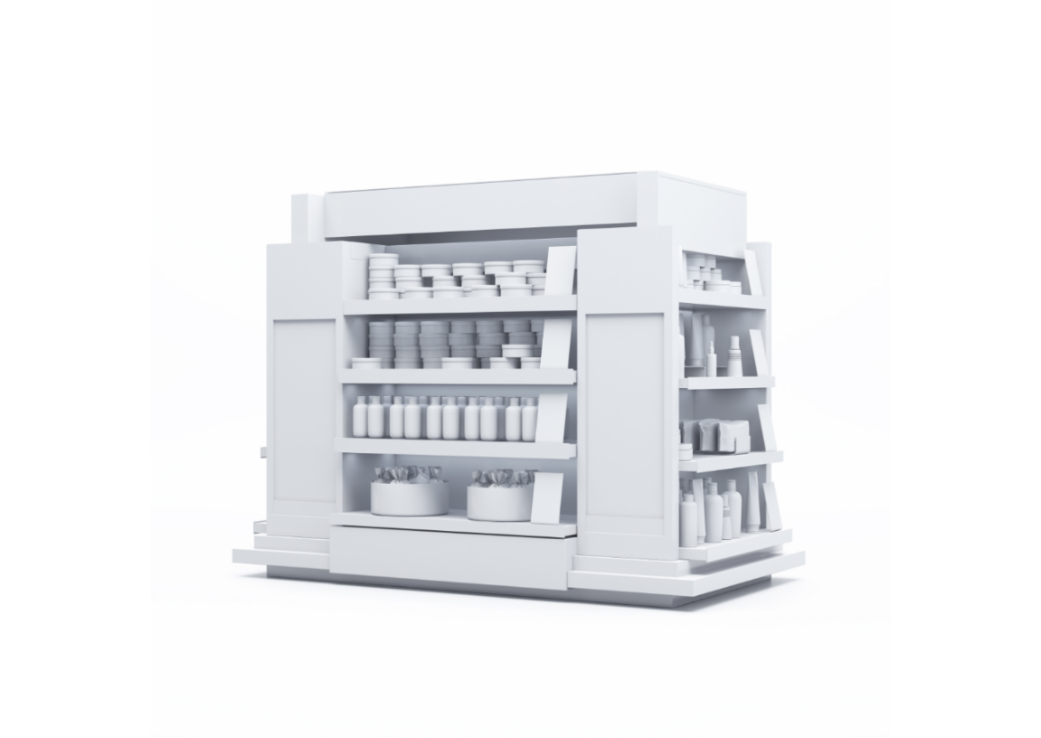

However, many companies may neglect or devote less care to their warehouse, perhaps due to lack of time or organization, when instead this should represent one of the cornerstones of their business.

Optimizing and automating management also [saves time](https://www.treatwell.it/partners/risorse/blog/come-risparmiare-tempo-nella-gestione-del-tuo-salone/), and therefore also money, which could instead be invested in business growth.

Managing a warehouse does not mean dedicating yourself only to the management of product flows within your business but allows you to collect essential information for the correct business management. It also allows you to assess if there is waste or excessive product orders, risking that they make "dust" between the shelves of the warehouse.

The five main operations for the correct management of the warehouse concern:

* keep your budget under control,
* monitor stocks,
* manage the warehouse constantly,
* avoid clutter,
* automate management (where possible).

**1. Manage your purchase budget**

Budget management is another fundamental point to which attention must be paid.

A correct management of the budget allows you to have under control the stocks of the products and avoid the accumulation of the same in your warehouse.

A correct management of the budget is possible thanks to a strategic planning of expenses, creating a periodic budget of purchases based on the turnover of previous periods, which in the case of the beauty salon must also be compared to the seasonal period.

It is therefore better to aim for a lower budget, since it is always possible to implement with last-minute orders in case of product shortages.

The opposite is not true, that is, to acquire greater quantities of products, which cannot be converted into expendable money but will inevitably remain stuck in stock.

**2. Manage stocks**

Inventory management is also linked to budget management.

Verifying the economic value of the warehouse at periodic intervals, allows you to have full control of the products in relation to the real business need.

For example, establishing a deadline within which the goods must be used or processed guarantees a continuous replacement cycle and avoids the accumulation of goods (sometimes even unused) in the warehouse.

In this way, inventory operations are also streamlined, a fundamental action for the correct management of the beauty salon.

Not knowing the inventory of your products, therefore the exact availability of the same in the warehouse, is not a situation related to a healthy business activity: you must in fact always have under control the availability of products within your warehouse.

**3. Always be constant**

Another important point for a correct management of a warehouse is that of the time to devote to this activity.

In fact, it is not possible to spend time managing the warehouse without first planning it. This means that it is necessary to do these operations regularly and precisely, perhaps by appointing a manager and possibly also a deputy manager, based on the size of the warehouse, which guarantee the correct execution of the various tasks.

The management must therefore become an integral part of the daily activity to be carried out in the salon.

**4. Avoid clutter**

As in any self-respecting warehouse, it is in fact a priority to keep everything in its place and give a place to every product or work tool, such as gloves and capes of color.

A well-ordered warehouse allows first of all to save time and better manage stocks, avoiding the accumulation of misplaced products and keeping stocks monitored.

In this way it is possible to keep a watchful eye on the movement of goods, on the management of the documentation of the same and consequently guarantee a healthy business growth, limiting inconsistencies to a minimum.

It is important not to have sheets scattered around the reception and packages stacked in the warehouse, without being opened, checked and stored in the appropriate shelves. Only by keeping everything in order can you know exactly what, where, how and when to find or order a certain product again, keeping the management of the business clear.

**5. Automate management**

Nowadays, technology can also help in the management of a beauty salon, especially about product orders.

In fact, there are management software able to process orders and move all products, verify and monitor sales and always have stocks and items under stock under control.



6.3 What’s an order?

A purchase order is essentially a contract that authorizes a supplier to deliver goods or services at a predetermined price. If the company needs to regularly make purchases from suppliers one of the fundamentals of the purchase process is precisely the purchase orders. Purchase orders can be of varying complexity and structure, but they should always be drafted including at least the following essential points:

* Type of Product/Service: The purchase order must indicate what you intend to purchase. You must also include the quantity, type of unit as well as a detailed description of the Product/Service to be *purchased*
* Terms of Delivery and Shipping: in addition to the delivery date, you must indicate the destination address, how the goods will be shipped who is responsible for the shipment and who pays for the shipment
* Amount: Make sure you correctly indicate the amount of the order and the type of currency. Specify the cost for each unit, the total cost, and its tax.
* Payment Terms: Specify how you intend to pay for the product / service purchased (bank transfer, cash, credit card etc. ...) and the times within which the payment must take place.

The purchase order is a fundamental document that should be part of a standardized purchasing process with appropriate procedures that help streamline the supply cycle thus contributing to business efficiency. Of course, the completeness in the contents of an order depends decisively on an accurate preparation of the [Purchase Request](https://www.logisticaefficiente.it/wiki-logistica/procurement/richiesta-acquisto-rda.html) and  the [Request for Offer](https://www.logisticaefficiente.it/wiki-logistica/procurement/richiesta-offerta-rdo.html) whose primary purpose is to fully define the characteristics / technical specifications of the product or service to be purchased as well as the related supply conditions. Finally, it is good to say that now many purchase orders are not paper but are transmitted electronically on the Internet or, today more and more often, through the use of appropriate e-Procurement platforms capable of managing the entire purchase process via the web. After contacting a company and receiving their price lists, we can place an order. Nowadays not all orders are made by letter: some companies require an IT order, others enter on their website the order form already pre-printed, others are waiting for e-mail communications. Any either the nature or the method of shipment the order must still have a progressive number that allows us to identify it and must explain the conditions of payment. The Order Number is usually entered in the subject.

Elements of the text of the letter

1. THANK YOU FOR SENDING CATALOGS AND PRICE LISTS

2. DETAILED DESCRIPTION OF THE GOODS TO BE ORDERED (product code, description, quantity, unit price)

3. SUMMARY OF THE GENERAL CONDITIONS (Means of shipment, delivery terms, methods of payment, other conditions, any previously agreed discounts must be made clear.

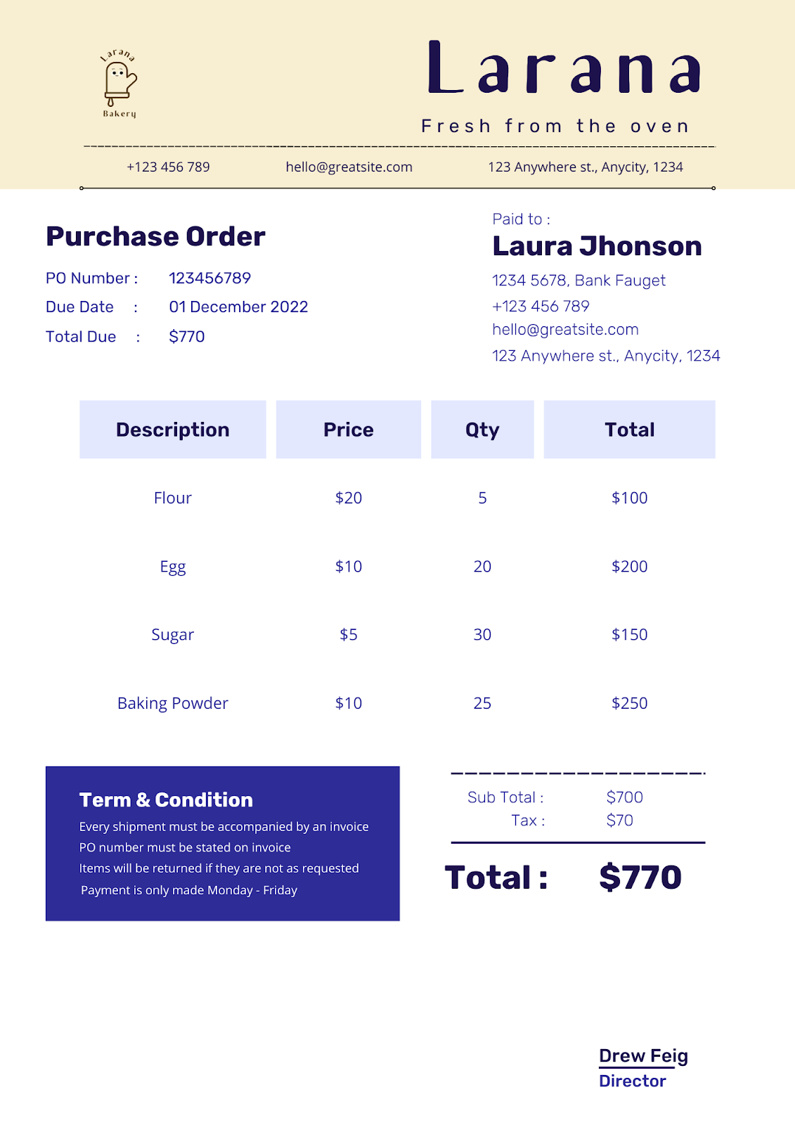



After carrying out the warehouse inventory you realized that you had arrived at the understock of the following products:

Create two purchase orders using:

1. an excel sheet also adding the images you can find
2. one of the two free apps suggested below:

PURCHASE ORDER PO PDF MAKER



ZOHO PURCHASE ORDER GENERATOR

https://www.zoho.com/inventory/purchaseorder-generator/