
Future skills & sustainable development
in the Green Salon

Module 1 – Environment and Recycling


Teacher’s resource kit
Authors: Bridgwater & Taunton College, IES El Palo, ROC van Amsterdam
Future Skills & Sustainable Development in the Green Salon is a European project that aims to combine the sustainable ideas through education and training with innovative ideas within the sector.
This project has been funded with support from the European Commission. This publication reflects the views only of the author, and the Commission cannot be held responsible for any use which may be made of the information contained therein.
The project partners within this program are:
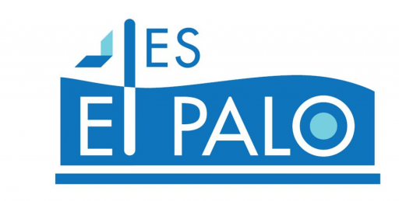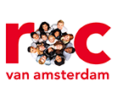

© 2017 Green Salon project, Erasmus+ 2015-1-NL01-KA202-008844. No part of this document may be reproduced in any form without the authorisation of Stivako (project coordinator) and the author.

Contact address:
Stivako
Boeingavenue 207
1119 PD Schiphol-Rijk
The Netherlands
tel. +31 20 5435670
info@stivako.nl

Project website: www.greensalon.eu
Table of content

Lesson 1 Recycling Waste 4
Media Used 4
Powerpoint Presentation 4
Student Handout 5
YouTube Clip 5
Student Handout Answers 6
Lesson 2 Recycling Electrical items and Plastic 7
Media Used 7
Powerpoint 7
Student Handout 8
Student Handout Answers 9
Lesson 3 Reducing Consumption (Energy, Products, Paper, etc.) 10
Media Used 10
Powerpoint 10
YouTube Link 11
Sustainability Games 11
Lesson 4 Eco Furniture 13
Activities 13
Tools, Information and Worksheets 15
Lesson 5 Encouraging Carbon-Reducing Journeys to Work 16
Media Used 16
Powerpoint 16
YouTube Links 16
Lesson 6 National Legislations or requirements about Environmental Protection and Recycling 17
Media Used 17
Powerpoint 17
Kahoot Link 17
Student Handout 18
Student Worksheet 20
Student Answers 20

Lesson 1

Recycling Waste

Media used for this lesson is:
- Power point
- Student handouts
- Computers
- YouTube
- Other media (magazines, tap aerators, bulbs and other devices)
- Etc.

Power Point presentation

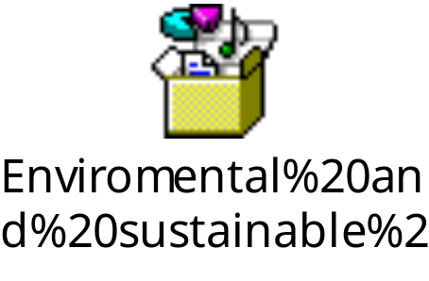

Student handout

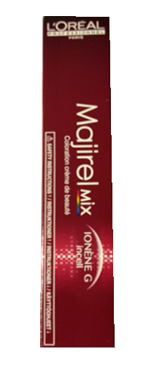
1. If a stylist mixed up 5% more tint than they needed for each colour client, over 20 clients a whole tube of tint has been wasted
(5% x 20 = 100% - a full tube)

If in one week, six salons stylist wasted 5% of tint, and carried out a total of 50 colour services- how many tubes of tint have been wasted?

2. If these six stylist mixed up ½ a tube of tint when a ¼ of a tube would have been sufficient, how much product has been wasted on 50 colouring services?

3. If one tube of tint coasts £6:50+Vat, how much money has been wasted

YouTube Link

https://www.youtube.com/watch?v=tCbFl9UHQh4

Student handout Answer

1. If a stylist mixed up 5% more tint than they needed for each colour client, over 20 clients a whole tube of tint has been wasted
(5% x 20 = 100% - a full tube)

If in one week, six salons stylist wasted 5% of tint, and carried out a total of 50 colour services- how many tubes of tint have been wasted?

2 and half tubes wasted

2. If these six stylist mixed up ½ a tube of tint when a ¼ of a tube would have been sufficient, how much product has been wasted on 50 colouring services?

12:50 tubes wasted

3. If one tube of tint coasts £6:50+Vat, how much money has been wasted

£97.50 waste

Lesson 2

Recycling Electrical Items and Plastic

Media used for this lesson is:
- Power point
- Student handouts
- Computers
- Etc.

Power Point presentation

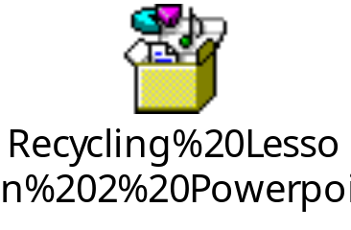

Student Handout

Plastic symbols, let’s identify examples of them, can they all be recycled?

Symbol | Polymer type | Examples | Recyclable
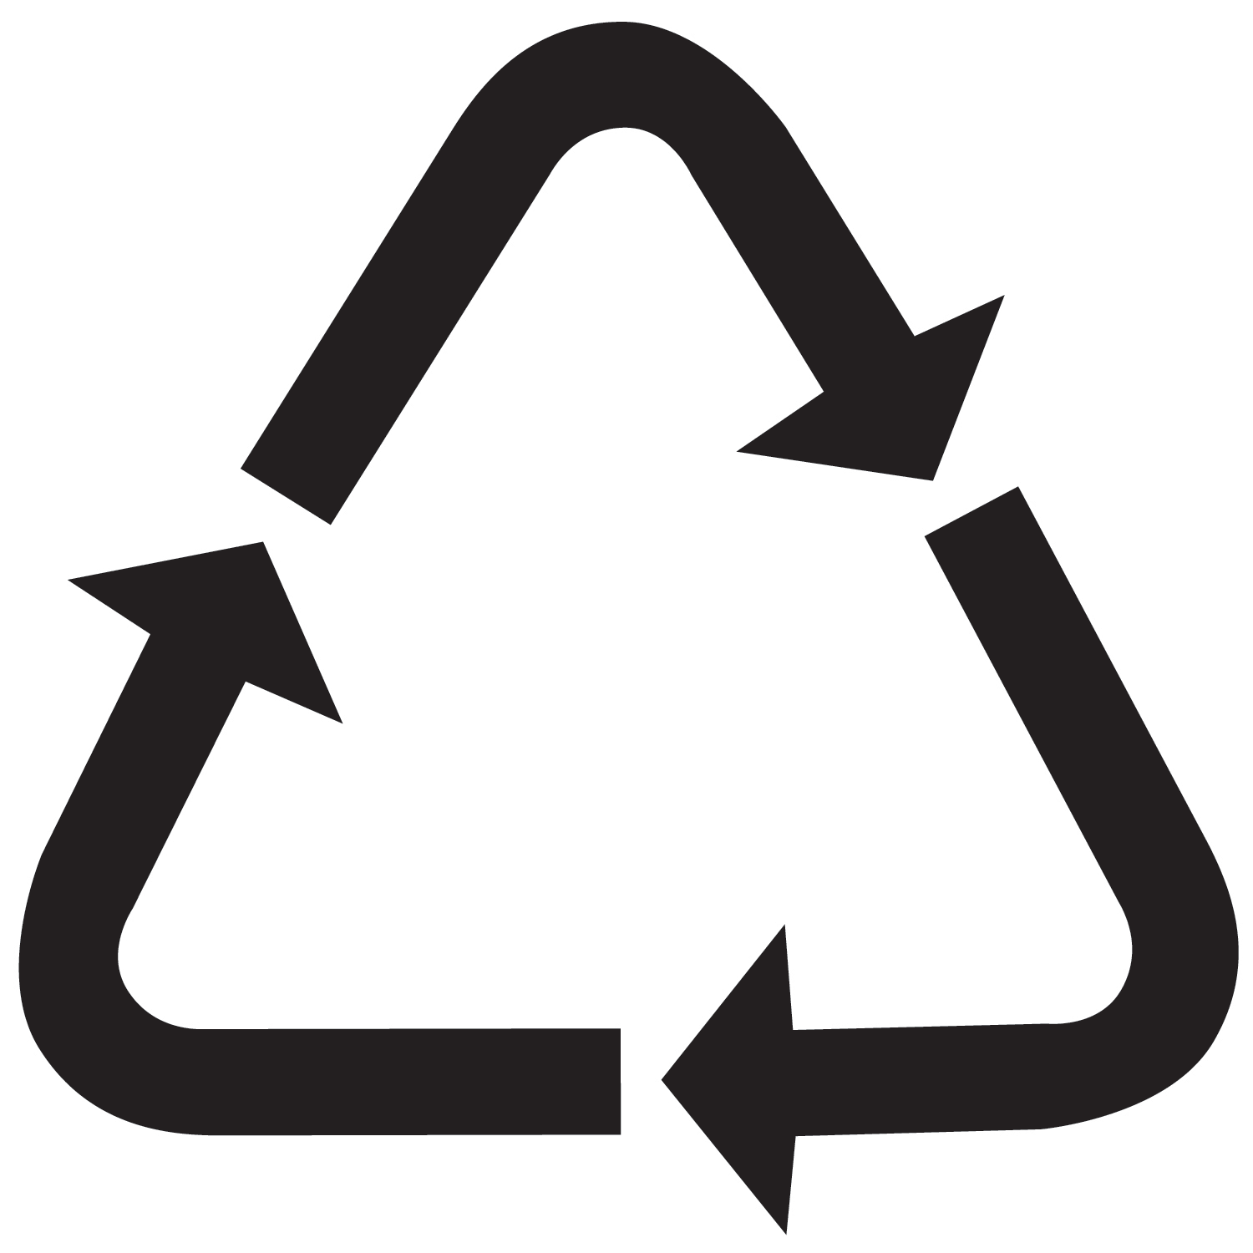  PETE | PET  Polyethylene  Terephthalate
HDPE | HDPE  High Density  Polyethylene
PVC
Polyvinyl Chloride
LDPE | Low Density  Polyethylene
PP | PP  polypropylene
PS | PS  Polystyrene
OTHER | Other  All other resins & multi materials

Student handout answers

Plastic symbols, let’s identify examples of them, can they all be recycled?

Symbol | Polymer type | Examples | Recyclable
PETE | PET  Polyethylene  Terephthalate | Water bottles  Carbonated drink bottles  Cooking oil bottles | In many recycling plants
HDPE | HDPE  High Density  Polyethylene | Milk bottles  Washing up Liquid bottles  Shower crème bottles | In many recycling plants
 | PVC  Polyvinyl Chloride | Not to commonly found now but, can be found in some bottle forms | In many recycling plants
LDPE | Low Density  Polyethylene | Very common in many different types of plastic especially packaging cold meats and vegetables | In many recycling plants
PP | PP  polypropylene | Very common in many different types of plastic especially packaging cold meats and vegetables | In many recycling plants
PS | PS  Polystyrene | Very common in many different types of plastic especially packaging cold meats and vegetables | In many recycling plants
OTHER | Other  All other resins & multi materials | Very common in many different types of plastic especially packaging cold meats and vegetables | In many recycling plants

Lesson 3. Reducing consumption (energy, products, paper, etc.)

Media used for this lesson is:
- Power point
- You tube
- Laptop
- Other media (magazines, tap aerators, bulbs and other devices)
- Etc.

Power Point presentation
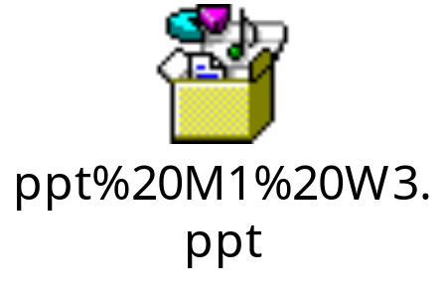

Activities
1. Use two similar containers, for example two glasses of water, to compare the expense of water with and without aerator. Time every 5 seconds with the tap open at maximum flow. Analyse the result.
You can also see the following video: https://www.youtube.com/watch?v=wXzDNzu1C1E for this, you will need computers and internet connection.

2. Use two similar containers. Pour in one the amount of shampoo that you consider necessary to wash the hair and weight it. Afterwards, weigh in the other container the amount of shampoo that is obtained by pressing the dispenser once. Compare and analyse the results.

3. Perform a conventional hair wash and collect the water used in a container. Right after repeat the washing but this time using a sprayer to emulsify the shampoo. Compare the amount of water used in both processes. Do the same activity but, this time, to wash some wicks.
https://es.slideshare.net/alopezpalomera/estudio-del-uso-eficiente-del-agua-en-las-peluqueras

4. In groups, think on some icons or tips to save energy, draw them and make stickers with them. The best will be placed in the working station to remind everyone the importance of reducing consumption.

5. Search in the press or on internet for news about sustainable hairdressing. Split the group in two teams; one will defend sustainable hairdressing and its benefits while the other will argue contrary. Finish the debate with a brainstorming.

6. Calculate the energy consumption of your hairdressing salon and the savings you could have with the consumption calculator available on:

7. Check your knowledge and your environmental awareness with some of the games you have in the resources. You will need computers and internet connection.

8. Research and describe the impact that regular hairdressers tasks produce in the environment, and the alternatives that could be used for saving and reducing the impact at the same time. For this you can use the following table:

PROCESS | MATERIALS | ENERGY | IMPACTS | ALTERNATIVES
Hair colouring
Hair washing
Hair drying and styling

YouTube link
- https://www.youtube.com/watch?v=bC6LUEEA6GQ&list=PLKrcqTEP23RhynHbREy7iZKLtjRnlN_NE
Here you will find the presentation about sustainability designed for the project Green’ability and that was the introduction for the fashion show Lookin’ green, which took place in Málaga in year 2014.

Sustainability games

- http://www.2020energy.eu/game
2020 energy is a serious game about energy efficiency, renewable energy and sustainable development created at Energy bits, which is a cross-media project on sustainable energy and energy saving, supported by Intelligent Energy Europe (European Commission), with the aim to stimulate behavioural change and promote innovative practices among the 14-18 years old. Its resource platform proposes a collection of 24 documentaries, a web documentary, participative tools and this game that can be played in 9 languages.

- http://www.olliesworld.com/club/gamehouse.htm
“Ollie's World” is the umbrella site for the suite of "Ollie" web sites, produced to support the "Ollie" Programs in various countries. “Ollie's World” contains two sections - one for adults and one for kids.

The adult section contains information about:
- Educational concepts for each Ollie Program
- Details about the companies and organisations involved in each Program
- How companies and organisations can become involved in supporting the distribution of Ollie CD ROMs into schools and community groups throughout the world.
- News on current events related to the Ollie Programs.
- Information for teachers and community groups.
- The Ollie online shop, where Ollie software and associated products can be purchased.

The extensive kids' section has information for children worldwide, about the 4Rs:
- Reduce
- Reuse
- Recycle, and
- Rethink.
These concepts are applied to 5 action issues:
- Waste
- Water
- Energy
- Air, and
- Biodiversity
These issues are brought into context under the organising principle of Sustainability.

- http://www.ocu.org/site_images/educar2/consumo.swf (only in Spanish)
Juego educativo en español sobre el consume sostenible, el ciclo del reciclaje y la relación de consume y las tecnologías de la información y la comunicación.

Lesson 4 Eco Furniture

Activities

Activity one:

Postcards exercise

Material: 20 – 40 postcards with a variety of pictures on them. Mostly furniture. Important is that the pictures lend themselves to multiple interpretations.

Space: Students are congregated in a circle with no more than 8 persons. Allow for more circles of 8 when needed.

Preparation: spread out all cards on a table within the group, ensure all can see at least some of the pictures at first glance.

How to: Let every participant / student choose two cards that say something about them as a person. Every student gets two minutes in total to explain why they have chosen this particular card (s). The other participants get one minute each maximum to react or to ask a question.

Activity two:

Black Box

The goals is to make attitudes come to light

Material:
- Voting boxes
- Empty cards
- Score forms
- Cards to help the contestants - red, yellow, green for each participant

Space – all participants are around a table

Preparation:

Prepare boxes for the voting cards, stacks or designated areas can also be used. Note, on this issue and subject you may want to design voting boxes that can be used several times.
Prepare questions that deal with the attitudes that you want to discuss.
- Examples are: Should eco -furniture be compulsory
- Should eco-furniture be less expensive and why
- Should the government make it more easy to buy eco-friendly furniture etc
Put these questions on label Cards
Make sure loose labels are available

How:
In the first round the teacher or designated student lets the voting box go round
Every student thinks about their answers and puts his/her answer into the voting box
The voting is anonymous.

The teacher rounds up the votes and decides on the outcome

Make sure not to make the voting cards available for all to see as some students might have written their name on it.

Students will want to explain their choices, let them!

Activity three:

Concept mapping

Materials: Flap overs and materials to hang them up

Space: A flexible room where people can work in groups of 6-8 students.
Preparation; a list of subjects written on a flip over
Approach:
- Introduce the assignment; concept mapping I meant to name the connections between concepts.
- Highlight these steps:
- Step 1: write down all terms that come to mind on this subject
- Step 2: Order all terms that were written down in order from abstract to concrete.
- Step 3: Group all terms in clusters, each cluster consists of terms equal in level of abstract or of term logically meant to be grouped.
- Step 4: Order: note all terms on a flip over and circle them, see how the different circles interact with each other.
- Step 5: Relate: Connect the circles through linear lines. Think of a word that denotes the relation t=between the circles.

Exchange the flip overs and discuss matches and differences.
Demonstrate in the group an example as best practice.

Notes:
- Making a concept map is not easy to start off with. Perhaps it is easier to complete a map that has been made.
- Ensure that all term all well-defined; in eco furniture for a green salon these are ‘furniture’, ‘green’, ‘durable’, ‘eco’ and many others.

Example of concept mapping:

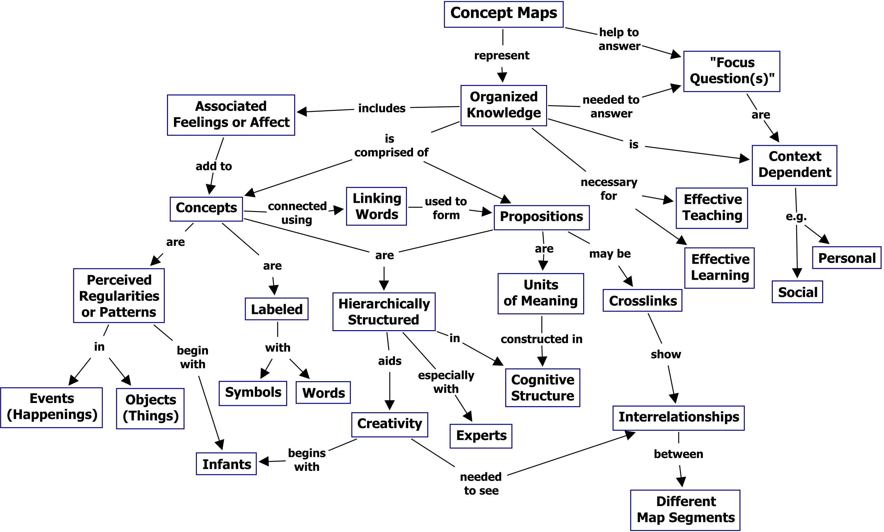

Tools, information and worksheets needed for the lesson:

- Student activity one: ensure to be aware of the furniture in the classroom. Where does it originate from? In what way is it eco-friendly or not?
- Student activity two: needed: Flip (or flap) over’s for the groups to use
- Student activity three: Smartboard or beamer / computer needed. Prior to lesson, check if everything works. If you do not have access to a smartboard, then magazines must be provided.
- Student activity four: Students present their material

Lesson 5
Encouraging carbon-reducing
Journeys to work

Media used for this lesson is:
- Power point
- Whiteboard
- Internet
- Computers
- YouTube
- Other media (magazines, tap aerators, bulbs and other devices)
- Etc.

Power Point presentation



YouTube Link

https://www.youtube.com/watch?v=YseZXKfT_yY

http://footprint.wwf.org.uk/

Lesson 6
National legislation or requirements about Environmental
Protection and recycling

Media used for this lesson is:
- Power point
- Whiteboard
- Internet
- Student handouts
- Computers
- Kahoots
- Other media (magazines, tap aerators, bulbs and other devices)
- Etc.

Power Point presentation

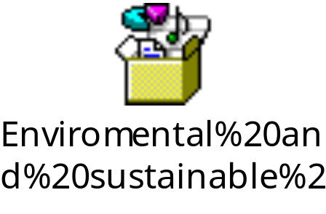

Link

Kahoot! | Learning Games | Make Learning Awesome!

Student Handout

This information is found on Wikipedia

The beginnings of the EU's environmental policy
The Paris Summit meeting of heads of state and government of the European Economic Community (EEC) in October 1972 is often used to pin point the beginning of the EU's environmental policy. A declaration on environmental and consumer policy was adopted at this summit which requested the European Commission to draw up an action programme for environmental protection. This (first) Environmental Action Programme was adopted in July 1973 and represented the EU’s first environmental policy. Furthermore, the task force within the Commission that drew up this action programme eventually led to the formation of a Directorate General for the Environment.
The primary reason at that time for the introduction of a common environmental policy was the concern that diverse environmental standards could result in trade barriers and competitive distortions in the Common Market. Different national standards for particular products, such as limitations on vehicle emissions for the lead content of petrol, posed significant barriers to the free trade of these products within the Economic Community (EC). An additional motivation driving the EU’s emerging environmental policy was the increasing international politicisation of environmental problems and the growing realisation from the beginning of the 1970s that environmental pollution did not stop at national borders, but had to be addressed by cross-border measures. At that time there was no mention of environmental policy in the founding treaties of the EU and therefore no explicit Treaty basis which underpinned EU environmental policy. However, the Treaty text was interpreted dynamically, enabling environmental policy to be regarded as an essential goal of the Community, even though it was not explicitly mentioned. It was not until the middle of the 1980s and the signing of the Single European Act in 1986 that economic and ecological objectives were put on a more equal footing within the Community.

Main actors
EU environmental policy is shaped by a variety of actors including all of the main EU institutions as well as lobby groups which makeup the wider Brussels policy making community.
Member states shape EU environmental policy by working within the Council of Ministers. The Council is a central actor in decision making in the EU sharing its decision making power with the European Parliament under the ‘ordinary legislative procedure’. There are different Council formations (made up of ministers responsible for particular policy areas) one of which is the Environment Council. The number of Environment Council meetings has increased significantly over time. Heads of state meet in something different – the European Council – which until recently had very little to do with environmental policy. However, more recently the European Council has played an important role in EU climate change policy in particular.
The European Commission not only has an exclusive right to propose new environmental policy, but it also has a responsibility to ensure the implementation of environmental rules. Therefore, since its creation in the 1950s the European Commission has been at the heart of the European Union. However, it did not set up a unit dedicated to environmental issues until the 1970s and a full Directorate General for the environment until 1981. Initially DG Environment was perceived as a relatively weak DG but it has gradually become more assertive through the development of technical and political expertise. However, the Commission still has to depend on member states to implement its policies.
Traditionally, the European Parliament gained a reputation as a champion of environmental interests within the EU where it provided an access point for those excluded from decision making and a voice for green political parties. However, it was a reactive and relatively weak institution. More recently the Parliament has benefited from treaty changes that have made it a co-legislator with the Council of Ministers. However, the empowerment of the Parliament seems to have reduced its green credentials as it now appears less willing to adopt green amendments.
Over the last 40 years the EU has attracted the interest of a vast number of lobby groups including environmental NGOs. As early as 1974, environmental groups from all the member states established a central representation in Brussels, founding the European Environmental Bureau. Other environmental NGOs only set up shop in Brussels from the late 1980s onwards. European institutions, especially the European Commission, provide relatively easy access to these groups compared to some national governments. The European Commission has even actively encouraged their participation in policy making by setting up consultative committees and other bodies, and providing funds to establish and maintain certain core groups.
Considerably to the practical difficulty of evaluating policies. Assessing impacts and finding side-effects of policies is best achieved by a plurality of data, methods, analysts and theories, as well as evaluation criteria. In recent years the demand for evaluations of EU policies and programmes has increased as the importance of evaluation has become more widely recognised. Many actors have become involved in commissioning, producing and using evaluations (including the European Environment Agency), but the role of evaluation is often still quite weak.
Synergic to the environmental policy in Europe is the European environmental research and innovation policy. It aims at defining and implementing a transformative agenda to greening the economy and the society as a whole so to achieve a truly sustainable development.

Student Worksheet

Please answer the following:

- What is the primary reason for the introduction of the common Environmental policy?
- When was the signing of the Single European Act?
- How did this help Economic an Ecological objectives?
- Who has played an important role in the EU climate change?
- What commission holds the right to propose change to the policy?
- How many years has the EU attracted interest to a number of lobby groups?
- What have the European Commission’s encouraged their participants to implement?

Answers

- The primary reason for the introduction of a common environmental policy was the concern that diverse environmental stands could result in trade barriers and competitive distortions in the Common Market
- The signing of the Single European Act was in 1986
- European Council
- European Council played an important role in EU climate change.
- The European Commission not only has an exclusive right to propose new environmental policy, but also has a responsibility to ensure the implementation of environmental rules.
- Forty years the EU has attracted interest to a number of lobby groups.
- Environmental

